Launch Horizon HQ | Full collection for owner review | 2 November 2026

Launch Horizon HQ activity collection
  - Sixty activities to explore at your pace
Follow an interest, try a small practical idea and decide what you want to do next. These pages offer a starting point, a worked example and room to change the direction.


Choose a starting point
Three activities in each of twenty subjects
Art, Astronomy, Biology, Chemistry, Computing, Design, Ecology, Engineering, Film & Animation, Games, Geography, History, Languages, Mathematics, Music, Philosophy, Physics, Sport & Movement, Storytelling, Zoology.
Use the activity names and IDs to find a matching worksheet or a small individual PDF. You do not need to work through this collection in order.
Use any page that interests you. There is no order to complete, score to reach or personal story to share. You can change direction, work in another way or stop.

Make these activities yours
Start with a question that catches your attention. The first action is deliberately small. Use the worked example, change the idea or invent another version.

Choose how to take part
Read, draw, talk, write, make or listen first. Work with someone or explore independently. Ask for fewer choices, clearer instructions, an example or a break.

Use what you have
The supplied examples work offline with paper and a pencil. Time guides are estimates, not deadlines. Materials and a different way are listed on each activity.

Keep work in your own way
Use a blank sheet, the matching worksheet or an editable document. The website can open the activity as a project. Downloading a project works without an account; account saving uses the existing invited My Horizon pilot.

Choose what to share
Your work can stay private. Keep names, passwords, addresses, private messages and other people’s identifying details out of learning sheets. Nothing here sends a message or submits your work.

Notice something useful
A sketch, a better question, a changed rule or a decision to pause can be worth keeping. Reflection is optional. The examples are invented models, not results you must reproduce.

Find a matching sheet
The activity IDs appear on the matching worksheet and website page. Keep the resources together when you download or print them. Original diagrams are accompanied by text descriptions.

01 Art | art-two-moods

One doorway two possibilities
How much can one line choice change the way an image is read?
Draw an imaginary scene twice, change one visual choice and separate what you can see from what you interpret.
Make | 10-20 minutes, or one small sketch | Scrap paper and a pencil or pen, The supplied original doorway example; no image search needed
Start here Draw a rectangle for a doorway, a circle for its window and a triangle above it. A rough version is enough.
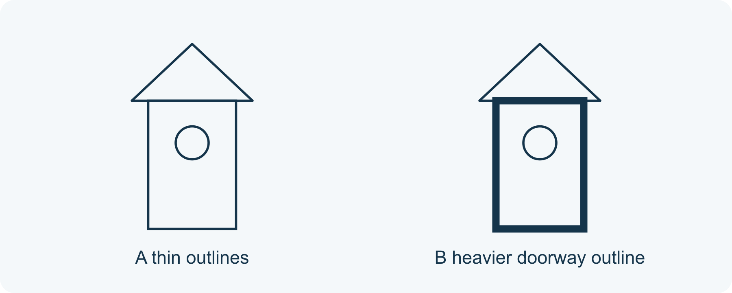
Same shapes, one changed outline
1 Keep a reference
Draw the same three shapes again beside the first scene. Keep their positions and sizes similar so you can explain what changes. You can use the supplied example throughout.
2 Change one choice
Use thin outlines in version A. In version B, make only the doorway outline heavier by tracing it again. Keep the circle and triangle thin. You may choose another single change instead, such as spacing, if you name it.
3 Describe, then interpret
Write or say one visible difference: ‘The doorway outline is thicker.’ Then offer one possible reading: ‘It draws my attention to the entrance.’ Someone else may interpret it differently.
4 Choose what to keep
Keep either version, combine an idea or leave both unfinished. If you want feedback, ask a precise question such as ‘What catches your eye first?’ No sharing is required.

01 A worked example | art-two-moods

Original example an imaginary doorway
This is an invented design comparison, not a report of audience responses. A and B contain the same rectangle, circular window and triangular roof in the same positions.
• A: all three outlines are thin.
• B: only the doorway outline is heavier.
• Visible change: line weight. Possible interpretation: the doorway attracts more attention.
What this example can show A different reading is possible. These drawings do not establish how every viewer feels, or that one version is better.

A different way
Point to the changed outline in the example, describe it aloud or direct someone else to draw it. You can compare without making your own picture.

If you want to go further
Make a third version changing only spacing. Compare whether line weight and spacing guide attention in different ways; keep your claims tied to the actual drawings.

Something to notice
Which part was a visible change, and which part was my interpretation?

Read or explore more
Horizon topic Art
https://launchhorizonhq.com/learn/art/
Horizon topic Colour Contrast
https://launchhorizonhq.com/learn/colour-contrast/
Horizon topic Composition Balance
https://launchhorizonhq.com/learn/composition-balance/
National Gallery of Victoria Explore the Art Elements
https://www.ngv.vic.gov.au/learn/explore-the-art-elements/
National Gallery of Art The Elements of Art
https://www.nga.gov/educational-resources/elements-art

02 Art | art-marks-and-texture

A texture made of marks
How can repeated marks suggest a surface without copying a photograph?
Use repeated lines to suggest a surface, then show what changed in the arrangement.
Make | 10-20 minutes, or one comparison | The supplied example, read or heard, Optional scrap paper and a pen or pencil
Start here Look at the two supplied patches: each contains 12 short slanting marks. A spaces them evenly; B gathers them into three groups of four.
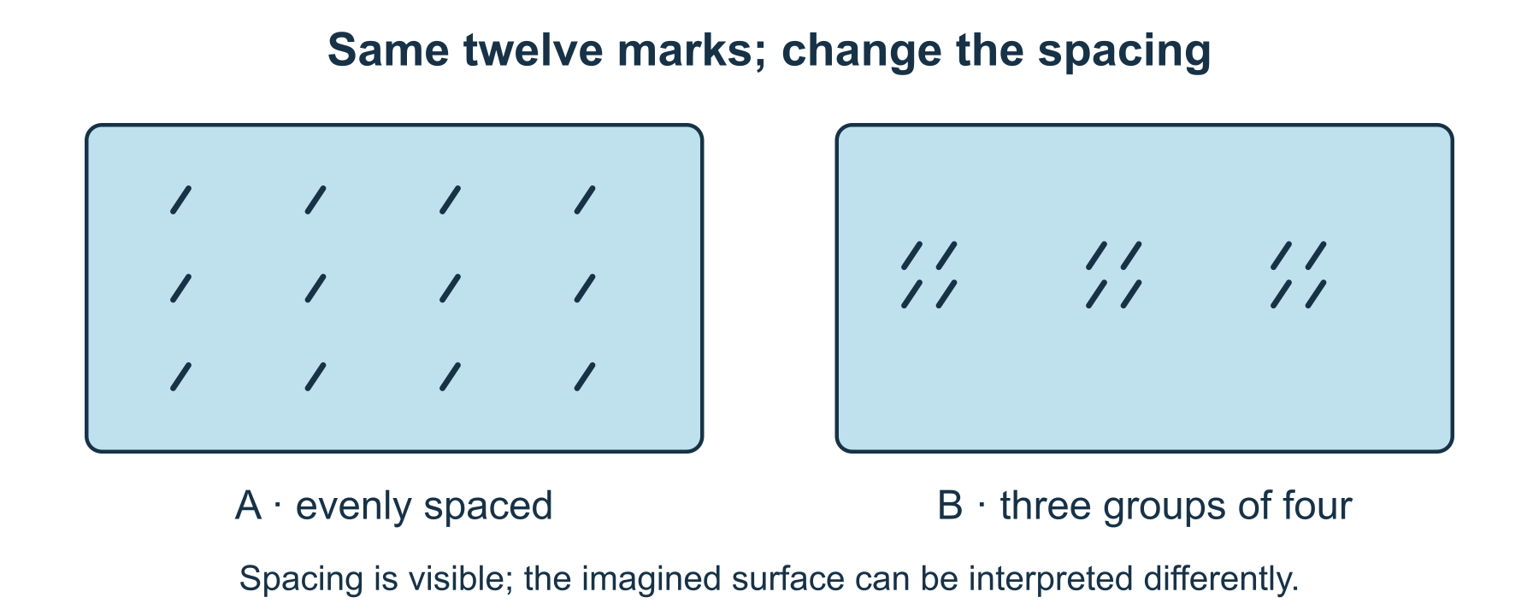
Twelve marks, two arrangements
1 Choose a mark
Draw one small slanting line, or use the supplied mark. Repeat it 12 times in a rectangular patch without trying to depict a real object.
2 Rearrange the same marks
Make a second patch with 12 similar lines gathered into three groups of four. Keep the mark size and direction similar; change the spacing.
3 Describe a possible texture
Name a visible feature first: ‘three tight groups’. Then suggest a surface it could evoke. A drawing can suggest roughness without its paper actually becoming rough.
4 Keep a useful comparison
Label the two patches and choose which arrangement you would develop, if either. You can also explain the example without making your own.

02 A worked example | art-marks-and-texture

Original model twelve marks two arrangements
These invented patches compare mark spacing. They do not copy a photograph or show a measured physical surface.
• A contains 12 evenly spaced slanting marks.
• B contains the same 12 marks in three groups of four.
• ‘More clustered’ describes B; ‘looks bark-like’ is one possible interpretation.
What this example can show Spacing can suggest texture, but this pair does not show that every viewer sees the same surface or that the paper has changed texture.

A different way
Compare the supplied patches by pointing, speaking or directing someone else to place the marks. No touching or collecting surfaces is needed.

If you want to go further
Keep spacing fixed in a third patch and change only mark direction. Compare how each change affects your reading.

Something to notice
Which part was visible spacing, and which part was an imagined surface?

Read or explore more
Horizon topic Texture Marks
https://launchhorizonhq.com/learn/texture-marks/
Horizon topic Print Patterns
https://launchhorizonhq.com/learn/print-patterns/
Horizon topic Art
https://launchhorizonhq.com/learn/art/
National Gallery of Art The Elements of Art: Texture
https://www.nga.gov/educational-resources/elements-art/elements-art-texture
National Gallery of Art The Elements of Art: Line
https://www.nga.gov/educational-resources/elements-art/elements-art-line

03 Art | art-viewpoint-study

Three views of an invented object
What does each viewpoint reveal or leave hidden?
Compare three straight-on views of an invented block and distinguish a hidden face from a missing feature.
Explore | 15-25 minutes, or two views | The supplied example, read or heard, Optional scrap paper and a pen or pencil
Start here Use an invented block 4 units wide, 3 high and 2 deep. It has one dot on its front face and one stripe on its top face.
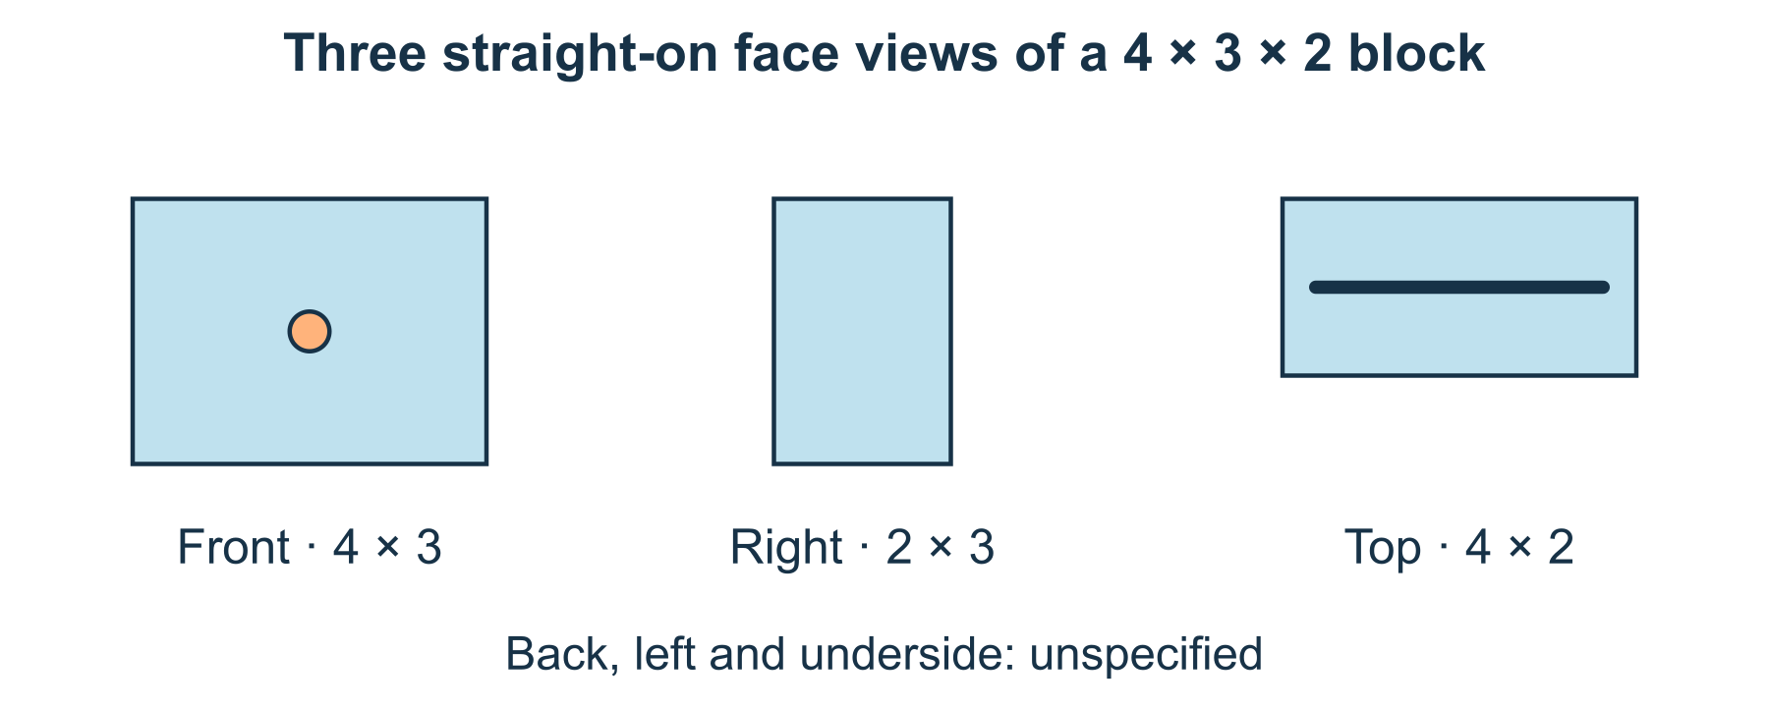
Three face views of one block
1 Name the viewpoints
Treat front, right and top as separate straight-on views. Front shows width and height; right shows depth and height; top shows width and depth.
2 Draw the three faces
Sketch front 4 by 3 with a dot, right 2 by 3 blank, and top 4 by 2 with a stripe. These are labelled face views, so you do not need a perspective drawing.
3 Track the information
List where the dot and stripe appear. Not seeing the front dot in the right view does not prove that the block has no dot.
4 Leave unseen faces open
Write a question about the back, left or underside. The supplied model gives no design for them, so do not silently add an answer.

03 A worked example | art-viewpoint-study

Constructed object front right and top
The block is invented; its dimensions and face markings are supplied facts of the model.
• Front: 4 wide × 3 high, with a dot.
• Right: 2 deep × 3 high, with no marking supplied.
• Top: 4 wide × 2 deep, with a stripe; the other three faces remain unspecified.
What this example can show A view selects information. These schematic views do not establish the appearance of an unshown face or reproduce the perspective of a photograph.

A different way
Compare front and top only, or use spoken labels and rectangles already drawn. No object or model construction is needed.

If you want to go further
Add one clearly declared marking to an unseen face, then make a back view. Distinguish your new design decision from the original specification.

Something to notice
When a feature disappeared from a view, did I mistake hidden for absent?

Read or explore more
Horizon topic Perspective Views
https://launchhorizonhq.com/learn/perspective-views/
Horizon topic Drawing Observation
https://launchhorizonhq.com/learn/drawing-observation/
Horizon topic Art
https://launchhorizonhq.com/learn/art/
National Gallery, London Perspective
https://www.nationalgallery.org.uk/paintings/glossary/perspective
National Gallery of Art The Elements of Art: Line
https://www.nga.gov/educational-resources/elements-art/elements-art-line

04 Astronomy | astronomy-scale-labels

A space map with honest scale labels
Which comparisons can one small Solar System drawing show accurately?
Use rounded orbital-distance values to make a labelled scale line, and show which parts are not to scale.
Make | 15-25 minutes, or one calculation | The supplied example, read or heard, Optional scrap paper and a pen or pencil
Start here Use these rounded average distances from the Sun: Earth 1 AU, Mars 1.5 AU, Jupiter 5.2 AU. Let 1 AU occupy 2 cm on a model line.
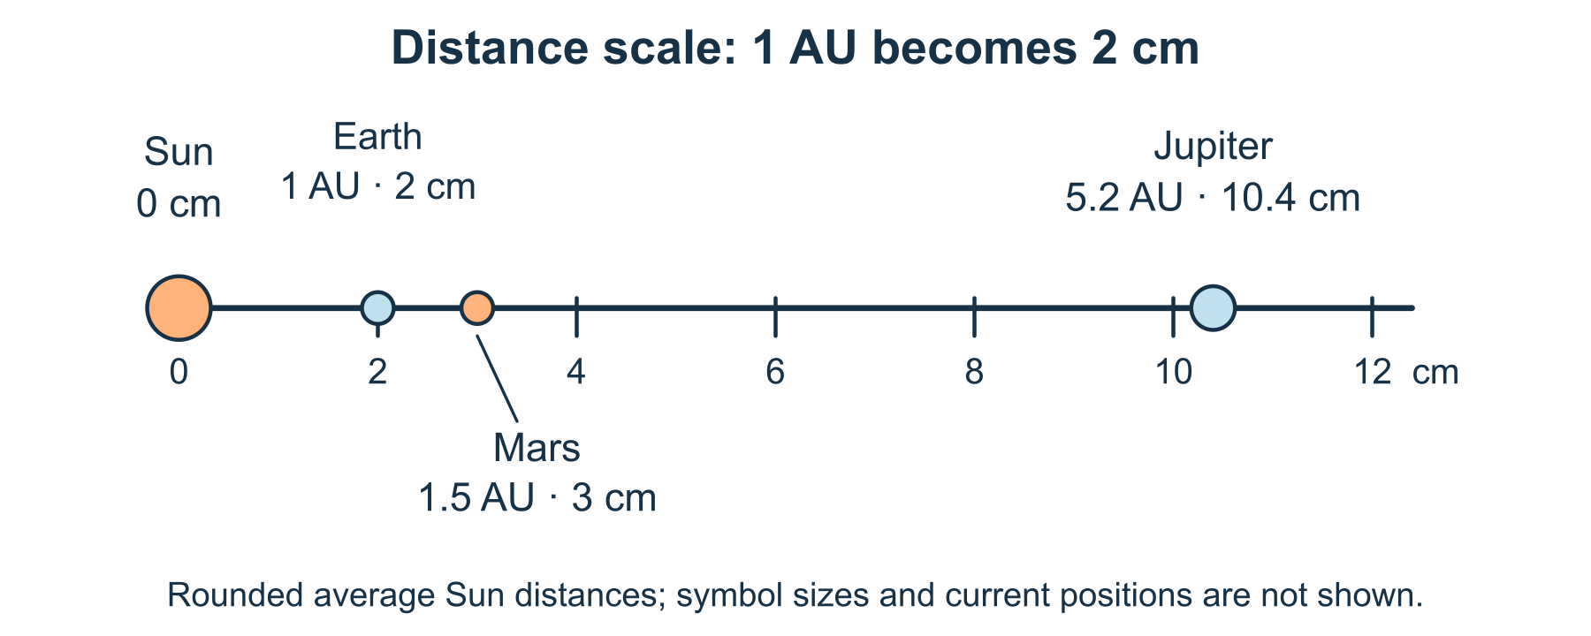
One scale for rounded average Sun distances
1 Convert the values
Multiply each supplied AU value by 2: Earth 2 cm, Mars 3 cm and Jupiter 10.4 cm. A labelled sketch is enough if no ruler is available.
2 Place the markers
Start at a Sun reference mark 0. Put each distance marker the calculated distance along a single line. Treat this as a comparison of distances, not a picture of current planet locations.
3 Make simplifications visible
Use readable planet symbols and label ‘symbol sizes not to scale’. The supplied averages are rounded; planets travel around orbits rather than staying in this line.
4 Check one claim
Explain why Jupiter’s marker is farther along than Mars’s. Do not call the 1 cm gap between Earth and Mars markers their actual separation in space.

04 A worked example | astronomy-scale-labels

Worked scale 1 AU becomes 2 cm
This constructed distance line uses rounded NASA average values. It is not an observation of a real alignment.
• Earth: 1 × 2 = 2 cm; Mars: 1.5 × 2 = 3 cm.
• Jupiter: 5.2 × 2 = 10.4 cm from the Sun reference.
• All marks use one distance scale; their symbol sizes and current directions are not represented.
What this example can show The difference between two average Sun-distance markers is not a general Earth-to-planet distance. This line is not a sky chart or an observing instruction.

A different way
Use the printed line and compare labels, or explain just Earth and Mars aloud. A ruler, telescope and outdoor observation are unnecessary.

If you want to go further
Change the distance scale to 1 AU = 1 cm. Predict and calculate all three new positions; keep planet symbol sizes separately labelled.

Something to notice
Which distances share a scale, and which visual details are only symbols?

Read or explore more
Horizon topic Astronomy
https://launchhorizonhq.com/learn/astronomy/
Horizon topic Orbits Solar System
https://launchhorizonhq.com/learn/orbits-solar-system/
Horizon topic Galaxies Cosmic Scale
https://launchhorizonhq.com/learn/galaxies-cosmic-scale/
NASA Science Mars Facts
https://science.nasa.gov/mars/facts/
NASA Science Jupiter Facts
https://science.nasa.gov/jupiter/jupiter-facts/

05 Astronomy | astronomy-moon-model

Read a Moon phase model
What can a labelled paper model explain about the Moon's changing appearance?
Read a space-view model to explain how our view of reflected sunlight changes as the Moon moves.
Explore | 10-20 minutes, or one explanation | The supplied example, read or heard, Optional scrap paper and a pen or pencil
Start here In the supplied model sunlight comes from the left. Mark the Sun-facing half of each Moon as illuminated, wherever the Moon is placed.
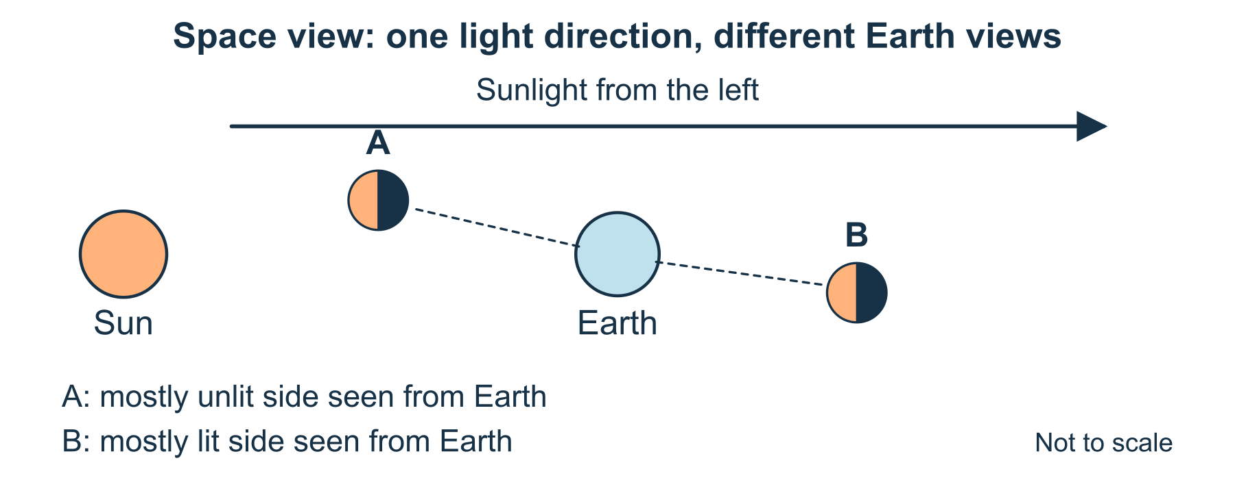
One light direction, two Earth views
1 Separate light from viewpoint
The Moon reflects sunlight. In this simple model its Sun-facing half is lit. That is different from how much of the lit half an observer on Earth can see.
2 Compare two positions
At A the Moon is on the Sunward side of Earth, so Earth sees mostly its unlit side. At B it is on the far side, so Earth sees mostly its lit side. Trace a line of sight from Earth.
3 Name what ordinary phases mean
Explain the change using viewpoint and reflected light. Ordinary phases are not caused by Earth’s shadow; that is a different eclipse situation.
4 Add an honest label
Label the drawing ‘space view, not to scale’. Its staggered positions are schematic; it does not show a real eclipse alignment, a date or how a phase is rotated in the Australian sky.

05 A worked example | astronomy-moon-model

Constructed space view one light direction
The sketch places two possible Moon positions around one Earth. They are comparisons, not two Moons present at once.
• Sunlight travels from left to right; the left half of both Moon symbols is lit.
• A is on the Sunward side: the Earth-facing view contains mostly unlit surface.
• B is on the far side: the Earth-facing view contains mostly lit surface.
What this example can show The sketch omits orbital tilt, scale, dates and sky orientation. It explains a relationship, not tonight’s phase or an eclipse prediction.

A different way
Point to the illuminated halves or have the model described aloud. No torch, dark room, ball or sky observation is required.

If you want to go further
Add a position roughly to one side of Earth’s Sunward direction and explain why the view could show about half of the Moon’s face lit. Keep sky orientation unspecified.

Something to notice
Did I keep the illuminated half separate from the part visible to the observer?

Read or explore more
Horizon topic Moon Phases
https://launchhorizonhq.com/learn/moon-phases/
Horizon topic Models Explanations
https://launchhorizonhq.com/learn/models-explanations/
Horizon topic Astronomy
https://launchhorizonhq.com/learn/astronomy/
NASA Science Moon Phases
https://science.nasa.gov/moon/moon-phases/
Science Education Resource Center, Carleton College What is a Model?
https://serc.carleton.edu/teachearth/teaching_methods/models/WhatIsAModel.html

06 Astronomy | astronomy-planet-signal

Find a pattern in an invented star signal
What might a repeated dip suggest, and what would still need checking?
Read a complete invented brightness series, identify a recurring gap and distinguish a pattern from a confirmed planet.
Investigate | 15-25 minutes, or three data points | The supplied example, read or heard, Optional scrap paper and a pen or pencil
Start here Use times 0 to 10. Brightness is 100 units at every time except 2, 6 and 10, where it is 98 units. These numbers form an invented signal.
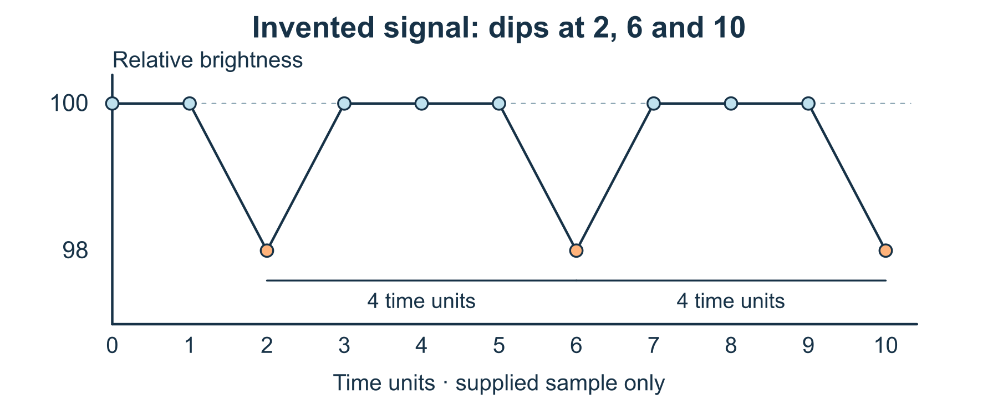
Two equal gaps in an invented signal
1 Put the numbers on a graph
Draw time on the horizontal axis and relative brightness on the vertical axis, or read the supplied graph. Include every time 0, 1, 2, 3, 4, 5, 6, 7, 8, 9, 10.
2 Find what repeats
Mark the three low readings. The gaps are 6 − 2 = 4 and 10 − 6 = 4 time units. Say ‘two equal gaps in this sample’, rather than claiming an endless pattern.
3 Make a conditional prediction
If the same spacing continues, the next dip would be at 14. Mark this as a prediction outside the supplied data, not another measured point.
4 Keep cause open
A transit can cause a dip in a real star’s measured light, but this invented pattern cannot confirm a planet. Name a next check, such as more readings and independent checks of the signal.

06 A worked example | astronomy-planet-signal

Invented data three dips
The complete series for times 0 through 10 is 100, 100, 98, 100, 100, 100, 98, 100, 100, 100, 98. Units are arbitrary.
• Low readings occur at 2, 6 and 10.
• The observed sample gaps are 4 and 4 time units.
• 14 is the next predicted dip only if that pattern continues; no value at 14 is supplied.
What this example can show The dataset is made up, so it is not a discovery. Repeating dips in actual observations would still need investigation and confirmation.

A different way
Compare only the labelled low readings or explain the pattern aloud. No calculations beyond the two gaps are required.

If you want to go further
Replace the final low-reading time 10 with 11 in a newly labelled dataset. Explain which equal-gap conclusion changes and why.

Something to notice
Where did my description of supplied data become a prediction?

Read or explore more
Horizon topic Exoplanet Detection
https://launchhorizonhq.com/learn/exoplanet-detection/
Horizon topic Stars Starlight
https://launchhorizonhq.com/learn/stars-starlight/
Horizon topic Statistics Data
https://launchhorizonhq.com/learn/statistics-data/
NASA Science What’s a transit?
https://science.nasa.gov/exoplanets/whats-a-transit/
NASA Science Exoplanets: In Depth
https://science.nasa.gov/exoplanets/facts/

07 Biology | biology-leaf-models

Compare two leaf diagrams
Which features are visible and which functions need a reference?
Compare two original leaf diagrams and distinguish visible lines from a biological function explained by a reference.
Explore | 10-20 minutes, or one pair | The supplied example, read or heard, Optional scrap paper and a pen or pencil
Start here Compare A, a broad leaf outline with a central line and branching side lines, and B, a narrow outline with several roughly parallel lines.
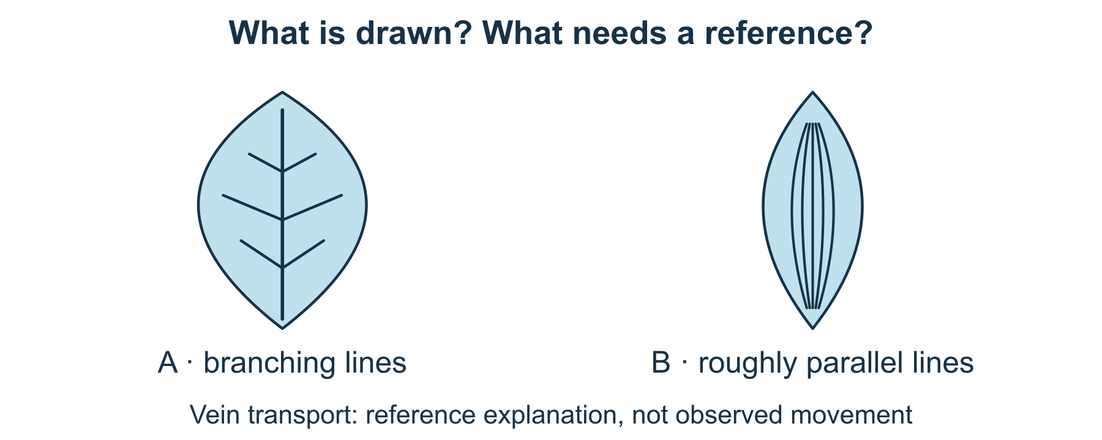
Visible pattern and reference explanation
1 Record the visible pattern
Describe line arrangements and outline shape before naming a plant. The drawings are simplified designs, not collected leaves or species records.
2 Use one reference fact
Leaf veins contain vascular tissue involved in transport. The visible pattern can be described in a diagram; its function is reference knowledge, not something the drawing alone demonstrates.
3 Make two kinds of label
Put ‘drawn feature’ beside a line you can see and ‘reference explanation’ beside the transport statement. Keep the categories separate.
4 Leave identification open
Write one question the diagrams cannot answer, such as the plant’s species or growing place. You can sketch another labelled model without answering it.

07 A worked example | biology-leaf-models

Original diagrams branching and parallel lines
A and B are constructed leaf diagrams; they are not photographs or full botanical identification keys.
• A: a broad outline with a central line and branching side lines.
• B: a narrow outline with roughly parallel lengthways lines.
• Vein transport is a reference explanation; no water movement is observed in either drawing.
What this example can show A line pattern can support a description, but these simple models do not identify a species or measure a leaf’s function.

A different way
Choose between the descriptions ‘branching’ and ‘roughly parallel’, or direct someone to add a label. No plant handling is needed.

If you want to go further
Draw a third imagined leaf whose veins fork repeatedly. Label it as an invented model and explain why it is not a complete species identifier.

Something to notice
Which sentence described the diagram, and which relied on a reference?

Read or explore more
Horizon topic Leaf Veins
https://launchhorizonhq.com/learn/leaf-veins/
Horizon topic Plant Structures
https://launchhorizonhq.com/learn/plant-structures/
Horizon topic Biology
https://launchhorizonhq.com/learn/biology/
OpenStax, Rice University 30.4 Leaves
https://openstax.org/books/biology-2e/pages/30-4-leaves
OpenStax, Rice University 30.1 The Plant Body
https://openstax.org/books/biology-2e/pages/30-1-the-plant-body

08 Biology | biology-cell-analogy

Where a cell analogy stops working
How can an everyday comparison explain a cell without becoming misleading?
Use a workshop analogy to explain selected plant-cell structures, then mark where the comparison fails.
Explore | 15-25 minutes, or one comparison | The supplied example, read or heard, Optional scrap paper and a pen or pencil
Start here Use three reference facts: the cell wall gives support, the membrane regulates exchange, and chloroplasts carry out photosynthesis in photosynthetic plant cells.
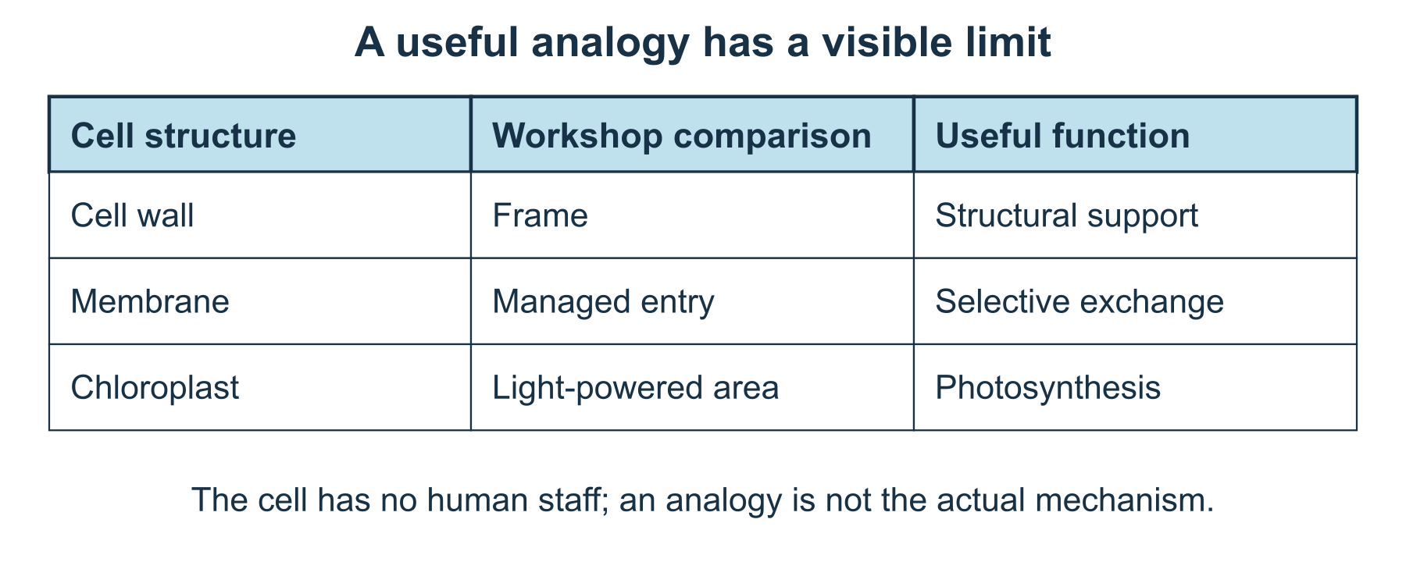
A useful link and a clear mismatch
1 Build a useful mapping
Compare a cell wall with a workshop frame, the membrane with managed entry points, and chloroplasts with a light-powered production area. Each pairing describes one function, not a complete identity.
2 Explain one link
Choose a pair and say what it helps explain. A frame can support a space; that makes support a useful connection to the cell wall.
3 Find a break in the analogy
A workshop has people making decisions. A cell membrane has no receptionist deciding what to admit, and a chloroplast is not a person or an electrical solar panel.
4 Improve the label
Write ‘helps explain…’ and ‘does not mean…’ beside your chosen pair. Keep a comparison, revise it or choose a different everyday model.

08 A worked example | biology-cell-analogy

Constructed analogy a plant cell as a workshop
Only selected functions are compared. The factual labels concern cell structures; the workshop is invented.
• Cell wall ↔ frame: useful for structural support.
• Membrane ↔ managed entry: useful for selective exchange, but no conscious gatekeeper exists.
• Chloroplast ↔ light-powered production: photosynthesis makes sugars; a solar panel making electricity is not the same process.
What this example can show An analogy does not reproduce a cell’s size, chemistry or all its structures. Not every plant cell contains chloroplasts.

A different way
Choose between the supplied pairings or listen while someone reads them. A short explanation can replace a drawing.

If you want to go further
Compare the membrane with a sieve instead. Explain one useful feature and one failure of that new comparison without treating either analogy as literal.

Something to notice
Did my comparison make a function clearer while keeping its limits visible?

Read or explore more
Horizon topic Cells Microscopy
https://launchhorizonhq.com/learn/cells-microscopy/
Horizon topic Plant Cell Roles
https://launchhorizonhq.com/learn/plant-cell-roles/
Horizon topic Analogy Comparison
https://launchhorizonhq.com/learn/analogy-comparison/
OpenStax, Rice University 4.3 Eukaryotic Cells
https://openstax.org/books/biology-2e/pages/4-3-eukaryotic-cells
Science Education Resource Center, Carleton College What is a Model?
https://serc.carleton.edu/teachearth/teaching_methods/models/WhatIsAModel.html

09 Biology | biology-growth-record

Read an invented growth log
What does a small growth table support, and what cannot it tell us?
Read two complete invented plant-height logs and separate a measured change in the example from an explanation of its cause.
Investigate | 15-25 minutes, or two differences | The supplied example, read or heard, Optional scrap paper and a pen or pencil
Start here Use this invented table: day 0, 2, 4; plant A heights 2, 3, 4 cm; plant B heights 2, 4, 5 cm. Their growing conditions are not supplied.
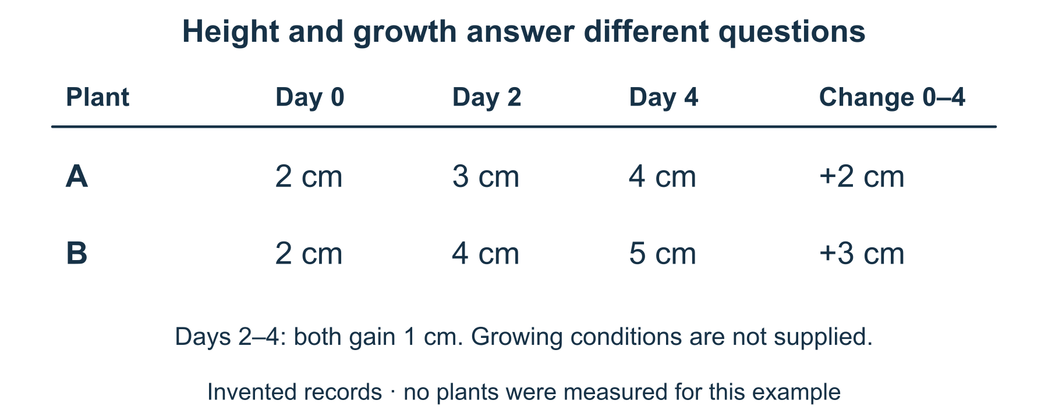
Height is not the same as growth
1 Keep units and timing
Copy or read both rows with the same day headings. These numbers are a constructed practice dataset, not plants measured by Horizon.
2 Calculate a change
From day 0 to 4, A changes by 4 − 2 = 2 cm and B by 5 − 2 = 3 cm. Compare changes from the starting height, not only final heights.
3 Keep cause open
B has a larger total change in this example. You cannot explain that difference by light, water or treatment because those conditions and repeated samples are missing.
4 Choose a next question
Name information that would help a fair comparison, such as the starting type, conditions and repeated records. You can leave the cause unresolved.

09 A worked example | biology-growth-record

Invented record same start different changes
Day headings are 0, 2, 4. A is 2, 3, 4 cm; B is 2, 4, 5 cm. The table supplies no growing conditions.
• Both begin at 2 cm. A gains 2 cm by day 4; B gains 3 cm.
• During days 2 to 4 both gain 1 cm, although their final heights differ.
• The table supports these differences; it does not identify why they occurred.
What this example can show Two invented logs cannot establish that a treatment causes growth, predict a species’ growth or represent all plants.

A different way
Compare the start and finish labels aloud, or draw arrows showing the changes. Growing a plant or plotting a graph is optional.

If you want to go further
Plot the three supplied values for each plant on the same labelled axes. Explain why B’s two interval changes are unequal rather than assuming a constant growth rate.

Something to notice
Did I describe a difference without inventing its cause?

Read or explore more
Horizon topic Plant Growth Data
https://launchhorizonhq.com/learn/plant-growth-data/
Horizon topic Plants Photosynthesis
https://launchhorizonhq.com/learn/plants-photosynthesis/
Horizon topic Statistics Data
https://launchhorizonhq.com/learn/statistics-data/
OpenStax, Rice University 30.1 The Plant Body
https://openstax.org/books/biology-2e/pages/30-1-the-plant-body
Australian Bureau of Statistics Correlation and causation
https://www.abs.gov.au/statistics/understanding-statistics/statistical-terms-and-concepts/correlation-and-causation

10 Chemistry | chemistry-particle-pages

Three particle pictures
How can symbols explain states of matter while showing a model's limits?
Use equal-count dot pictures to discuss arrangement and motion in three simple states-of-matter models.
Explore | 10-20 minutes, or one model comparison | The supplied example, read or heard, Optional scrap paper and a pen or pencil
Start here Each supplied box contains six identical particle symbols. Solid A keeps them close in a regular cluster; liquid B close but irregular; gas C spread through the box.
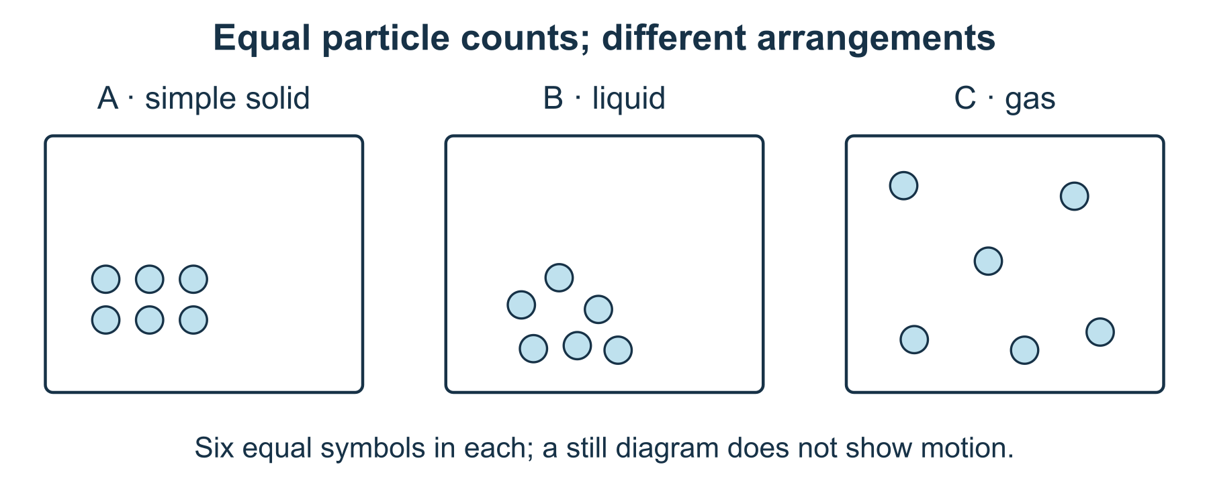
Same six symbols, different arrangements
1 Count before interpreting
Check that all three pictures contain six dots of the same size. The dots stand for particles; changing the drawing’s arrangement does not create extra particles.
2 Describe the arrangement
Compare regular and irregular close arrangements with widely separated positions. Describe what the dots show, rather than treating the empty paper as a different substance.
3 Add the motion the picture omits
In this simple description, solid particles vibrate around positions, liquid particles move past neighbours, and gas particles move around through the available space. A still drawing does not show that motion directly.
4 Label a model limit
Write ‘symbols, not a magnified photograph’. These pictures select arrangement and motion ideas, leaving detailed particle shape, forces and scale out.

10 A worked example | chemistry-particle-pages

Original model six symbols in every state
The three schematic pictures are constructed examples of a simple solid, liquid and gas description; no substance is handled.
• A: six close symbols in a regular arrangement; vibration is described, not shown as stillness.
• B: six close symbols arranged irregularly; neighbours can change.
• C: six symbols separated across a larger occupied region; the particles themselves have not grown.
What this example can show Not all solids have a regular structure. Dot spacing is schematic and does not by itself supply measured density, temperature or speed.

A different way
Point to close and separated arrangements or have the models described aloud. You can complete the comparison without drawing or using any substances.

If you want to go further
Redraw one box with motion arrows, explaining what each arrow means. Do not change particle size to represent heating.

Something to notice
Did I mistake a still symbol for a particle that never moves?

Read or explore more
Horizon topic States Matter
https://launchhorizonhq.com/learn/states-matter/
Horizon topic Density Models
https://launchhorizonhq.com/learn/density-models/
Horizon topic Chemistry
https://launchhorizonhq.com/learn/chemistry/
OpenStax, Rice University 1.2 Phases and Classification of Matter
https://openstax.org/books/chemistry-2e/pages/1-2-phases-and-classification-of-matter
OpenStax, Rice University 10.3 Phase Transitions
https://openstax.org/books/chemistry-2e/pages/10-3-phase-transitions

11 Chemistry | chemistry-material-cards

Choose a material from evidence cards
Which stated properties matter for an invented design brief?
Select a fictional material against a clear design brief, then see what changes when an unknown becomes an essential requirement.
Investigate | 15-25 minutes, or one decision | The supplied example, read or heard, Optional scrap paper and a pen or pencil
Start here A drawing sleeve must be transparent and flexible for dry indoor use. Read the supplied cards A, B and C; their features are invented.
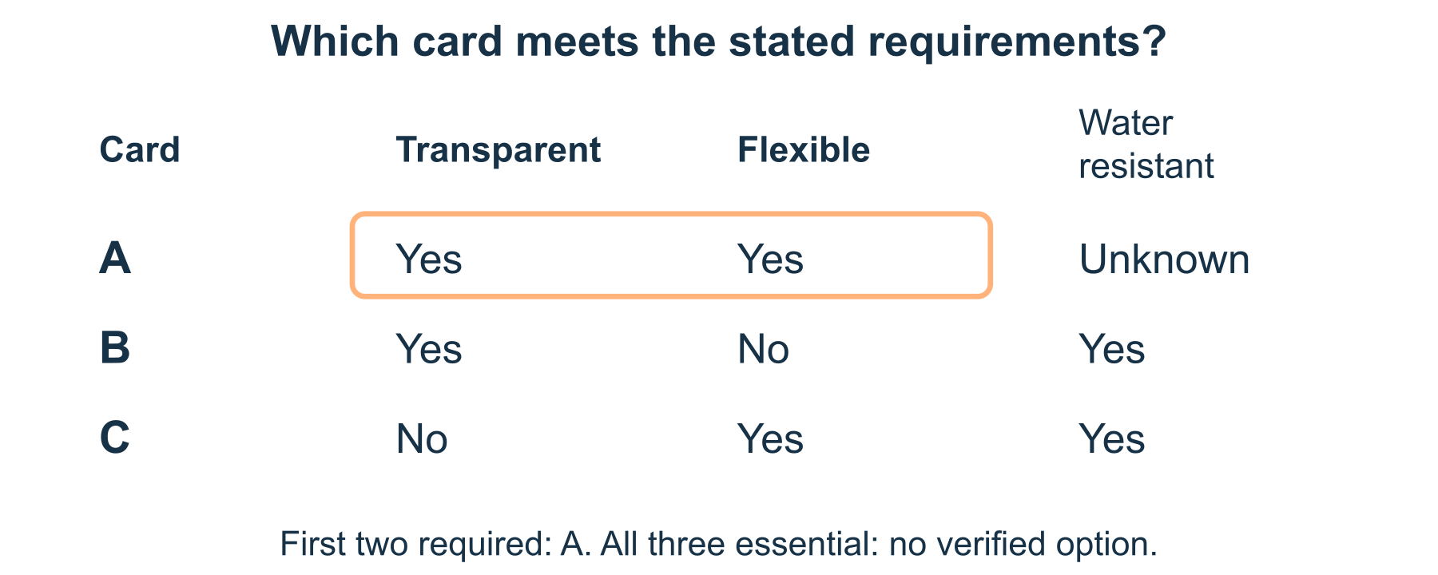
A requirement is different from a wish
1 Read the evidence cards
A: transparent yes, flexible yes, water resistance unknown. B: transparent yes, flexible no, water resistant yes. C: transparent no, flexible yes, water resistant yes.
2 Apply the two required criteria
For the dry-use brief, A meets both stated requirements. B fails flexibility and C fails transparency. Do not let an extra desirable property erase a required one.
3 Change the brief
Now imagine water resistance is also essential. A’s unknown is not a yes, so none of the three cards is verified as meeting all requirements.
4 Explain a conditional choice
Write ‘A fits the first brief on the supplied evidence’. For the changed brief, request the missing evidence or revise the design instead of guessing.

11 A worked example | chemistry-material-cards

Constructed cards a dry use sleeve
The cards are invented property reports, not test results about named plastics or products. Y means yes, N no and ? unknown.
• A: transparent yes, flexible yes, water resistance unknown.
• B: yes, no, yes. C: no, yes, yes. Only A meets the first two required criteria.
• When all three become essential, no card is confirmed to meet them all.
What this example can show This table does not certify a real material, establish its safety or tell you what an unknown result would be.

A different way
Compare only A and B, or direct someone else to mark the two required columns. No real materials need testing.

If you want to go further
Add a fourth invented card with all three properties known. State its entries before deciding whether it meets the changed brief.

Something to notice
Did I treat a desirable property or an unknown as if it met a requirement?

Read or explore more
Horizon topic Material Properties
https://launchhorizonhq.com/learn/material-properties/
Horizon topic Materials Constraints
https://launchhorizonhq.com/learn/materials-constraints/
Horizon topic Design Constraints
https://launchhorizonhq.com/learn/design-constraints/
Science Learning Hub, University of Waikato Properties of materials - introduction
https://www.sciencelearn.org.nz/resources/2659-properties-of-materials-introduction
NASA 6.8 Decision Analysis
https://www.nasa.gov/reference/6-8-decision-analysis/

12 Chemistry | chemistry-separation-plan

Plan a separation on paper
Which property would a proposed separation use, and what remains assumed?
Trace a paper filter model and explain why removing visible solids would not remove a dissolved substance.
Investigate | 10-20 minutes, or one trace | The supplied example, read or heard, Optional scrap paper and a pen or pencil
Start here Use a fictional mixture diagram containing four large blue chip symbols and six S symbols for dissolved salt in water. All of it stays on paper.
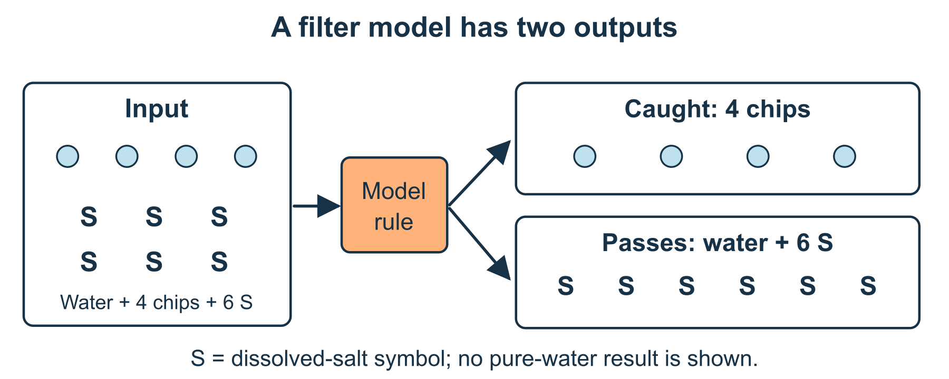
Two outputs, with every symbol accounted for
1 State the model rules
In this supplied model, a filter catches the large chips but allows water and the dissolved salt to pass. These are declared model rules, not results of a performed test.
2 Trace both outputs
Move or redraw all four chip symbols into ‘caught by filter’. Put all six S symbols with the water in ‘passes through’. Keep each kind of symbol accounted for.
3 Name what remains mixed
The passed-through liquid still contains dissolved salt. Removing the visible chips does not turn it into pure water or make it suitable to drink.
4 Keep a next method separate
If separating salt from water is a new goal, it needs a different justified process. State that question without heating, evaporating or trying anything physically.

12 A worked example | chemistry-separation-plan

Constructed filter model account for both parts
The four chip symbols represent an insoluble large-particle component; the six S symbols mark portions of dissolved salt, not individual molecules.
• Input: four chips plus water containing six S symbols.
• Caught: four chips. Passed through: water containing all six S symbols.
• The model separates the chips, while the salt-water mixture remains.
What this example can show Actual filtration depends on material properties and filter size. This diagram is not a water-treatment instruction or a claim that a real filter was tested.

A different way
Follow the symbols by pointing or explain where they go aloud. No filter, salt, water, containers or scissors are required.

If you want to go further
Change the model so the solid chips are smaller than its stated filter openings. Explain why the previous ‘caught’ output would no longer follow.

Something to notice
Did every symbol reach an output, and did I confuse clear-looking with pure?

Read or explore more
Horizon topic Mixtures Separation
https://launchhorizonhq.com/learn/mixtures-separation/
Horizon topic Solutions Dissolving
https://launchhorizonhq.com/learn/solutions-dissolving/
Horizon topic Chemistry
https://launchhorizonhq.com/learn/chemistry/
OpenStax, Rice University 1.2 Phases and Classification of Matter
https://openstax.org/books/chemistry-2e/pages/1-2-phases-and-classification-of-matter
Science Learning Hub, University of Waikato Soluble
https://www.sciencelearn.org.nz/glossary/soluble

13 Computing | computing-paper-robot

Debug a paper robot
Where does an instruction sequence first stop matching its goal?
Give a paper robot a starting direction, trace its commands and repair one route. No coding software is needed.
Investigate | 15-25 minutes, or one trace | Paper and a pen or pencil, A small paper arrow, or a drawn arrow you can redraw
Start here Draw a 4-by-4 grid. Columns run left to right and rows bottom to top, both 1 to 4. Put an east-facing arrow at (1,1), a goal at (3,3) and a block at (2,2).
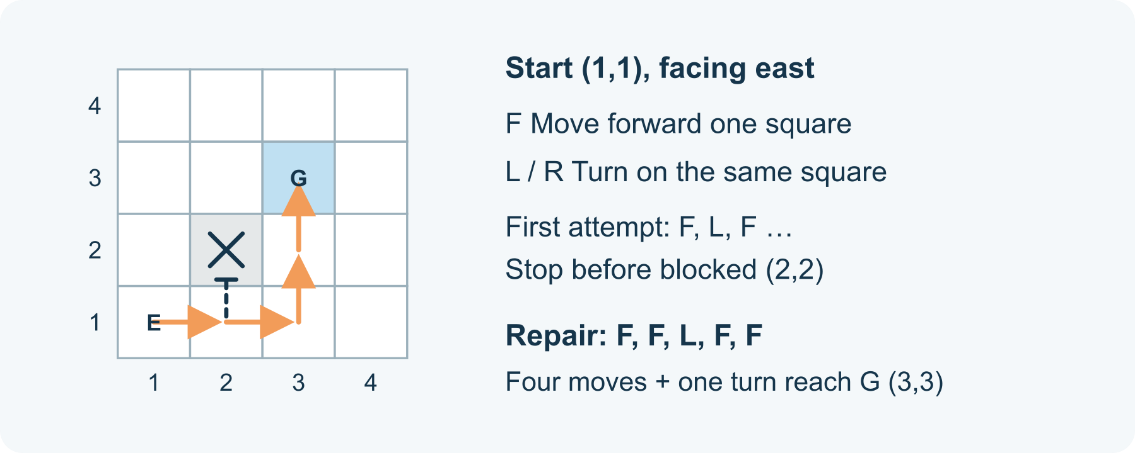
A turn changes direction, not position
1 Set the command language
F means move one square in the direction the arrow faces. L means turn left 90 degrees on the same square; R means turn right 90 degrees on the same square. Turns do not move the robot. Stop before a move would enter the block or leave the grid.
2 Trace the first program
Try F, L, F, F, R, F from the stated start. Record the square and facing direction after each command. At the first blocked move, stop and mark that command instead of completing the rest.
3 Make a repair
Reset the arrow to (1,1), facing east. Try F, F, L, F, F, or design your own sequence. Record the trace again. Reaching the goal is useful information about this starting case.
4 Explain the repair's limits
Describe which instruction caused the original problem and why the replacement route avoids it. If you want another test, change the starting direction on paper and predict whether the same commands still work.

13 A worked example | computing-paper-robot

Exact example locate the first blocked move
This robot and its board are invented. East is right, north is up. The goal is (3,3); the robot begins at (1,1), facing east.
• F, L, F…: move to (2,1) east; turn north at (2,1); the next F would enter blocked (2,2), so stop before it.
• Repair F, F, L, F, F: (2,1) east → (3,1) east → (3,1) north → (3,2) north → (3,3) north.
• The repair reaches this goal in five commands: four moves and one turn.
What this example can show The repair is tested by tracing this one starting case. It is not a general route-finding algorithm, a real robot test or proof that every changed board will work.

A different way
Use the supplied trace and point to the first problem, or have someone move the arrow exactly as you direct. A smaller empty grid is another valid starting point.

If you want to go further
Write a repeat instruction for two forward moves and explain what it expands to. Test a different starting direction before claiming the shorter notation still reaches the goal.

Something to notice
Did I check the robot's direction as well as its square?

Read or explore more
Horizon topic Computing
https://launchhorizonhq.com/learn/computing/
Horizon topic Algorithms Debugging
https://launchhorizonhq.com/learn/algorithms-debugging/
Horizon topic Loops Repetition
https://launchhorizonhq.com/learn/loops-repetition/
CS Unplugged, University of Canterbury Computational Thinking and CS Unplugged
https://www.csunplugged.org/en/computational-thinking/
Computer Science Field Guide, University of Canterbury Algorithms
https://www.csfieldguide.org.nz/en/chapters/algorithms/

14 Computing | computing-pixel-message

Encode a tiny pixel picture
Can someone rebuild a small image from an unambiguous written code?
Decode an original four-by-four bitmap with a complete legend, then check how one changed bit alters the picture.
Make | 15-25 minutes, or one row | The supplied example, read or heard, Optional scrap paper and a pen or pencil
Start here Use a 4-by-4 grid and these rows from top to bottom: 1001, 0110, 0110, 1001. Read each row left to right; 1 is dark and 0 is white.
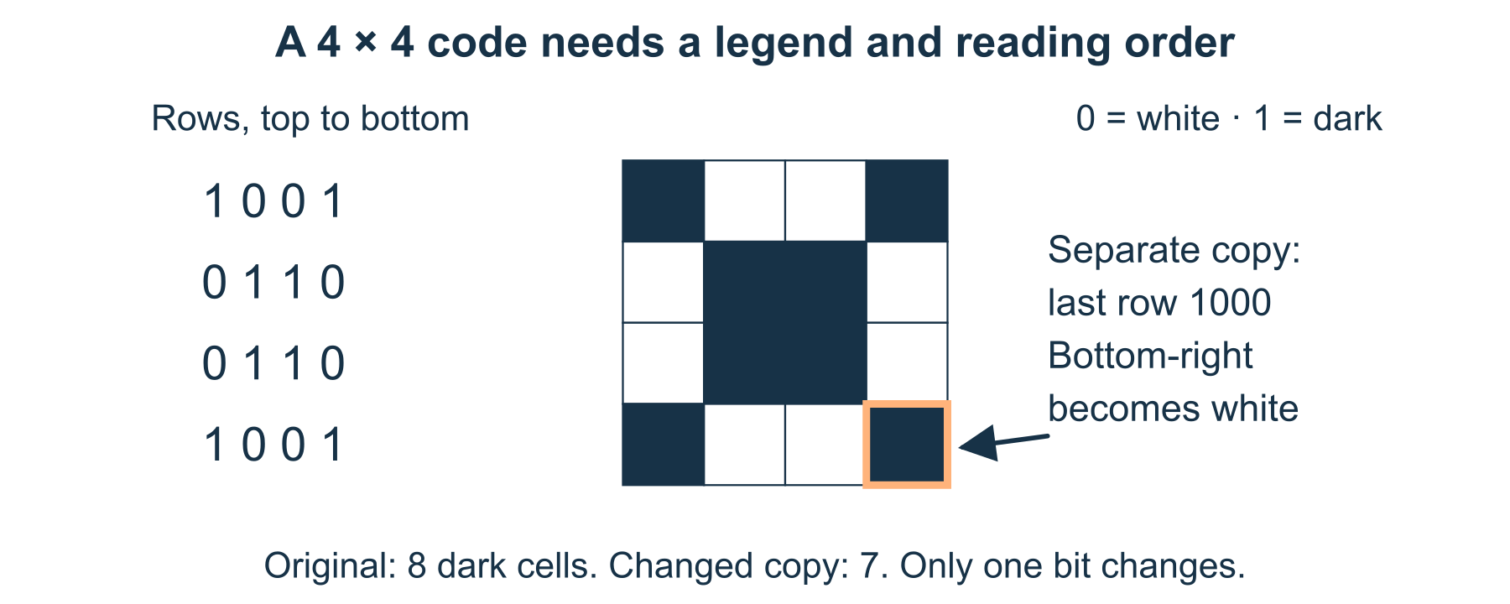
A code needs an arrangement rule
1 Keep the header with the data
Write width 4 and height 4 beside the rows. Without a size and reading-order convention, a string of digits may be arranged in different ways.
2 Decode the original
Shade cells marked 1 and leave 0 white. The pattern has dark cells along both diagonals: eight dark and eight white cells.
3 Check a round trip
Read your shaded grid back into four digit rows. Compare every row with the supplied code rather than deciding only whether the picture looks familiar.
4 Change one bit
Make a separately labelled copy whose last row is 1000. The bottom-right cell becomes white; the other 15 cells stay the same. Keep the original for comparison.

14 A worked example | computing-pixel-message

Original bitmap a tiny diagonal pattern
Header: width 4, height 4; row order top to bottom; within each row left to right; 0 white, 1 dark.
• Rows: 1001/0110/0110/1001. Each row contains four bits.
• The original contains eight digits equal to 1, so it has eight dark cells.
• Changing only the last digit produces 1000 in the last row and seven dark cells overall.
What this example can show This is a monochrome encoding exercise, not every image format. A code needs its agreed dimensions and symbol meanings to be decoded correctly.

A different way
Decode only the first row or point to the changed bottom-right cell. You can explain the supplied grid without drawing or installing anything.

If you want to go further
Describe row 1001 as one dark cell, two white cells and one dark cell. Explain why counts without a starting colour would be ambiguous.

Something to notice
Did my code preserve both the picture data and the rules for arranging it?

Read or explore more
Horizon topic Pixels Images
https://launchhorizonhq.com/learn/pixels-images/
Horizon topic Binary Digital Data
https://launchhorizonhq.com/learn/binary-digital-data/
Horizon topic Formats Compression
https://launchhorizonhq.com/learn/formats-compression/
Computer Science Field Guide, University of Canterbury Images and Colours
https://www.csfieldguide.org.nz/en/chapters/data-representation/images-and-colours/
Computer Science Field Guide, University of Canterbury Run length encoding
https://www.csfieldguide.org.nz/en/chapters/coding-compression/run-length-encoding/

15 Computing | computing-mini-index

Build a six card search index
What makes a paper search return a useful match?
Build a small keyword-to-card index, combine exact matches and explain what a missing word does and does not mean.
Make | 15-25 minutes, or one query | The supplied example, read or heard, Optional scrap paper and a pen or pencil
Start here Use six invented titles: A paper bridge; B bird song; C paper game; D leaf map; E game map; F bird sketch.
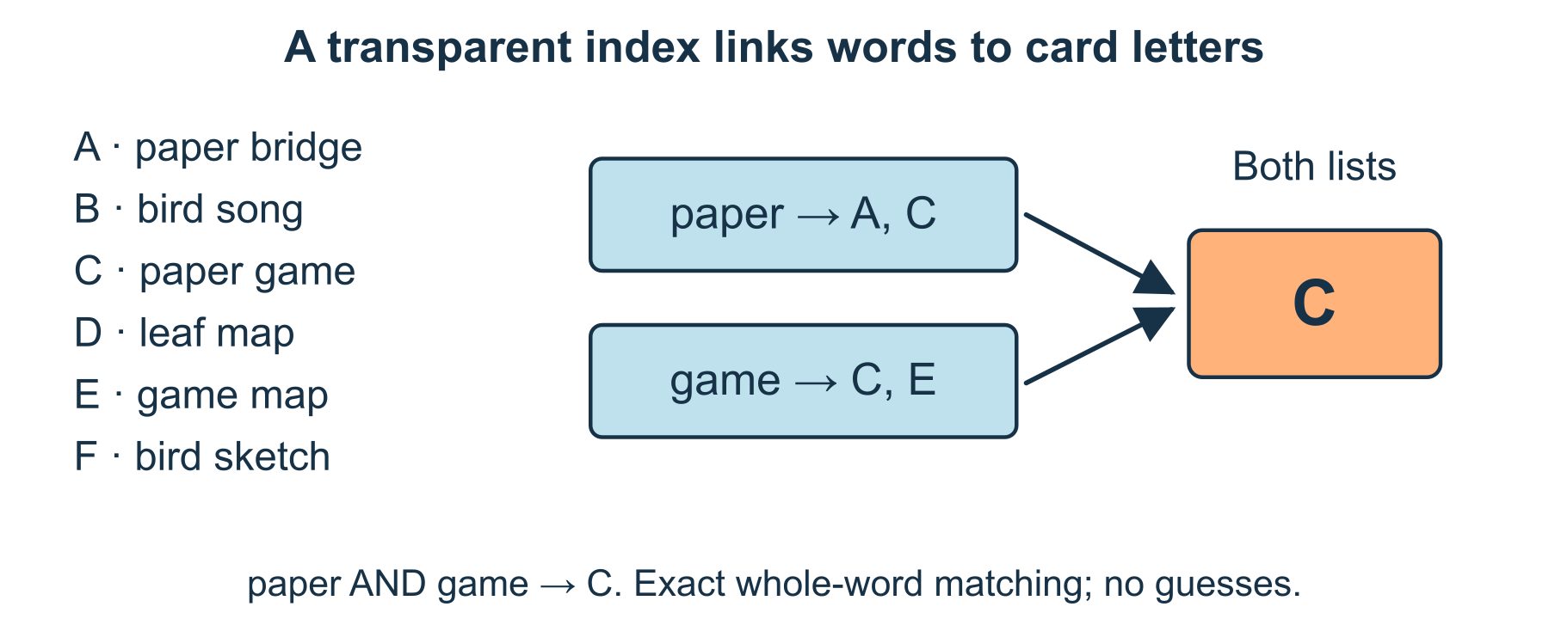
Six titles, a transparent matching rule
1 Define a matching rule
Use lowercase whole words exactly as written in the titles. Index every title word; do not guess synonyms, plurals or anyone’s interests.
2 Build the lists
For each word, list the matching card letters. For example paper → A, C; bird → B, F; game → C, E; map → D, E. Also include bridge → A, song → B, leaf → D, sketch → F.
3 Combine a query
For paper AND game, keep only card letters in both lists. The intersection of A, C and C, E is C. The word games has no exact match under this rule.
4 Explain the limit
A failed exact match does not show that the idea is uninteresting or unknown everywhere. It describes this small collection and this matching rule; you can edit the query.

15 A worked example | computing-mini-index

Constructed index six complete cards
All six titles and their words are supplied. Card letters identify records, not people or user profiles.
• paper → A, C; bird → B, F; game → C, E; map → D, E.
• bridge → A; song → B; leaf → D; sketch → F.
• paper AND game returns C; games returns none under exact whole-word matching.
What this example can show This is a tiny index model, not a prediction engine or a benchmark of real search speed. It cannot search words absent from its six supplied titles.

A different way
Compare only the paper and game lists, or have the titles read aloud. No device, account, browsing or personal search history is required.

If you want to go further
Rename F from bird sketch to paper sketch. Update the bird and paper lists while keeping the sketch entry, then rerun one query.

Something to notice
Did I distinguish the collection’s contents from the search rule’s limits?

Read or explore more
Horizon topic Search Indexes
https://launchhorizonhq.com/learn/search-indexes/
Horizon topic Tables Sorting
https://launchhorizonhq.com/learn/tables-sorting/
Horizon topic Computing
https://launchhorizonhq.com/learn/computing/
CS Unplugged, University of Canterbury Searching algorithms
https://www.csunplugged.org/en/topics/searching-algorithms/
PostgreSQL Global Development Group Preferred Index Types for Text Search
https://www.postgresql.org/docs/current/textsearch-indexes.html

16 Design | design-symbol-legend

A symbol that explains itself
What instructions help an unfamiliar icon communicate its meaning?
Give an original symbol one clear function, pair it with words and use the same meaning consistently.
Make | 10-20 minutes, or one label | The supplied example, read or heard, Optional scrap paper and a pen or pencil
Start here Look at an unlabelled triangle. It might suggest several actions. In this invented interface, the chosen action is ‘Try example’.
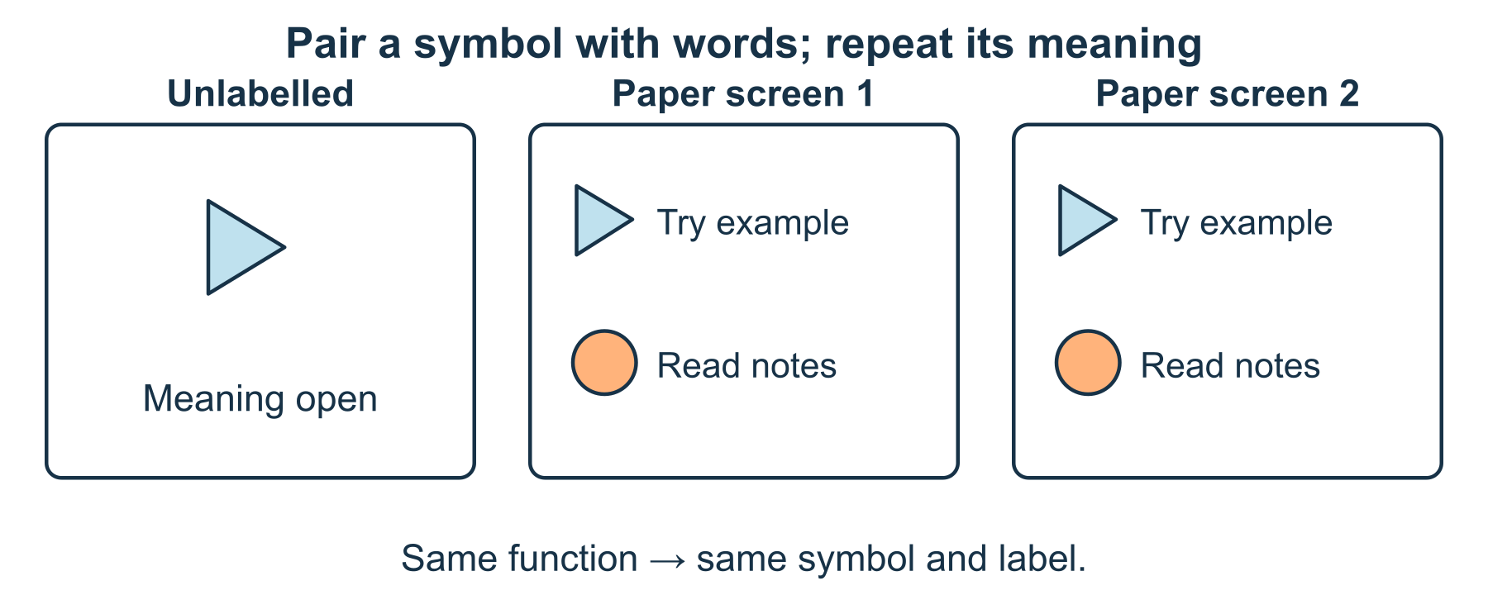
A symbol gets its meaning from a clear label
1 Choose one function
Write what the control is meant to do. Here, triangle means Try example; a circle means Read notes. The meaning comes from the declared legend, not the shape alone.
2 Pair the symbol with text
Draw the triangle beside the words Try example. Place the words close enough to belong to the same control. Keep the circle’s different label separate.
3 Repeat consistently
On a second paper screen, use the same triangle and label for the same action. Do not change it to mean Back without changing the design and explanation.
4 Check the instruction
Ask what information an unfamiliar reader would need. You can identify an ambiguity yourself; no other person or user study is required.

16 A worked example | design-symbol-legend

Constructed interface two functions
The symbols belong to an invented interface. The model chooses meanings and labels; it does not assume every reader already knows them.
• Triangle + Try example is one control.
• Circle + Read notes is a different control.
• On the next paper screen, triangle still means Try example.
What this example can show A clear legend and consistent labels can help, but this drawing is not a usability trial, a universal symbol set or accessibility certification.

A different way
Choose a supplied label for the triangle or explain which of two controls does the stated action. Drawing is optional.

If you want to go further
Design a third control for a different function and give it a distinct label. Explain how it avoids colliding with the first two meanings.

Something to notice
Did the symbol keep one meaning, and could the words explain it without the symbol?

Read or explore more
Horizon topic Icons Symbols
https://launchhorizonhq.com/learn/icons-symbols/
Horizon topic Wayfinding Signs
https://launchhorizonhq.com/learn/wayfinding-signs/
Horizon topic Accessible Design
https://launchhorizonhq.com/learn/accessible-design/
W3C Web Accessibility Initiative Use Icons that Help the User
https://www.w3.org/WAI/WCAG2/supplemental/patterns/o1p07-icons-used/
W3C Web Accessibility Initiative Understanding SC 3.2.4: Consistent Identification
https://www.w3.org/WAI/WCAG22/Understanding/consistent-identification.html

17 Design | design-packaging-plan

Sketch a small package net
Which folds and labels would another person need to understand the design?
Read a complete six-face cube net, identify neighbours and explain what a drawing leaves out of a real package.
Make | 15-25 minutes, or one face pair | The supplied example, read or heard, Optional scrap paper and a pen or pencil
Start here Use six equal square faces. In row 1 put Back; row 2 is Left, Base, Right; row 3 is Front; row 4 is Lid. The single faces line up with Base.
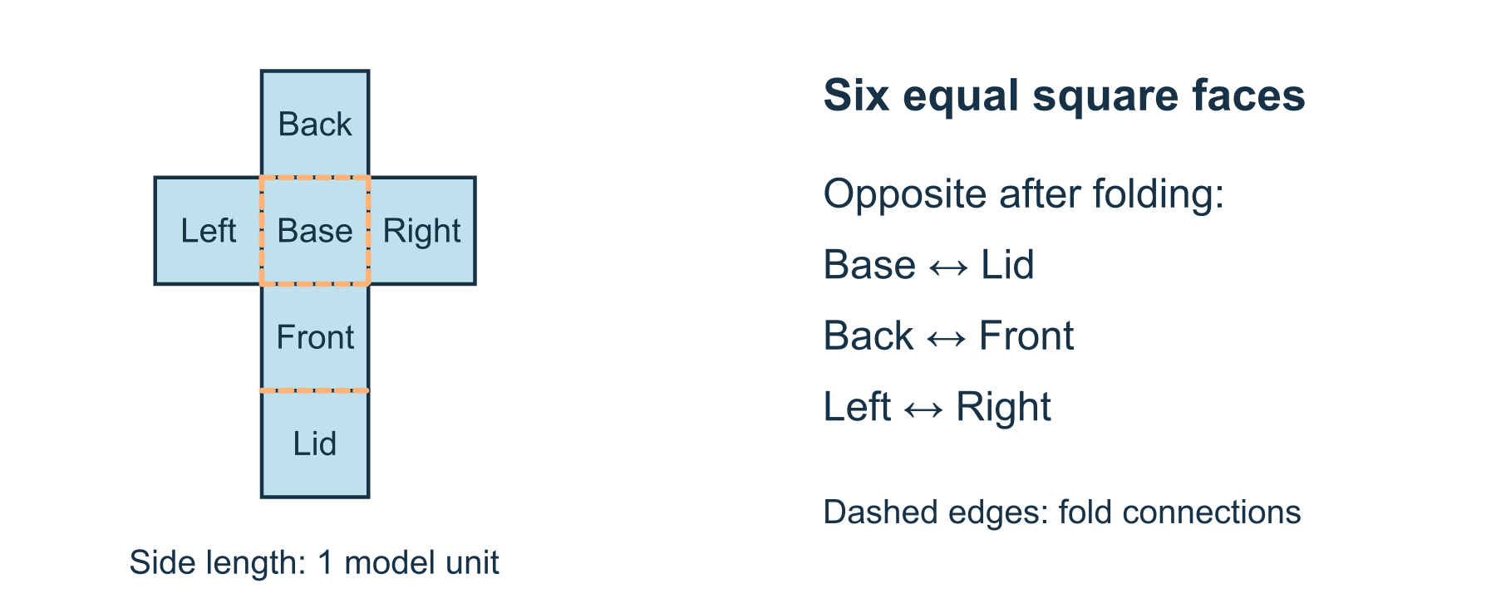
Six faces with explicit connections
1 Read the net
Use a top-to-bottom grid. Back is above Base, Front below Base and Lid below Front. Left and Right sit beside Base. Every face has side length 1 model unit.
2 Imagine the folds
Treat Base as the floor. Fold its four immediate neighbours up to form sides; Lid folds from Front over the opening. You can trace these changes without cutting or making anything.
3 Identify opposite faces
In the imagined cube, Base opposes Lid, Back opposes Front, and Left opposes Right. Adjacent on the flat net does not mean opposite in the cube.
4 Write a practical limit
The drawing shows face connections but no tabs, seam allowance, material thickness or tested closure. Label those as further design questions.

17 A worked example | design-packaging-plan

Original net six squares for a cube
The supplied positions define one constructed net. They are not a copied template or a manufactured package.
• Top row: Back above Base. Middle row: Left-Base-Right. Below: Front then Lid.
• All six faces are squares of side 1 model unit.
• Opposite pairs after folding: Base/Lid, Back/Front, Left/Right.
What this example can show A valid face net is not proof of a practical package. Its seams, thickness, closure and suitability for any object are untested.

A different way
Point to Base and one neighbour, listen to a folding description or use the supplied opposite pairs. No scissors, glue, real box or purchase is needed.

If you want to go further
Rotate the whole net on paper without changing face connections. Check whether the same opposite pairs still follow.

Something to notice
Did I distinguish a flat neighbour from an opposite face in the folded shape?

Read or explore more
Horizon topic Packaging Nets
https://launchhorizonhq.com/learn/packaging-nets/
Horizon topic Products Prototypes
https://launchhorizonhq.com/learn/products-prototypes/
Horizon topic Design
https://launchhorizonhq.com/learn/design/
NRICH, University of Cambridge Cut Nets
https://nrich.maths.org/problems/cut-nets
Government Digital Service, GOV.UK Making prototypes
https://www.gov.uk/service-manual/design/making-prototypes

18 Design | design-clear-poster

Make an invented poster easier to read
Which layout change helps a reader find one important detail?
Reorganise an invented poster so its title, time and place are easier to locate without changing the facts.
Make | 10-20 minutes, or one layout change | The supplied example, read or heard, Optional scrap paper and a pen or pencil
Start here Use this complete fictional notice: ‘Paper Planet display. Saturday 14:00. Table 3. Viewing is optional.’ It is not an actual event invitation.
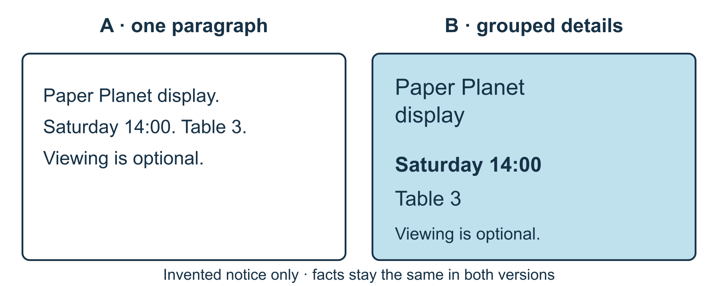
Same facts, clearer groups
1 Keep the facts fixed
Copy the title, day, time, place and optional-viewing statement. First arrange them as one unbroken paragraph with equal emphasis.
2 Create a second hierarchy
Give the title a clear heading, then place Saturday 14:00 and Table 3 on separate short lines. Keep Viewing is optional as a readable note.
3 Check a concrete question
Point to where a reader would find the time in each version. Explain the structure that helps locate it, rather than asserting that everyone will read it faster.
4 Make one revision
Choose a clearer order, more space or a shorter label. Verify that no time, place or participation fact changed during the redesign.

18 A worked example | design-clear-poster

Constructed poster same information two arrangements
Both versions describe the same invented Paper Planet display. No actual session, booking or location is offered.
• A puts all four sentences in one paragraph with equal emphasis.
• B uses a title followed by Saturday 14:00, Table 3 and Viewing is optional on separate lines.
• The facts stay fixed; the grouping and heading structure change.
What this example can show A layout explanation is not a timed reading test. Font, size, contrast and the actual reader’s needs still matter.

A different way
Reorder spoken labels, direct someone to place the lines or compare the two supplied versions. A finished graphic is unnecessary.

If you want to go further
Make a narrow-screen version with the same reading order. Explain which lines can wrap without separating the day from its time.

Something to notice
Did I improve the organisation without quietly changing the message?

Read or explore more
Horizon topic Typography Layout
https://launchhorizonhq.com/learn/typography-layout/
Horizon topic Information Design
https://launchhorizonhq.com/learn/information-design/
Horizon topic Human Centred Design
https://launchhorizonhq.com/learn/human-centred-design/
Australian Government Style Manual Structuring content
https://www.stylemanual.gov.au/structuring-content
W3C Web Accessibility Initiative Headings
https://www.w3.org/WAI/tutorials/page-structure/headings/

19 Ecology | ecology-food-web-model

A food web with labelled assumptions
How do arrows and evidence change the meaning of a simple food web?
Build a food-web diagram from supplied fictional feeding records and keep a proposed link different from a reported one.
Make | 15-25 minutes, or one chain | The supplied example, read or heard, Optional scrap paper and a pen or pencil
Start here Use these invented records: Plant feeds Leaf-eater and Snail; Leaf-eater and Snail feed Lizard; Lizard feeds Bird. Arrows point from food to consumer.
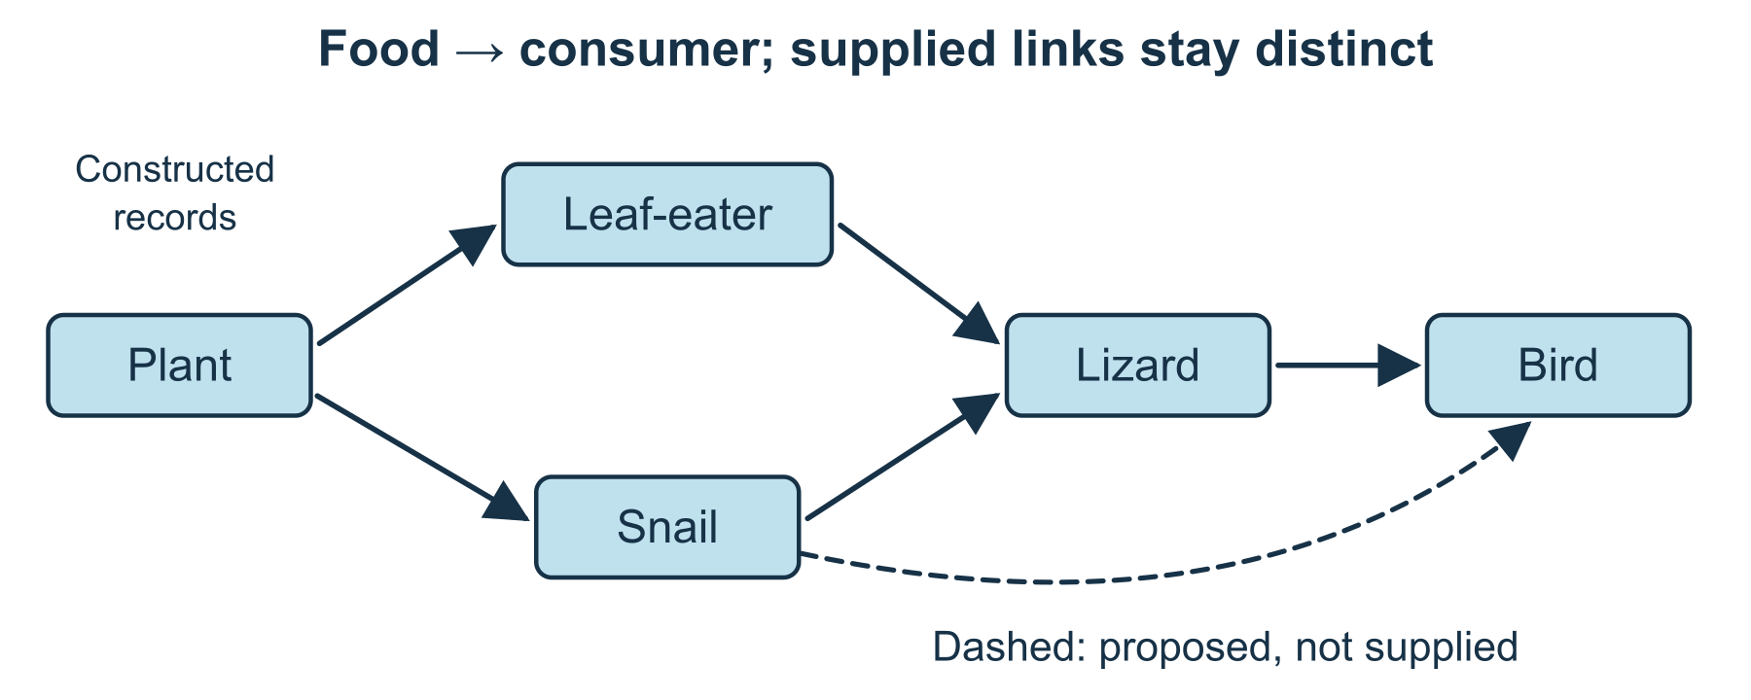
One arrow rule and two evidence states
1 Write the arrow key
An arrow A → B means material and energy from A can reach B when B consumes A. It does not mean A actively helps or chases B.
2 Draw five supplied links
Draw Plant → Leaf-eater, Plant → Snail, Leaf-eater → Lizard, Snail → Lizard and Lizard → Bird. Keep every direction consistent with the key.
3 Label a new question
Someone proposes that Bird also consumes Snail. Draw that optional idea as a dashed link labelled ‘not supplied’, rather than adding it to the five solid recorded links.
4 Explain what the model leaves open
Name a missing detail such as quantities, seasonal change or other foods. The web does not tell you exactly how any population would change.

19 A worked example | ecology-food-web-model

Constructed food web five reported links
The feeding statements are invented model records, not observations of real animals or universal species diets.
• Solid links: Plant → Leaf-eater; Plant → Snail; Leaf-eater → Lizard; Snail → Lizard; Lizard → Bird.
• Each arrow runs from the consumed resource to its consumer.
• Snail → Bird is a separate proposed link, shown dashed and marked not supplied.
What this example can show The model omits amounts and many relationships. It does not establish actual diets, complete energy budgets or a definite population outcome.

A different way
Follow only Plant → Snail → Lizard, or read the links aloud. No animals, food, samples or outdoor visit are required.

If you want to go further
Remove one supplied link in a newly labelled model. Describe which route disappears without asserting a measured population change.

Something to notice
Could someone distinguish a supplied relationship from a proposed one in my drawing?

Read or explore more
Horizon topic Food Webs
https://launchhorizonhq.com/learn/food-webs/
Horizon topic Habitats Niches
https://launchhorizonhq.com/learn/habitats-niches/
Horizon topic Ecology
https://launchhorizonhq.com/learn/ecology/
OpenStax, Rice University 46.2 Energy Flow through Ecosystems
https://openstax.org/books/biology-2e/pages/46-2-energy-flow-through-ecosystems
OpenStax, Rice University 46.1 Ecology of Ecosystems
https://openstax.org/books/biology-2e/pages/46-1-ecology-of-ecosystems

20 Ecology | ecology-microhabitat-map

Map a fictional microhabitat
Which small differences would be useful to record before making an explanation?
Read a complete fictional map with equal sampling squares, then separate a pattern in the record from its cause.
Investigate | 15-25 minutes, or two squares | The supplied example, read or heard, Optional scrap paper and a pen or pencil
Start here Use a 2-by-2 map: top row A1, B1; bottom row A2, B2. Each square represents 1 m² of a fictional garden, with counts of a model groundcover P.
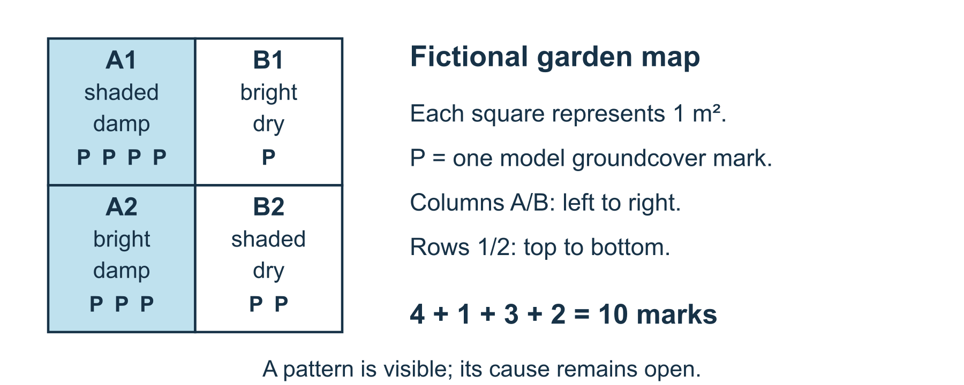
A complete key makes a small map useful
1 Read the full key
A1 is shaded, damp, 4 P; B1 bright, dry, 1 P; A2 bright, damp, 3 P; B2 shaded, dry, 2 P. Counts, light descriptions and moisture labels are supplied model data.
2 Compare like areas
All four squares represent the same area and use the same counting rule. Add the counts if wanted: 4+1+3+2 = 10 P marks across the model.
3 Describe one pattern
The two damp squares contain 4 and 3 marks; the two dry squares 1 and 2. Describe that contrast without claiming dampness caused it.
4 Plan a better question
Ask what repeated records, dates or other conditions would help examine the pattern. You can keep this a plan without going outside or identifying a real plant.

20 A worked example | ecology-microhabitat-map

Invented map four equal squares
Columns A and B run left to right; rows 1 and 2 run top to bottom. P means one model groundcover mark, not a verified species.
• Top: A1 shaded/damp/4 P; B1 bright/dry/1 P.
• Bottom: A2 bright/damp/3 P; B2 shaded/dry/2 P.
• There are 10 P marks altogether; the two damp squares have higher counts in this supplied model.
What this example can show Four invented squares do not prove a habitat preference or causal effect. Different areas, counting rules or unrecorded conditions would affect a real comparison.

A different way
Compare A1 and B1 only, point to the counts or have the map described. No quadrat construction, garden access or specimens are required.

If you want to go further
Imagine that B1 represents 2 m² instead of 1. Explain why raw counts would no longer compare equal areas without adjustment.

Something to notice
Did I keep the area and counting rule attached to the numbers?

Read or explore more
Horizon topic Microhabitat Maps
https://launchhorizonhq.com/learn/microhabitat-maps/
Horizon topic Quadrat Sampling
https://launchhorizonhq.com/learn/quadrat-sampling/
Horizon topic Ecology
https://launchhorizonhq.com/learn/ecology/
Field of Mars Environmental Education Centre, NSW Department of Education Schoolyard safari learning resource
https://fieldofmar-e.schools.nsw.gov.au/learning-resources/primary-learning-resources/schoolyard-safari
Science Learning Hub, University of Waikato Making and using a quadrat
https://www.sciencelearn.org.nz/resources/2318-making-and-using-a-quadrat

21 Ecology | ecology-record-quality

What makes a useful species record
Which details turn an invented sighting note into a clearer record without guessing an identity?
Improve a fictional sighting note using only a supplied field slip, retaining an uncertain identity rather than inventing detail.
Investigate | 10-20 minutes, or one correction | The supplied example, read or heard, Optional scrap paper and a pen or pencil
Start here Compare a draft note ‘Sparrow, park’ with a supplied fictional slip: 12 October 2026, 14:00, Invented Park, B2, one bird, brown back, short beak, no identification confirmed.
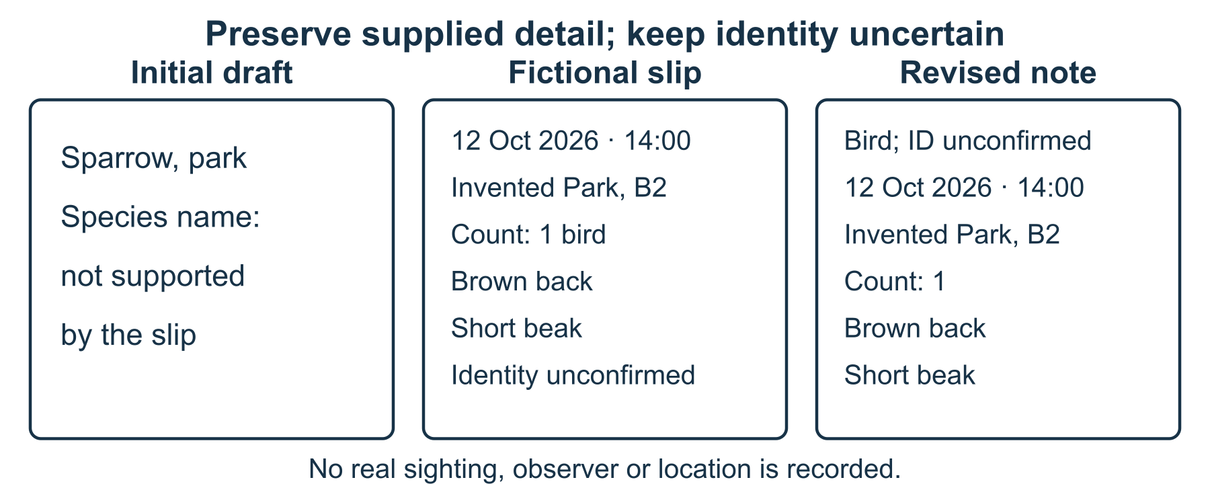
Improve the record without guessing the species
1 Separate source from guess
The slip supports an observation of one bird with two described features. It does not support the draft’s species name sparrow. Mark that identity as unconfirmed.
2 Carry over supplied details
Make a clearer note with the supplied date, time, fictional location, count and visible features. Do not add a photograph, observer name or exact real-world coordinates.
3 Keep provenance and uncertainty
Label the new note as transcribed from the supplied fictional slip. Use bird, identity unconfirmed, so the correction does not silently become a new confident identification.
4 Choose a useful next check
Suggest checking the original record or suitable identification information. Do not submit the exercise to a real species database or fill missing details from imagination.

21 A worked example | ecology-record-quality

Constructed records correct without inventing
The original slip and incomplete draft are both fictional practice material. No real bird sighting or person is recorded.
• Slip: 12 October 2026 at 14:00; Invented Park, B2; count 1.
• Features: brown back, short beak; identity unconfirmed.
• Revised note keeps those details and replaces the unsupported sparrow label with bird, identity unconfirmed.
What this example can show Two visible features do not identify a species. A clearer record preserves useful detail and uncertainty; it does not manufacture missing evidence.

A different way
Correct only the species label, or compare the notes aloud. No photograph, online account, wildlife contact or real location is needed.

If you want to go further
Remove the time from a copy of the source slip. Show how the revised record should mark it unknown rather than retain an unsupported 14:00.

Something to notice
Did my revision improve clarity without increasing unsupported certainty?

Read or explore more
Horizon topic Species Records
https://launchhorizonhq.com/learn/species-records/
Horizon topic Biodiversity Conservation
https://launchhorizonhq.com/learn/biodiversity-conservation/
Horizon topic Knowledge Evidence
https://launchhorizonhq.com/learn/knowledge-evidence/
Atlas of Living Australia Flagging an issue with a record
https://support.ala.org.au/support/solutions/articles/6000262125-flagging-an-issue-with-a-record
Science Learning Hub, University of Waikato Making and using a quadrat
https://www.sciencelearn.org.nz/resources/2318-making-and-using-a-quadrat

22 Engineering | engineering-paper-bridge

What can one fold change
How can I compare two paper shapes without claiming more than I tested?
Sketch or compare a flat paper strip and the same strip with a shallow fold. Define a small observation before drawing a conclusion.
Make | 15-25 minutes, or two labelled sketches | Three small pieces of scrap paper, Pen or pencil, Optional ruler; approximate sizes are sufficient
Start here Sketch a paper strip resting across two folded-paper pads on a flat desk. Label a gap of about 4 cm between the pads. You can complete the whole activity as a drawing.
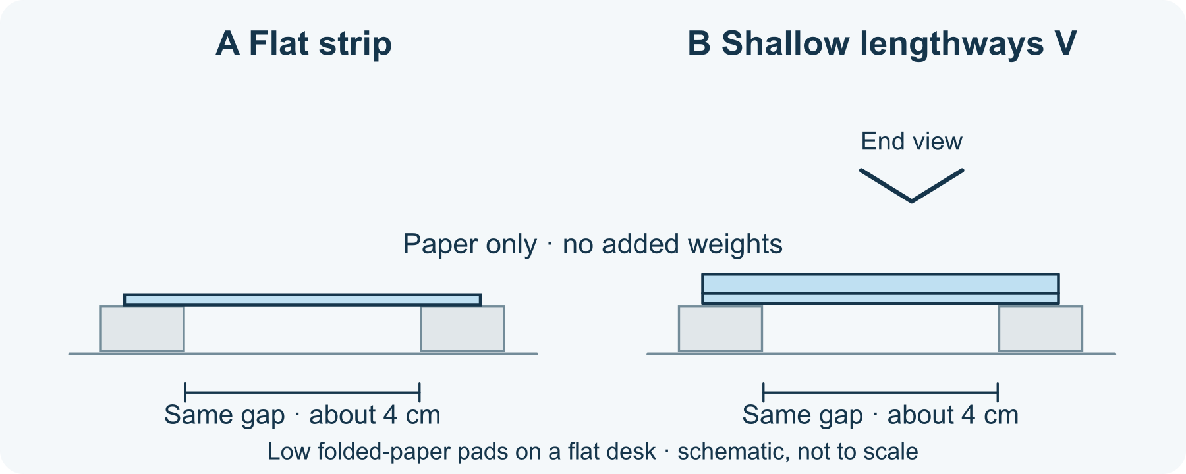
Same paper and gap, different cross-section
1 Choose a small comparison
If making the model, fold two paper pieces into matching low pads, less than 1 cm high, on the same flat desk. Leave a gap of about 4 cm. Lay an approximately 8-by-4 cm paper strip across them with both ends supported. Use paper only and add no objects or weights.
2 Define the observation
Version A is flat. Before trying it, choose what to notice: whether the middle stays clear of the desk or touches it during a slow count of five. Record what happens, or leave the result unknown if you are sketching.
3 Change the shape
Use the same strip. Fold it once along its long centre line, then open it into a shallow V. Rest its ends on the same pads with the same gap. Keep the paper and supports unchanged; observe the same thing, with no added load.
4 Write a limited conclusion
Describe both versions, including an unchanged or uncertain result. Explain what you changed and what would need a different test. A paper model is not a design for a bridge anyone can use.

22 A worked example | engineering-paper-bridge

Fictional example two clear gaps
This is an invented recording example, not an experiment Horizon performed. It shows how an unchanged result can still be recorded honestly.
• A: flat strip; the fictional record says its middle stayed clear of the desk for a count of five.
• B: the same strip with a shallow lengthways V; the fictional record also says its middle stayed clear.
• The paper, pads and gap stayed the same. Only the strip's shape changed; the example shows no difference on this chosen observation.
What this example can show Neither entry establishes load capacity or a strongest design. Paper type, dimensions and observations matter; your model may behave differently.

A different way
Compare only the supplied sketches and fictional record. Describe the change or direct someone to add labels; construction is optional.

If you want to go further
Draw an alternative fold and predict what might change. Plan a comparison with the same paper and gap; no weights, larger structures or testing to failure are part of this activity.

Something to notice
Did my conclusion stay within the observation I actually made?

Read or explore more
Horizon topic Engineering
https://launchhorizonhq.com/learn/engineering/
Horizon topic Structures Bridges
https://launchhorizonhq.com/learn/structures-bridges/
Horizon topic Materials Constraints
https://launchhorizonhq.com/learn/materials-constraints/
TeachEngineering, University of Colorado Boulder Engineering Design Process
https://www.teachengineering.org/popular-topics/engineering-design-process
TeachEngineering, University of Colorado Boulder Bridge Types: Tensile & Compressive Forces
https://www.teachengineering.org/activities/cub_brid_lesson01_activity1

23 Engineering | engineering-mechanism-map

Explain an invented mechanism
How can a sequence of labelled drawings show where motion goes?
Trace the input and output of a fictional two-gear display without building a machine.
Investigate | 10-20 minutes, or one small comparison | Scrap paper and a pencil or pen, The supplied original model; no account, purchase or online search needed
Start here Draw two touching circles. Label the smaller input A: 12 teeth, and the larger output B: 24 teeth.
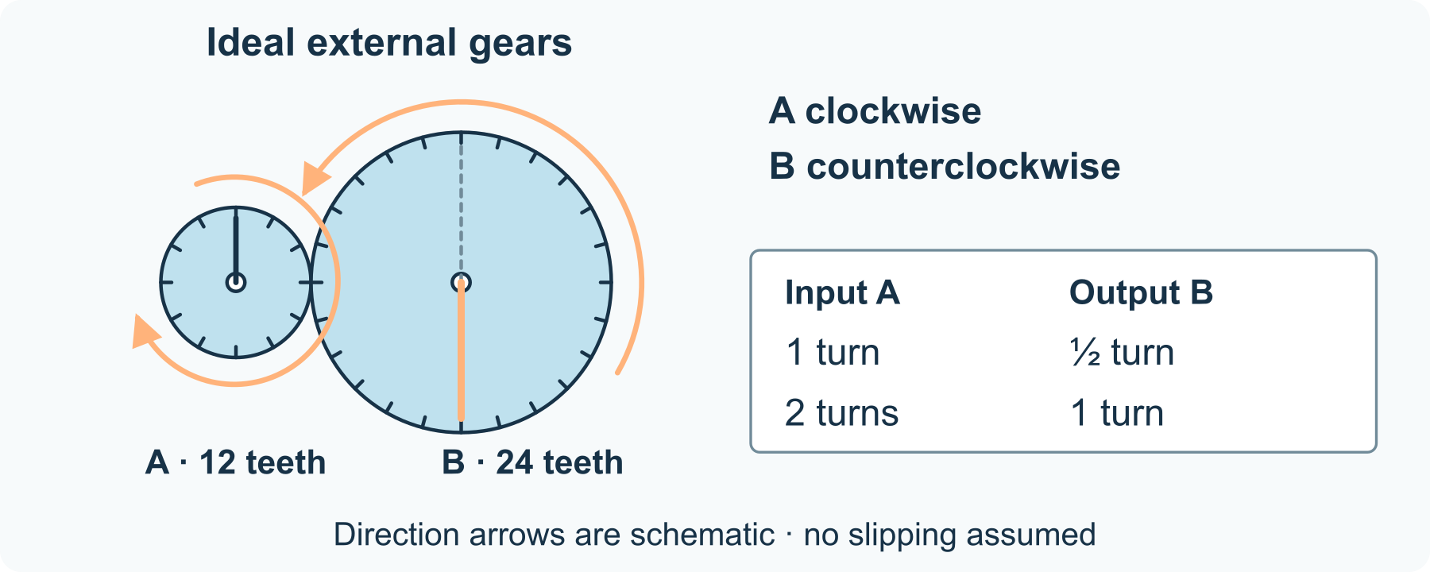
One input turn becomes half an output turn
1 Name the input
Choose which gear a fictional handle turns. Mark A with an arrow; this example uses clockwise input.
2 Follow the contact
For two external gears that mesh without slipping, the second turns in the opposite direction. Mark B counterclockwise.
3 Track a turn
One turn of A passes 12 teeth through the contact. That moves 12 of B’s 24 teeth: half a turn. Show the same starting mark on a second sketch.
4 Explain the model
Add an input-to-output caption. Keep your explanation to direction and turns; the sketch does not prove a real mechanism will work.

23 A worked example | engineering-mechanism-map

Original model a rotating sign
These are ideal external gears in an invented desk-display drawing, not tested hardware.
• A has 12 teeth; B has 24. Their sizes and tooth counts stay fixed.
• A turns clockwise once; B turns counterclockwise half a turn.
• Two turns of A would move B through one complete turn.
What this example can show The model assumes gears mesh without slipping. It does not calculate friction, strength or the force needed.

A different way
Trace the contact with a finger, point to the labelled arrows, or describe the turns while someone else marks them.

If you want to go further
Draw an equal-sized third gear touching B. Work out its direction and turns before changing the drawing.

Something to notice
Which claim follows from the tooth counts, and which claim would require a real test?

Read or explore more
Horizon topic Mechanisms Machines
https://launchhorizonhq.com/learn/mechanisms-machines/
Horizon topic Engineering Drawings
https://launchhorizonhq.com/learn/engineering-drawings/
Horizon topic Engineering
https://launchhorizonhq.com/learn/engineering/
TeachEngineering, University of Colorado Boulder Get in Gear
https://www.teachengineering.org/activities/nyu_getingear_activity1
OpenStax, Rice University Simple Machines
https://openstax.org/books/physics/pages/9-3-simple-machines

24 Engineering | engineering-flow-plan

A flow network on paper
What does a branching network allow, and where could a bottleneck appear?
Use drawn tokens to explore a branching network with a limited capacity.
Investigate | 10-20 minutes, or one small comparison | Scrap paper and a pencil or pen, The supplied original model; no account, purchase or online search needed
Start here Draw a source S feeding two branches A and B. Write: six tokens arrive each turn.
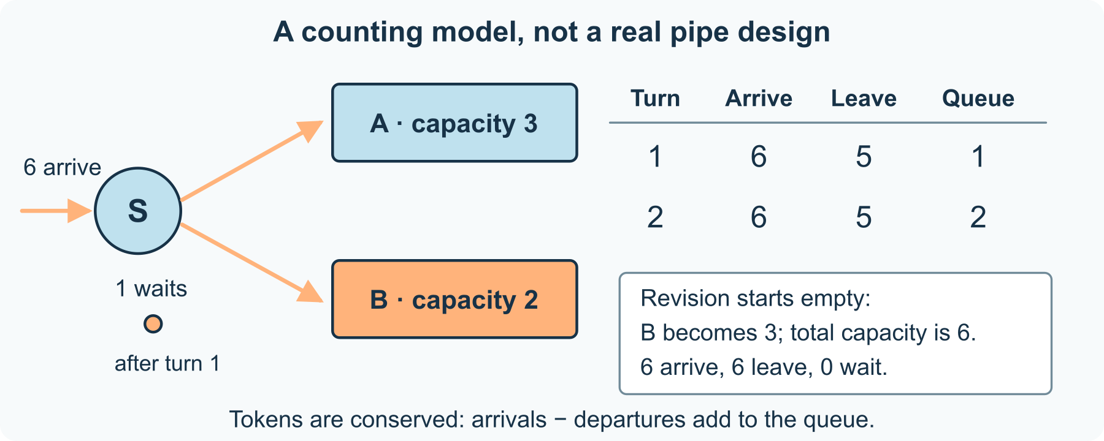
Six arrive; five can leave
1 State the rules
Branch A can pass at most three tokens per turn; B can pass at most two. Tokens do not disappear or jump a branch.
2 Trace one turn
Send six tokens to S. Move three along A and two along B. Mark the remaining token as waiting at S.
3 Trace another turn
Add six new tokens. There are now seven waiting or arriving; five can leave. Two remain. Record arrivals, departures and the queue.
4 Change one limit
Raise B’s capacity to three in a fresh model. From an empty start, all six incoming tokens can leave each turn. Explain the difference.

24 A worked example | engineering-flow-plan

Original model two display channels
The tokens and turns are invented counting units, not measurements from a water system.
• Original limits: 3 + 2 = 5 departures for 6 arrivals; one token is left after turn 1.
• Turn 2 starts with 1 waiting plus 6 new tokens. Five leave and 2 remain.
• With B changed to 3, total capacity is 6. An empty-start turn has 6 arrivals, 6 departures and no queue.
What this example can show Real water networks involve pressure, losses and other constraints. A token model cannot establish safe pipe sizes or real flow rates.

A different way
Use six small pencil marks, move imagined tokens aloud, or ask a partner to record your counts. No counters are required.

If you want to go further
Choose an incoming rate of four tokens per turn. Describe more than one valid split that stays within both branch limits.

Something to notice
Did I keep every token accounted for?

Read or explore more
Horizon topic Water Networks
https://launchhorizonhq.com/learn/water-networks/
Horizon topic Feedback Control
https://launchhorizonhq.com/learn/feedback-control/
Horizon topic Engineering
https://launchhorizonhq.com/learn/engineering/
OpenStax, Rice University Flow Rate and Its Relation to Velocity
https://openstax.org/books/college-physics-ap-courses/pages/12-1-flow-rate-and-its-relation-to-velocity
TeachEngineering, University of Colorado Boulder Engineering Design Process
https://www.teachengineering.org/popular-topics/engineering-design-process

25 Film & Animation | film-six-shot-story

Tell a small story in six shots
What information does each frame give the viewer?
Plan a small invented object story using six labelled frames.
Make | 10-20 minutes, or one small comparison | Scrap paper and a pencil or pen, The supplied original model; no account, purchase or online search needed
Start here Draw six empty boxes and choose a paper star as the fictional subject.
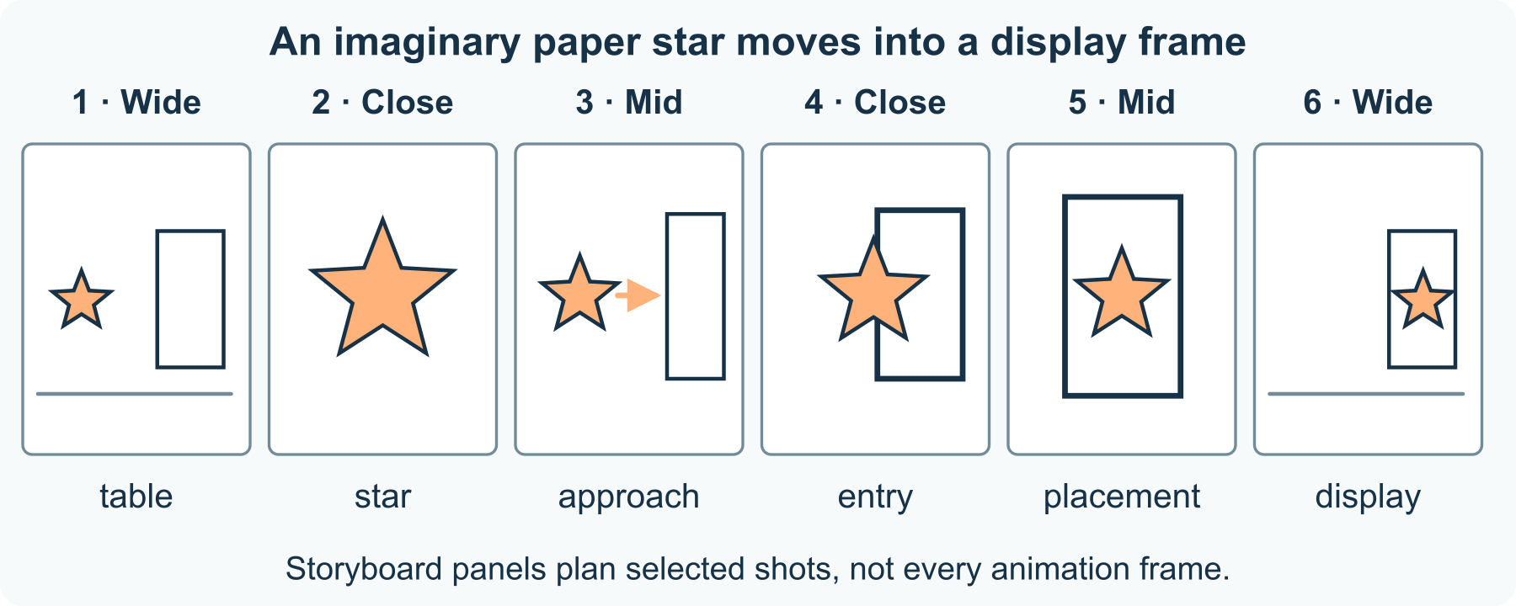
Six views of one small change
1 Choose a tiny change
Use the supplied story: a paper star moves from a table into a display frame. Decide what is different at the end.
2 Plan six shots
Sketch the table and frame, a closer view of the star, its approach, its entry, its placement and the finished display. Rough shapes are enough.
3 Name the information
Under each panel, write what the viewer can learn. Mark wide, mid or close views when the distinction helps.
4 Check the sequence
Read the panels in order. Point to any missing connection or repeated information. Keep, replace or leave out a panel if you explain why.

25 A worked example | film-six-shot-story

Original storyboard a star display
The six drawings plan an imaginary sequence. They are not stills from a real film.
• 1 wide: a star and an empty frame are on a table. 2 close: the star is the subject.
• 3 mid: the star approaches the frame. 4 close: it slides into the opening.
• 5 mid: the star sits inside. 6 wide: the finished display connects back to the table.
What this example can show A storyboard plans selected shots, not every animation frame. It does not guarantee what an audience understands.

A different way
Describe six views aloud, number six supplied scenes, or direct someone else’s drawing. Filming is unnecessary.

If you want to go further
Replace one close view with a wide view. Name one detail gained and one detail that becomes harder to see.

Something to notice
What does each frame contribute to the small story?

Read or explore more
Horizon topic Storyboards Shots
https://launchhorizonhq.com/learn/storyboards-shots/
Horizon topic Camera Viewpoint
https://launchhorizonhq.com/learn/camera-viewpoint/
Horizon topic Film Animation
https://launchhorizonhq.com/learn/film-animation/
ACMI Storyboards
https://www.acmi.net.au/education/school-program-and-resources/film-it-storyboards/
ACMI Exploring shot types
https://www.acmi.net.au/education/school-program-and-resources/exploring-shot-types/

26 Film & Animation | film-timing-cards

Change the timing of an invented sequence
How can the same drawn action suggest a different pace?
Compare two timing plans for the same four drawn positions.
Investigate | 10-20 minutes, or one small comparison | Scrap paper and a pencil or pen, The supplied original model; no account, purchase or online search needed
Start here Draw a dot in four positions along a line and label them 1 to 4.
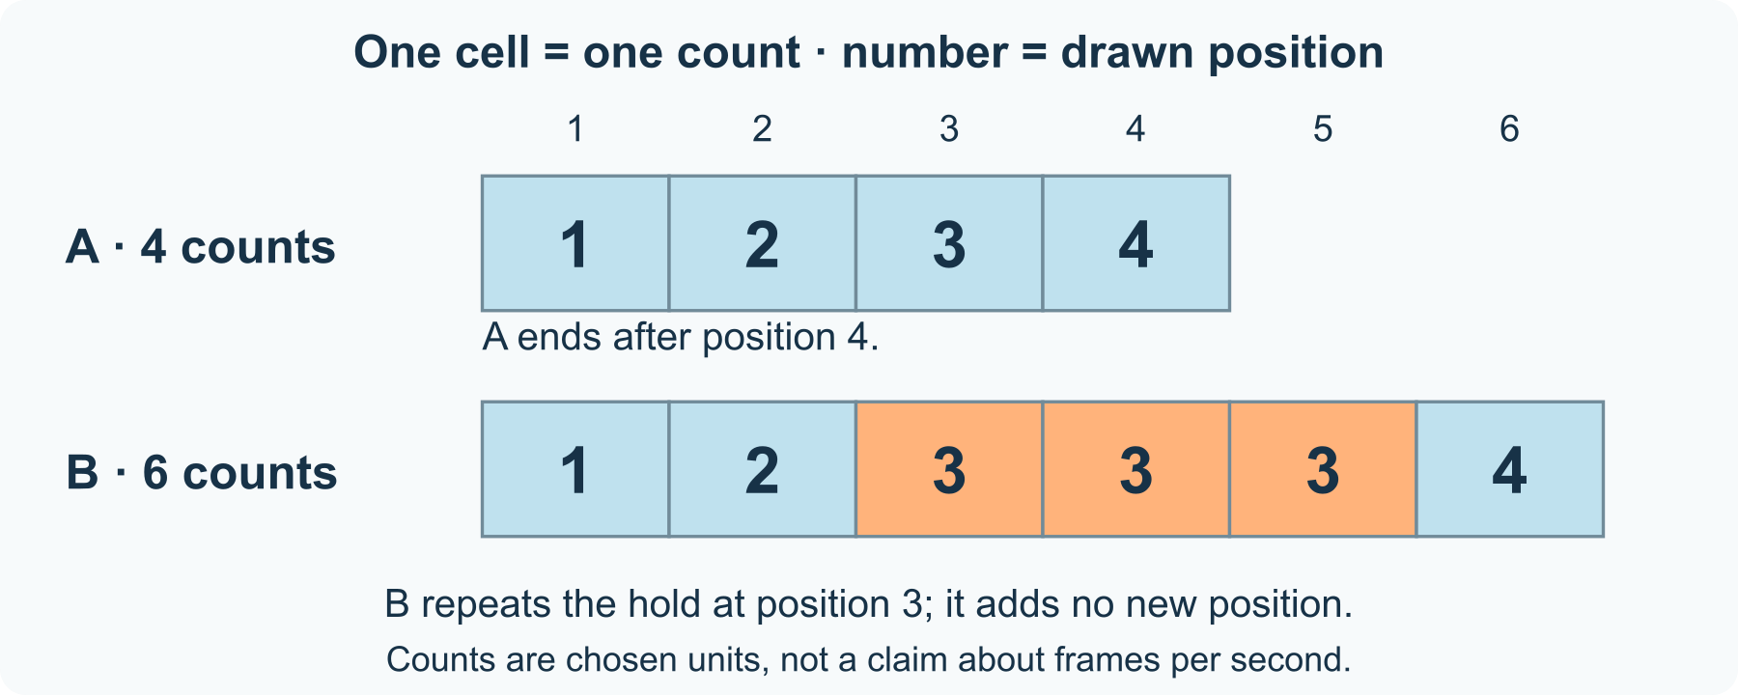
Same positions, different holds
1 Keep the action fixed
Use exactly the same four drawings in plans A and B. Only the time each position is held will change.
2 Set plan A
Give each drawing one count: 1, 1, 1, 1. The sequence lasts four equal counts.
3 Set plan B
Use 1, 1, 3, 1 counts. Hold the third position for three counts. This sequence lasts six counts.
4 Compare carefully
Point or count through both plans if you want. Describe the longer hold before suggesting an effect such as a pause. Different viewers may read it differently.

26 A worked example | film-timing-cards

Original model a travelling dot
These are paper timing plans, not measured frame rates or results from a viewer test.
• Both plans contain the same four positions in the same order.
• A totals 1 + 1 + 1 + 1 = 4 counts. B totals 1 + 1 + 3 + 1 = 6 counts.
• B holds position 3 for two extra counts. The move to position 4 is delayed.
What this example can show A count is a chosen timing unit. This comparison does not specify seconds, frames per second or a universal emotional effect.

A different way
Point through the labelled timeline, direct someone else’s counting, or compare the totals silently. Performing or recording is optional.

If you want to go further
Make a five-count version without changing the four positions. Explain two different places you could add the extra count.

Something to notice
Did I change the action, its timing or both?

Read or explore more
Horizon topic Animation Timing
https://launchhorizonhq.com/learn/animation-timing/
Horizon topic Stop Motion
https://launchhorizonhq.com/learn/stop-motion/
Horizon topic Editing Continuity
https://launchhorizonhq.com/learn/editing-continuity/
ACMI Make a stop-motion animation
https://www.acmi.net.au/education/school-program-and-resources/make-stop-motion-animation/
ACMI Editing
https://www.acmi.net.au/education/school-program-and-resources/film-it-editing/

27 Film & Animation | film-silent-sound-plan

Plan a soundscape without recording
What would a sound cue add that a picture leaves open?
Write two sound plans for the same quiet fictional scene, with no recording.
Make | 10-20 minutes, or one small comparison | Scrap paper and a pencil or pen, The supplied original model; no account, purchase or online search needed
Start here Sketch a paper disc beside an empty tray and write the time marks 0, 2 and 4 seconds.
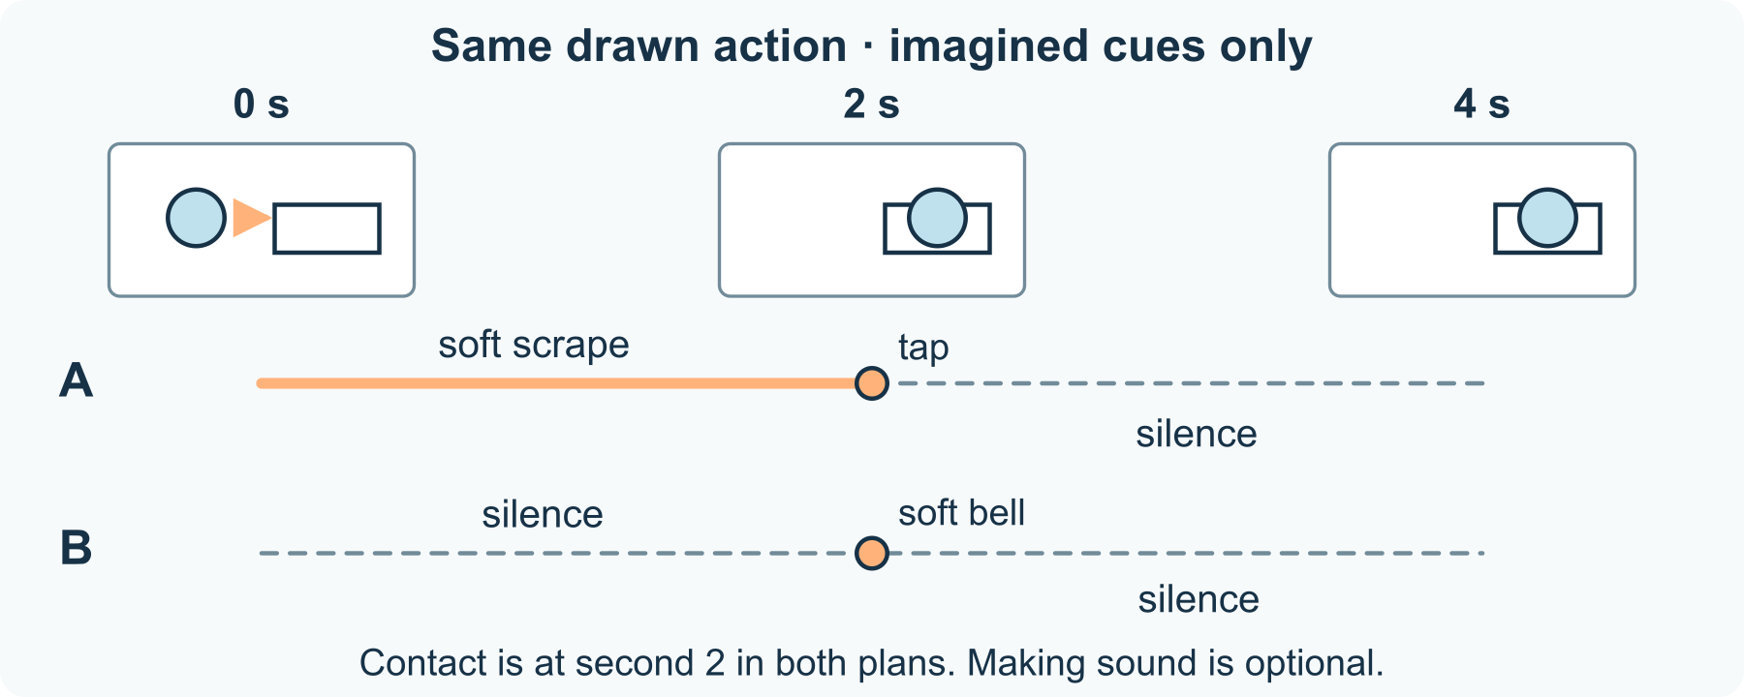
One picture, two cue plans
1 Fix the picture
Imagine the disc sliding into the tray at second 2, then resting until second 4. The picture is the same for both sound plans.
2 Plan cue A
Write: soft scrape from 0 to 2; a quiet tap at 2; silence from 2 to 4. Label when each cue begins and ends.
3 Plan cue B
Try silence from 0 to 2, a soft bell at 2, then silence to 4. These are imagined cues; you need not make the sounds.
4 Explain your choice
Describe what a cue could suggest and what the image already shows. Keep possible effects open rather than claiming every viewer hears the same story.

27 A worked example | film-silent-sound-plan

Original model a disc meets a tray
The timings and cues are invented. No sound, recording or audience response has been collected.
• Picture: the disc enters the tray at second 2 in both versions.
• A uses a scrape during the movement and a tap at contact; B uses only an imagined bell at contact.
• The changed cue may make the event read differently, while the visible movement remains fixed.
What this example can show A written sound plan cannot establish the loudness or effect of a finished soundtrack. Silence is a valid choice.

A different way
Use written cue words, point to time marks, or describe the plan quietly. Sound-making, speech and recording are unnecessary.

If you want to go further
Move the imagined tap to second 1, before visible contact. Describe the mismatch without deciding that it must be wrong.

Something to notice
Which meaning came from the picture, and which came from my sound choice?

Read or explore more
Horizon topic Sound Screen
https://launchhorizonhq.com/learn/sound-screen/
Horizon topic Lighting Scenes
https://launchhorizonhq.com/learn/lighting-scenes/
Horizon topic Film Animation
https://launchhorizonhq.com/learn/film-animation/
ACMI Editing
https://www.acmi.net.au/education/school-program-and-resources/film-it-editing/
ACMI Cinematography
https://www.acmi.net.au/education/school-program-and-resources/film-it-cinematography/

28 Games | games-change-one-rule

Change one movement rule
What changes when a puzzle allows diagonal moves?
Compare two versions of a complete paper puzzle. Keep the board and goal the same while changing the allowed movement.
Investigate | 10-20 minutes, or one route | Paper and a pen or pencil, A finger or small paper marker
Start here Draw a 3-by-3 grid. Number columns 1 to 3 from left to right and rows 1 to 3 from bottom to top. Mark Start at (1,1), Finish at (3,3) and block (2,2).
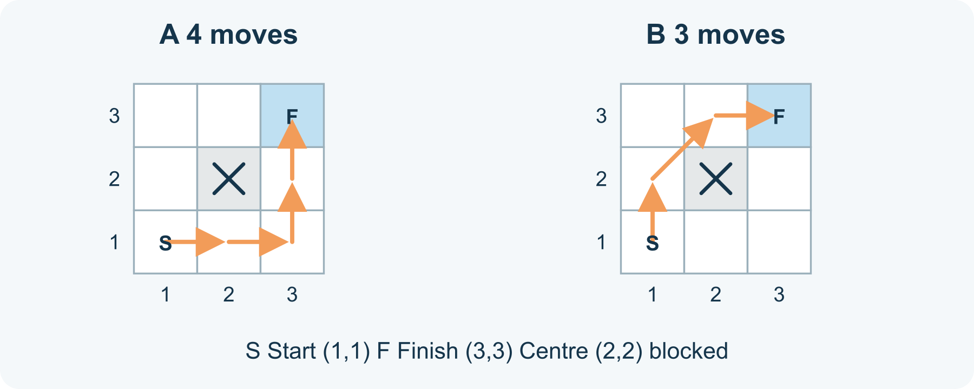
Same board, different routes
1 Agree the first rule
Begin at Start. One move goes one square up, down, left or right. Stay inside the grid and never land on the blocked square. The goal is to reach Finish; there is no timer.
2 Record a route
Trace a route and count moves between squares, not the number of squares visited. The supplied four-move route works if you prefer to examine a complete example.
3 Change only movement
Now also allow a move to a diagonally adjacent square. Passing a corner is allowed in this version; landing on (2,2) remains forbidden. Keep the same Start, Finish and board. Find or trace a route again.
4 Explain a consequence
Compare your routes. Name what the new rule permits. A shorter route may be interesting, but you can also discuss which choices change or whether you would prefer another rule.

28 A worked example | games-change-one-rule

Worked puzzle four moves or three
This is a constructed puzzle with exact rules, not a study of player preferences. Coordinates identify squares as (column,row).
• Up/down/left/right: (1,1) → (2,1) → (3,1) → (3,2) → (3,3). Four moves.
• With diagonals: (1,1) → (1,2) → (2,3) → (3,3). Three moves; no landing on the centre.
• Two diagonal moves would pass through (2,2), so they do not solve this board under the stated rule.
What this example can show These paths demonstrate the stated puzzle. They do not show that diagonal movement makes every game easier, fairer or more enjoyable.

A different way
Trace the two supplied paths with a finger, have the coordinates read aloud, or compare just the first move. No game account or digital game is needed.

If you want to go further
Move one blocked square and test both rules again. Keep the original board as a reference. Can you explain whether your conclusion still holds?

Something to notice
Which difference came from the rule, and which came from the route I chose?

Read or explore more
Horizon topic Games
https://launchhorizonhq.com/learn/games/
Horizon topic Rules Mechanics
https://launchhorizonhq.com/learn/rules-mechanics/
Horizon topic Spatial Puzzles
https://launchhorizonhq.com/learn/spatial-puzzles/
ACMI Game Builder
https://www.acmi.net.au/education/game-builder/
ACMI Game Lessons
https://www.acmi.net.au/education/school-program-and-resources/game-lessons/

29 Games | games-maze-clues

A maze with a readable clue
How can a clue help a player without silently solving the puzzle?
Create a small grid puzzle and choose a clue that leaves room to explore.
Make | 10-20 minutes, or one small comparison | Scrap paper and a pencil or pen, The supplied original model; no account, purchase or online search needed
Start here Draw a 4 by 4 grid. Mark start (1,1), finish (4,4), and blocked squares (2,2) and (3,2).
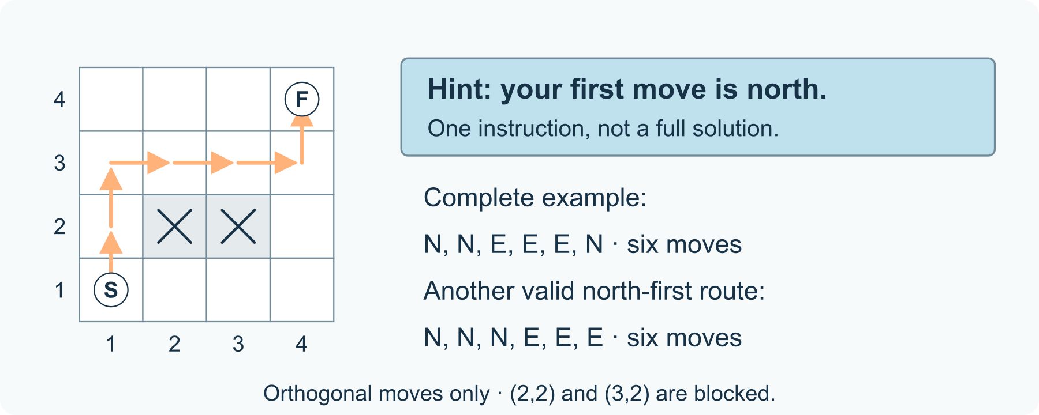
A clue is not the whole route
1 State movement
Move one square north, south, east or west. Do not enter a blocked square or jump diagonally. The bottom-left cell is (1,1).
2 Find a route
Trace a route before writing a clue. One example is north, north, east, east, east, north: six moves to the finish.
3 Choose a clue
Try ‘Your first move is north.’ This removes the east-first option, but does not list every move. Find two routes that still fit it.
4 Check the information
Compare that clue with the complete route. Decide whether your player should receive a hint, a full solution or neither; label each honestly.

29 A worked example | games-maze-clues

Original model a clue with choices left
The grid and routes are invented paper examples, not records of playtesting.
• Example route: (1,1), (1,2), (1,3), (2,3), (3,3), (4,3), (4,4).
• Another north-first route goes up to (1,4), then across to (4,4). Both take six moves.
• The clue fixes only the first move. It does not select one unique complete route.
What this example can show This grid maze has blocked cells and more than one valid route. A checked example does not establish ideal difficulty for every player.

A different way
Call out directions, point to cells, or use the supplied grid while someone else traces. No timed challenge is needed.

If you want to go further
Block one additional square. Check that at least one route remains before claiming the new version is playable.

Something to notice
Does my hint support a choice, or has it already supplied the whole answer?

Read or explore more
Horizon topic Maze Design
https://launchhorizonhq.com/learn/maze-design/
Horizon topic Game Worlds
https://launchhorizonhq.com/learn/game-worlds/
Horizon topic Playtesting Balancing
https://launchhorizonhq.com/learn/playtesting-balancing/
NRICH, University of Cambridge Maze 100
https://nrich.maths.org/problems/maze-100
ACMI Game builder: overview for teachers
https://www.acmi.net.au/education/school-program-and-resources/game-builder-overview-teachers/

30 Games | games-cooperative-rules

Design a cooperative paper puzzle
Which rule makes two fictional roles useful without requiring competition?
Build a shared-goal puzzle in which two fictional rule cards contribute different information.
Make | 10-20 minutes, or one small comparison | Scrap paper and a pencil or pen, The supplied original model; no account, purchase or online search needed
Start here Draw three tokens: circle, square and triangle, with three empty slots in a row.
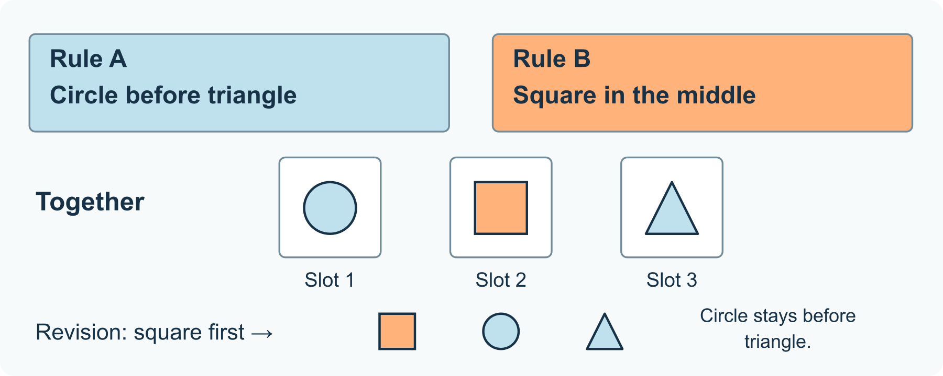
Two rules choose an order
1 Set a shared goal
The aim is one arrangement satisfying both rules. Role A’s card says circle before triangle; Role B’s card says square in the middle.
2 Combine the clues
The square takes slot 2. The circle must be before the triangle, so place the circle in slot 1 and triangle in slot 3.
3 Choose how to play
You can read both role cards yourself, take turns with a mentor, or simply discuss the solution. No hidden information or partner is required.
4 Revise one rule
Change the second card to square first. Keep circle before triangle. Find the new order and explain which placement changed.

30 A worked example | games-cooperative-rules

Original model two rules one arrangement
These fictional roles organise a paper puzzle. No claims about social-skill improvement or participant responses are made.
• Rule A: circle before triangle. Rule B: square in the middle.
• Both together give circle, square, triangle. With square fixed in the middle, only that order has circle before triangle.
• Changing only B to square first gives square, circle, triangle.
What this example can show A one-solution token puzzle does not establish how all cooperative games work. Information can be shared openly if that suits the learner.

A different way
Point to drawn tokens, speak the order, or direct someone else to number the slots. One person can use both roles.

If you want to go further
Remove the middle-slot rule and count how many arrangements still keep circle before triangle. Check all six orders if you want.

Something to notice
Which part of the solution depends on each rule?

Read or explore more
Horizon topic Cooperative Games
https://launchhorizonhq.com/learn/cooperative-games/
Horizon topic Turn Sequences
https://launchhorizonhq.com/learn/turn-sequences/
Horizon topic Player Choices
https://launchhorizonhq.com/learn/player-choices/
ACMI Choosing the right game for collaborative learning
https://www.acmi.net.au/stories-and-ideas/choosing-the-right-game-for-collaborative-learning/
ACMI Game builder: overview for teachers
https://www.acmi.net.au/education/school-program-and-resources/game-builder-overview-teachers/

31 Geography | geography-map-scale

Scale an imaginary island map
Which distances can I calculate from a clearly stated scale?
Use a stated scale to calculate distances on a completely imaginary island.
Investigate | 10-20 minutes, or one small comparison | Scrap paper and a pencil or pen, The supplied original model; no account, purchase or online search needed
Start here Draw three invented places on a square grid: A (1,1), B (4,1) and C (4,3).
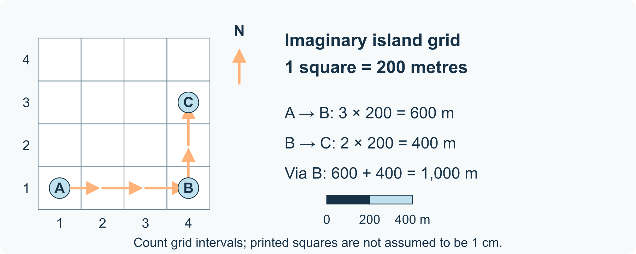
Five squares become one kilometre
1 State the scale
Each grid square represents 200 metres. On a hand-drawn map with 1 cm squares, that would be 1 cm to 200 m, or 1:20,000.
2 Count the legs
A to B spans three squares east. B to C spans two squares north. Count the intervals between points, not the number of labelled points.
3 Convert the route
Three squares represent 600 m; two represent 400 m. The route A-B-C is 1,000 m in this model.
4 Label what you know
Add a scale bar and north arrow. Count squares on the supplied drawing; resizing a printed illustration does not make each square exactly 1 cm.

31 A worked example | geography-map-scale

Original model an invented island grid
A, B and C are fictional sites. The graphic is schematic and is not an outdoor navigation map.
• A(1,1) to B(4,1): 3 squares × 200 m = 600 m.
• B(4,1) to C(4,3): 2 squares × 200 m = 400 m.
• Via B, the total is 1,000 m. The straight line A-C is a different distance.
What this example can show Map distance alone does not establish a real route, journey time, access or terrain. The supplied grid must be read by its labels or scale bar, not assumed physical print size.

A different way
Count intervals aloud, point to the scale bar, or direct someone else to note the calculations. A ruler is optional.

If you want to go further
Change the scale to 100 m per square without moving any points. Recalculate the two legs and route total.

Something to notice
Did I count spaces between points or count the points themselves?

Read or explore more
Horizon topic Maps Scale
https://launchhorizonhq.com/learn/maps-scale/
Horizon topic Directions Coordinates
https://launchhorizonhq.com/learn/directions-coordinates/
Horizon topic Geography
https://launchhorizonhq.com/learn/geography/
Geoscience Australia What is Map Scale?
https://www.ga.gov.au/scientific-topics/national-location-information/topographic-maps-data/basics/what-is-map-scale
Geoscience Australia Map Reading Guide: How to use Topographic Maps
https://www.ga.gov.au/bigobj/GA7194.pdf

32 Geography | geography-contour-story

Read the shape of a drawn hill
What do contour spacing and height labels tell us about a landscape model?
Read equal-height lines on an invented hill and leave the exact summit unknown.
Investigate | 10-20 minutes, or one small comparison | Scrap paper and a pencil or pen, The supplied original model; no account, purchase or online search needed
Start here Draw three nested loops and label the outer 20 m, middle 40 m and inner 60 m.
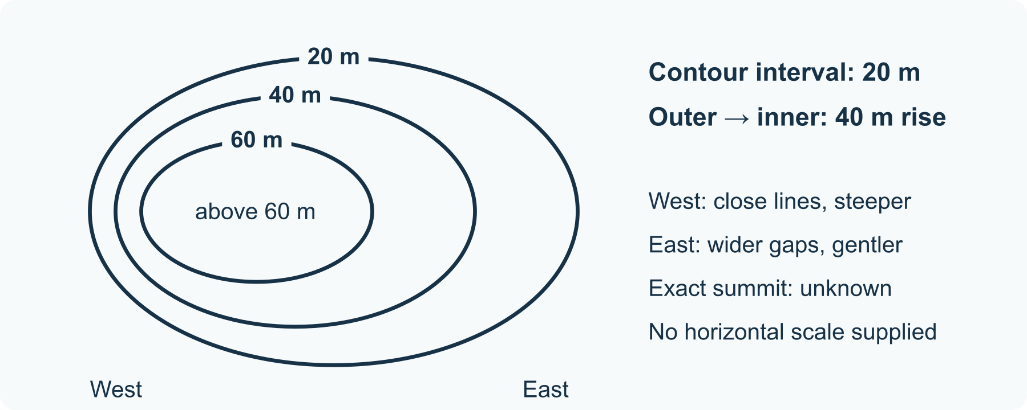
Same rise, different spacing
1 Keep equal intervals
Each loop joins points at the same height. In this hill model, height increases inward by 20 m between neighbouring loops.
2 Compare spacing
Bring the loops close together on the west side and farther apart on the east. Keep the loops nested without crossing.
3 Read the slope
Both sides rise through the same 20 m intervals. The shorter horizontal gaps on the west indicate a steeper slope than the wider east gaps.
4 Show uncertainty
Label the inside area above 60 m, with exact summit unknown. The lines alone do not show how or when the hill formed.

32 A worked example | geography-contour-story

Original model one imaginary hill
This schematic is a drawing to interpret, not a survey or a measured landscape.
• The outer, middle and inner loops are 20 m, 40 m and 60 m.
• From the outer to inner loop, the height rises 40 m on either side.
• Contours are closer on the west, so that side is steeper in this model. The exact summit is not labelled.
What this example can show No horizontal scale is supplied, so an exact gradient cannot be calculated. The drawing does not establish a safe real walking route.

A different way
Trace the three loops with a finger, describe a side aloud, or use the supplied labels instead of drawing.

If you want to go further
Keep the loops in place and change their labels to 10 m, 20 m and 30 m. Compare the rise without claiming a new horizontal scale.

Something to notice
Which part of my description is supported by contour values and spacing?

Read or explore more
Horizon topic Contours Height
https://launchhorizonhq.com/learn/contours-height/
Horizon topic Landform Processes
https://launchhorizonhq.com/learn/landform-processes/
Horizon topic Geography
https://launchhorizonhq.com/learn/geography/
Geoscience Australia Map Reading Guide: How to use Topographic Maps
https://www.ga.gov.au/bigobj/GA7194.pdf
Ordnance Survey Relief and contours
https://www.ordnancesurvey.co.uk/mapzone/assets/doc/map-skills/Relief-and-Contours-en.pdf

33 Geography | geography-route-choice

Compare two invented transport routes
What makes a route useful when distance is only one consideration?
Compare two fictional routes using a stated goal as well as their distance.
Investigate | 10-20 minutes, or one small comparison | Scrap paper and a pencil or pen, The supplied original model; no account, purchase or online search needed
Start here Draw two routes from A to B: a short route through C and a longer route through D.
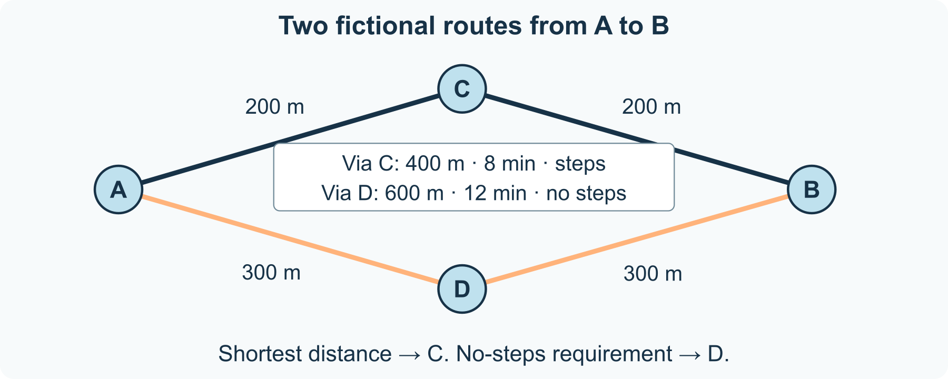
A route choice needs a criterion
1 Supply the facts
Route A-C-B has two 200 m legs, takes 8 invented minutes and includes steps. Route A-D-B has two 300 m legs, takes 12 invented minutes and has no steps.
2 Name one criterion
Choose a fictional requirement such as shortest distance or no steps. You do not need to disclose a personal reason for choosing it.
3 Compare against it
Shortest distance favours A-C-B: 400 m. The no-steps requirement favours A-D-B: 600 m. Each answer names its criterion.
4 List missing facts
Surface, slope, weather and other access details are not supplied. Do not turn no steps into a claim that every person can use the route.

33 A worked example | geography-route-choice

Original model two routes to a display hall
Distances, times and route features are supplied fictional data, not real transport information.
• Via C: 200 + 200 = 400 m; 8 minutes; steps.
• Via D: 300 + 300 = 600 m; 12 minutes; no steps.
• For a no-steps requirement choose D; for minimum distance choose C, given only these facts.
What this example can show The invented minutes are given data, not a general walking-speed rule. No-steps alone does not establish full accessibility.

A different way
Point to route labels or say which fact matters. Someone else can add the distances or mark the selected route.

If you want to go further
Add a second criterion: no steps and no more than 10 minutes. Explain why neither supplied route meets both, without inventing a third route as fact.

Something to notice
What changed when I changed the criterion?

Read or explore more
Horizon topic Transport Networks
https://launchhorizonhq.com/learn/transport-networks/
Horizon topic Cities Settlements
https://launchhorizonhq.com/learn/cities-settlements/
Horizon topic Maps Scale
https://launchhorizonhq.com/learn/maps-scale/
NRICH, University of Cambridge Only Connect
https://nrich.maths.org/problems/only-connect
Geoscience Australia What is Map Scale?
https://www.ga.gov.au/scientific-topics/national-location-information/topographic-maps-data/basics/what-is-map-scale

34 History | history-object-clues

An object and three possible explanations
Which details support an explanation of an invented historical object?
Compare possible uses of a completely invented object while keeping observation separate from a guess.
Investigate | 10-20 minutes, or one small comparison | Scrap paper and a pencil or pen, The supplied original model; no account, purchase or online search needed
Start here Use the supplied drawing of a 60 mm disc with an 8 mm centre hole, four edge notches and worn paint.
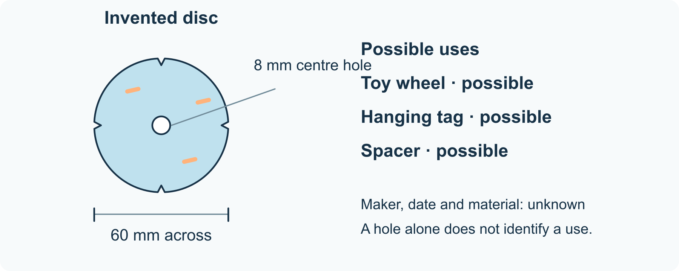
One object, several possible uses
1 Describe first
List the round outline, hole, notches and paint wear without naming a function or date. These details are supplied fictional observations.
2 Offer explanations
Try toy wheel, hanging tag and spacer. More than one explanation can fit a centre hole; you may add or reject a possibility.
3 Match clues cautiously
A centre hole and edge wear could fit a toy wheel, but neither proves one. A hanging tag or spacer can also have a hole.
4 Choose a next check
Suggest a useful record or test, such as a matching axle drawing with dimensions. Do not invent that evidence or claim the object’s age.

34 A worked example | history-object-clues

Original example an unidentified disc
This is an invented object drawing, not an artefact or a discovery from a real place.
• Observed: 60 mm across, 8 mm centre hole, four edge notches and worn paint.
• Tentative idea: a toy wheel, supported weakly by the hole and wear.
• Alternative: a tag or spacer could share those details. A matching dimensioned parts record would be useful.
What this example can show No supplied detail identifies the maker, date, material or actual use. A plausible explanation remains a hypothesis.

A different way
Point to details, dictate a description, or compare the three written hypotheses. No real object or collection visit is needed.

If you want to go further
Add one explicitly fictional new record: an axle drawing with an 8 mm shaft. Explain what it supports and why a match still needs context.

Something to notice
Where did I move from describing a clue to interpreting it?

Read or explore more
Horizon topic Archaeology Objects
https://launchhorizonhq.com/learn/archaeology-objects/
Horizon topic Evidence Archives
https://launchhorizonhq.com/learn/evidence-archives/
Horizon topic History
https://launchhorizonhq.com/learn/history/
National Museum of Australia What is this?
https://www.nma.gov.au/learn/classroom-resources/what-is-this
National Archives of Australia Research skills
https://www.naa.gov.au/learn/learning-resources/research-skills

35 History | history-timeline-choices

A timeline with honest gaps
How can I order supplied records while making missing information visible?
Order supplied fictional records without turning missing dates into facts.
Investigate | 10-20 minutes, or one small comparison | Scrap paper and a pencil or pen, The supplied original model; no account, purchase or online search needed
Start here Write four record cards: 1902 sketch, 1905 picture, 1908 catalogue, and an undated revision label.
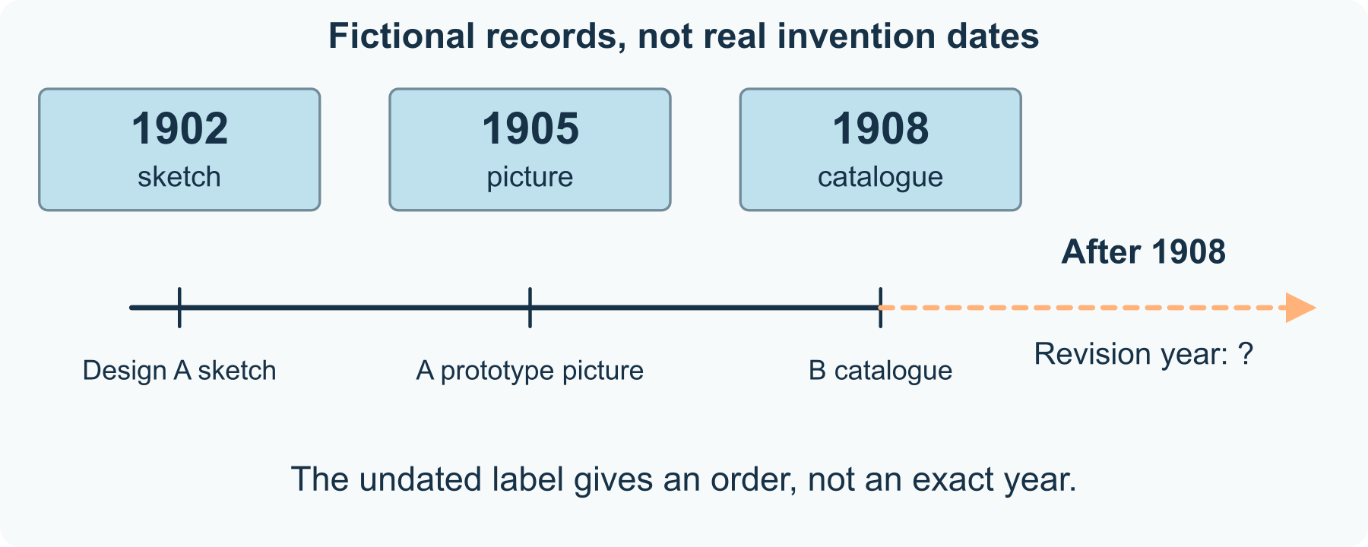
A dated sequence with an open end
1 Read the records
The sketch shows design A; the picture shows an A prototype; the catalogue offers design B. The last label says revised after the 1908 catalogue.
2 Place dated items
Put 1902, 1905 and 1908 in order. These dates belong to the fictional records, not necessarily to the first invention of either design.
3 Place the uncertain item
The revision must come after the 1908 catalogue under the supplied label. Use a dashed area after 1908 rather than assigning a guessed year.
4 Write an honest caption
State what is dated, what order is supported and what remains unknown. You can leave the timeline unfinished.

35 A worked example | history-timeline-choices

Original records a made up display stand
The dates, designs and record labels are invented for this exercise.
• 1902: a design A sketch. 1905: a picture of an A prototype. 1908: a catalogue offering design B.
• The undated label says revised after the 1908 catalogue, so it belongs somewhere later than that catalogue.
• The exact revision year and the original invention date are not supplied.
What this example can show The earliest surviving record in a set is not automatically the date something was invented. The fictional cards are not historical evidence about a real product.

A different way
Read dates aloud, point to an ordered list or ask someone to move the labels for you. No scissors or real archives are required.

If you want to go further
Add a fictional dated revision receipt from 1911. Decide what this new record would change and what uncertainty would remain.

Something to notice
Have I given an unknown event a date that the records do not supply?

Read or explore more
Horizon topic Timelines Sequencing
https://launchhorizonhq.com/learn/timelines-sequencing/
Horizon topic Everyday Inventions
https://launchhorizonhq.com/learn/everyday-inventions/
Horizon topic History
https://launchhorizonhq.com/learn/history/
Museums Victoria Gather materials
https://museumsvictoria.com.au/education/making-history/3-research/gather-materials/
London Museum Paper clip, letter clip: object Z 6182
https://www.londonmuseum.org.uk/collections/v/object-66830/paper-clip-letter-clip/

36 History | history-picture-labels

Separate a picture from its caption
Which claim comes from visible detail and which depends on a record?
Compare what an original drawing shows with claims supplied by a separate caption.
Investigate | 10-20 minutes, or one small comparison | Scrap paper and a pencil or pen, The supplied original model; no account, purchase or online search needed
Start here Look at the invented workshop drawing: three windows and two boxes beside a plain round sign.
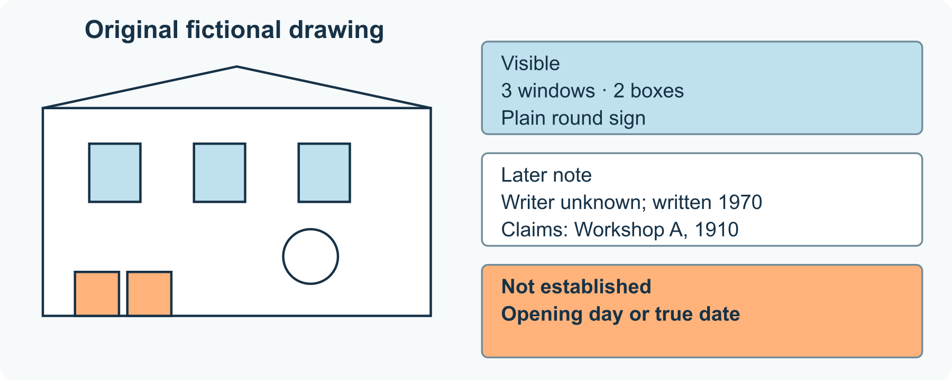
Visible, reported and unknown
1 Record visible details
Describe the windows, boxes and sign. The drawing itself contains no readable date or place name.
2 Read a separate label
A fictional note written in 1970 calls the scene Workshop A, 1910. Its writer is unknown. This is a record claim, not something visible in the drawing.
3 Test another caption
Try Opening day at Workshop A. Nothing supplied establishes an opening day. Label that phrase unconfirmed rather than treating it as an observation.
4 Write a careful label
Combine a visible description with the attributed note and its uncertainty. A short label can still make the evidence boundary clear.

36 A worked example | history-picture-labels

Original model a drawing and a later note
The picture, workshop, dates and note are all fictional; this is not an archival photograph.
• Visible: three windows, two boxes and a plain circular sign.
• Supplied note: an unknown writer in 1970 labelled the scene Workshop A, 1910.
• Not established: whether 1910 is correct or whether the scene shows an opening day.
What this example can show A later caption can be useful but is not automatically accurate. Appearance alone does not supply the maker, location or date.

A different way
Point to the supplied image, dictate a label or sort statements into visible, reported and unknown. Personal photographs are unnecessary.

If you want to go further
Write two careful captions for different purposes: a short display label and a fuller research note. Keep the same uncertainty in both.

Something to notice
Did my caption make an interpretation look like a visible fact?

Read or explore more
Horizon topic Photographs Clues
https://launchhorizonhq.com/learn/photographs-clues/
Horizon topic Place Histories
https://launchhorizonhq.com/learn/place-histories/
Horizon topic Evidence Archives
https://launchhorizonhq.com/learn/evidence-archives/
Library of Congress Teacher’s guide: Analyzing Photographs and Prints
https://www.loc.gov/static/programs/teachers/getting-started-with-primary-sources/documents/Analyzing_Photographs_and_Prints.pdf
National Archives of Australia Research skills
https://www.naa.gov.au/learn/learning-resources/research-skills

37 Languages | languages-punctuation-choice

One sentence two readings
How can punctuation change the way an invented message is understood?
Use the same words to compare direct address with the object of a sentence.
Investigate | 10-20 minutes, or one small comparison | Scrap paper and a pencil or pen, The supplied original model; no account, purchase or online search needed
Start here Write two messages about an imaginary robot: Let’s draw, Pip. and Let’s draw Pip.
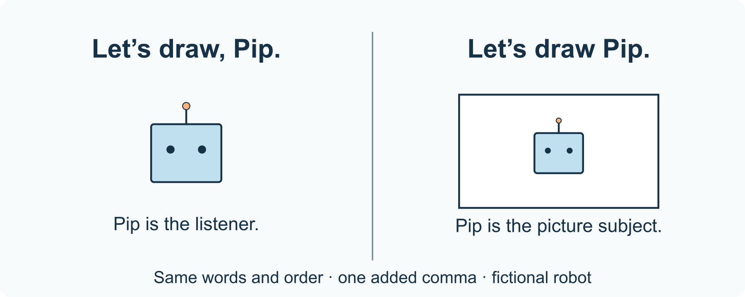
A comma changes Pip’s role
1 Keep the words fixed
Both messages use Let’s, draw and Pip in the same order. Only the comma changes.
2 Read the first
Let’s draw, Pip. addresses Pip: it invites the fictional robot to join the drawing. Pip is the listener.
3 Read the second
Let’s draw Pip. proposes drawing a picture of Pip. Pip is what the drawing will show.
4 Make the task explicit
Write a short explanation or add a sketch for each reading. You can compare silently; no particular voice or accent is required.

37 A worked example | languages-punctuation-choice

Original example Pip the invented robot
Pip is a fictional robot, not a real person or an existing character.
• With the comma: Pip is being addressed and invited to draw.
• Without the comma: Pip is the subject to be depicted in a drawing.
• A small punctuation mark changes the grammatical role of the same name.
What this example can show Context and speech can add clues too. This pair illustrates one English sentence distinction, not a rule for every language.

A different way
Sort the two messages beside supplied sketches, point to the comma, or ask someone else to read them. Speaking is optional.

If you want to go further
Try Let’s build, Pip. and Let’s build Pip. Explain the two tasks before deciding whether punctuation alone gives enough context.

Something to notice
Which role changed when I moved from one reading to the other?

Read or explore more
Horizon topic Punctuation Meaning
https://launchhorizonhq.com/learn/punctuation-meaning/
Horizon topic Word Order
https://launchhorizonhq.com/learn/word-order/
Horizon topic Languages
https://launchhorizonhq.com/learn/languages/
Australian Government Style Manual Commas
https://www.stylemanual.gov.au/grammar-punctuation-and-conventions/punctuation/commas
Australian Government Style Manual Sentences
https://www.stylemanual.gov.au/writing-and-designing-content/clear-language-and-writing-style/sentences

38 Languages | languages-invented-word-rules

Find a rule in invented words
What pattern can a small set of made-up words support?
Find a pattern in a tiny fictional label system and state how far the evidence goes.
Investigate | 10-20 minutes, or one small comparison | Scrap paper and a pencil or pen, The supplied original model; no account, purchase or online search needed
Start here Read the supplied made-up pairs: mep labels one box; mepli labels two boxes. taz labels one circle; tazli labels two circles.
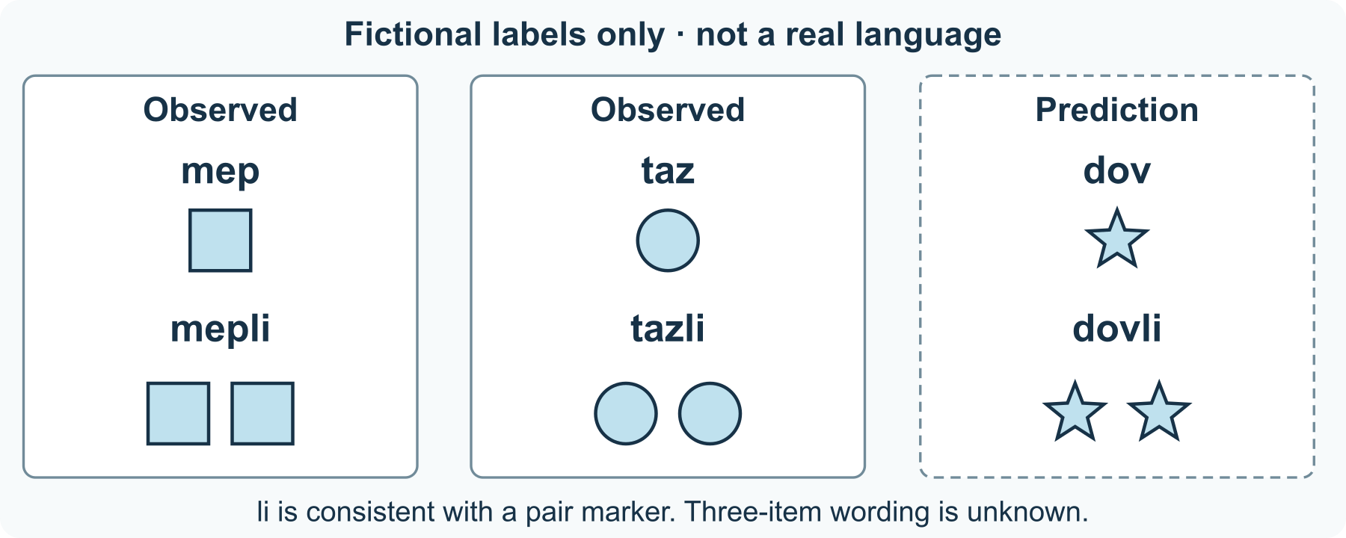
An observed ending and a prediction
1 Compare pairs
Underline the ending li in the two-item labels. These are invented puzzle labels, not words presented as a real language.
2 Propose a narrow rule
Try the hypothesis: adding li marks a pair of the named item in this toy system. Do not assume it means any number greater than one.
3 Make a prediction
A new card says dov labels one star. Predict dovli for two stars and mark it as a prediction, not another observed card.
4 Choose a test
A two-star label would check that prediction. A three-star card would help distinguish pair from a wider plural rule; its label is not supplied.

38 A worked example | languages-invented-word-rules

Original model a made up pair marker
All labels and meanings in this small dataset were invented for the puzzle.
• mep → one box; mepli → two boxes. taz → one circle; tazli → two circles.
• The shared ending li is consistent with a pair marker in both observed examples.
• Given dov for one star, dovli is a prediction for two stars. The label for three stars remains unknown.
What this example can show A small set can support a useful hypothesis without proving every future case. No claim is made about an actual language or culture.

A different way
Match labels to simple drawings, point to the repeated ending or direct someone else’s underlining. Pronouncing the invented labels is optional.

If you want to go further
Invent a separate marker for exactly three items and supply two worked pairs. Keep your invented rule distinct from the observed dataset.

Something to notice
Which examples did I observe, and which result did I predict?

Read or explore more
Horizon topic Word Building
https://launchhorizonhq.com/learn/word-building/
Horizon topic Sounds Grammar
https://launchhorizonhq.com/learn/sounds-grammar/
Horizon topic Languages
https://launchhorizonhq.com/learn/languages/
NSW Education Standards Authority English K-10 Syllabus (2022): Glossary
https://curriculum.nsw.edu.au/learning-areas/english/english-k-10-2022/glossary
The Open University, OpenLearn Describing language
https://www.open.edu/openlearn/languages/describing-language

39 Languages | languages-meaning-options

Two ways to express one idea
Which part of a meaning survives when the wording changes?
Compare paraphrases by checking which details they preserve.
Investigate | 10-20 minutes, or one small comparison | Scrap paper and a pencil or pen, The supplied original model; no account, purchase or online search needed
Start here Write the fictional instruction: After the bell, place the blue card inside the tray.
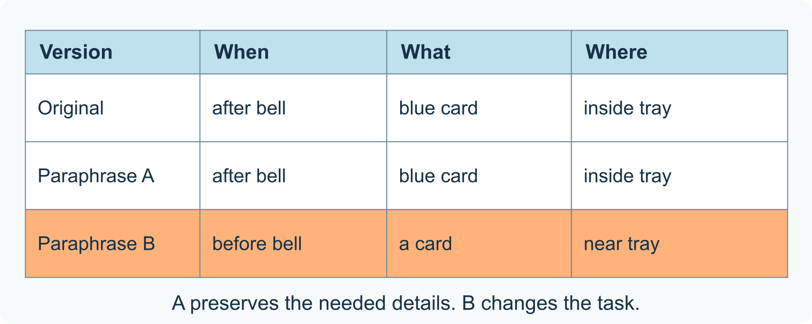
Same idea, different words-or a changed task
1 Break up the meaning
Name the action, the blue card, the inside of the tray and the timing after the bell. These are the details to track.
2 Compare a paraphrase
Put the blue card in the tray once the bell has sounded keeps those details, despite changing several words.
3 Spot a changed instruction
Put a card near the tray before the bell changes colour information, destination and timing. It is not equivalent for this task.
4 Choose an audience
Write a clear version for an invented display sign or a longer explanation. Keep the required meaning, while noting that real translation also depends on context.

39 A worked example | languages-meaning-options

Original example a card and a tray
The bell, card and instruction are fictional. No real translation or delivery task is being assessed.
• Original: after the bell; blue card; inside the tray.
• Paraphrase A preserves those three details using once the bell has sounded and in the tray.
• Paraphrase B says before, drops blue and changes inside to near, so it changes the required task.
What this example can show Near-equivalent wording can still differ in tone or context. Comparing English paraphrases does not qualify someone to translate another language.

A different way
Use three labelled cards for when, what and where, point to matching details, or dictate a paraphrase. No other language knowledge is needed.

If you want to go further
Make the instruction shorter for a small sign. Ask whether a reader can still recover the timing, blue card and inside-tray destination.

Something to notice
Did I preserve the needed meaning or only reuse some of the same words?

Read or explore more
Horizon topic Translation Meaning
https://launchhorizonhq.com/learn/translation-meaning/
Horizon topic Writing Purposes
https://launchhorizonhq.com/learn/writing-purposes/
Horizon topic Metaphor Comparison
https://launchhorizonhq.com/learn/metaphor-comparison/
The Open University, OpenLearn Semantic vs communicative translation, part 1
https://www.open.edu/openlearn/mod/oucontent/view.php?id=66419&section=4.1
Monash University Purpose and audience
https://www.monash.edu/student-academic-success/advance-your-graduate-studies/write-for-the-general-public/purpose-and-audience

40 Mathematics | mathematics-tiling-rules

A tiling pattern with a rule
How can a repeated shape cover a region without gaps or overlaps?
Cover a small drawn region with repeated two-square tiles, then explain why a count alone is not a complete proof.
Make | 15-25 minutes, or one row | Paper and a pencil or pen, Optional squared paper or ruler; a rough labelled grid is enough
Start here Draw a rectangle with 6 equal columns and 4 equal rows. One little square is one unit of area. Your tile is a domino covering two neighbouring squares.
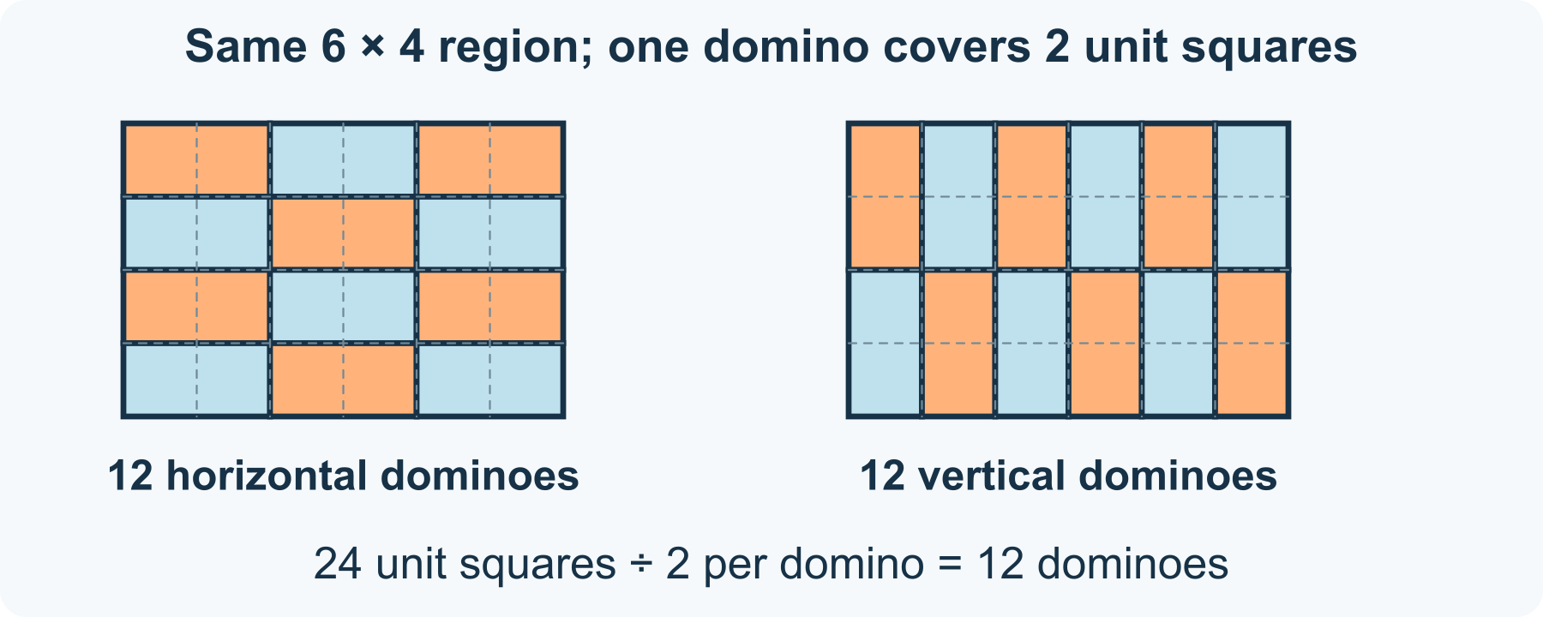
Two arrangements, the same covered region
1 State the rule
Use whole dominoes only. Each must cover exactly two side-by-side unit squares. Tiles may turn, but cannot overlap, cross the boundary or leave gaps.
2 Make a complete arrangement
Draw three horizontal dominoes across each row. Repeat that row four times. Trace the outline of each tile so the unit grid does not hide where one tile ends.
3 Check placement and count
Check every one of the 24 unit squares belongs to exactly one tile. Four rows with three dominoes give 12 tiles; 12 × 2 = 24 unit squares.
4 Try another arrangement
Turn all dominoes vertically. Each column now has two dominoes, and six columns still use 12. Describe the changed placement and unchanged coverage, or keep just the first arrangement.

40 A worked example | mathematics-tiling-rules

Constructed example two ways to cover 24 squares
These are original drawn arrangements, not a record of a real tiled floor.
• Horizontal: 3 dominoes per row × 4 rows = 12 dominoes.
• Vertical: 2 dominoes per column × 6 columns = 12 dominoes.
• Both cover 12 × 2 = 24 unit squares without cutting tiles. The drawn placement, as well as the area count, checks this region.
What this example can show Matching total area is necessary here, but does not by itself prove that any other board can be tiled. The shape and placement also matter.

A different way
Use the supplied arrangement and point to one row, dictate where a tile goes, or trace only a 2-by-2 corner. No cutting or coloured pens are needed.

If you want to go further
Cross out just one unit square on a copy. There are now 23 squares. Explain why whole two-square dominoes cannot cover an odd number of squares; do not claim this rules out every other altered board.

Something to notice
Did I check the actual placement as well as the total area?

Read or explore more
Horizon topic Tessellations
https://launchhorizonhq.com/learn/tessellations/
Horizon topic Geometry Symmetry
https://launchhorizonhq.com/learn/geometry-symmetry/
Horizon topic Mathematics
https://launchhorizonhq.com/learn/mathematics/
NRICH, University of Cambridge Tiling
https://nrich.maths.org/problems/tiling
NRICH, University of Cambridge Tessellating Triangles
https://nrich.maths.org/problems/tessellating-triangles

41 Mathematics | mathematics-chart-choices

Two charts from the same invented table
Which display choices change an impression without changing the values?
Display the same fictional token counts with two labelled scales, and separate a visual impression from a numerical difference.
Investigate | 15-25 minutes, or one comparison | Paper and a pen or pencil, The supplied invented counts; no survey or spreadsheet needed
Start here Write this fictional table: token type A = 8, B = 10, C = 12. These are invented token counts, not responses from people.
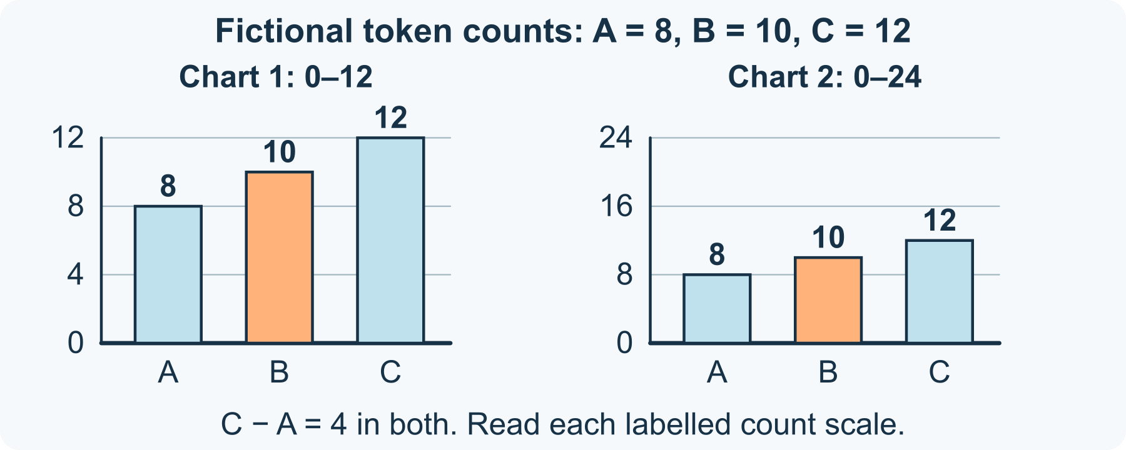
Same counts, two zero-based scales
1 Make the first display
Draw a bar chart with three equal-width bars labelled A, B and C. Use equally spaced marks 0, 4, 8 and 12 on the count axis; all bars begin at zero.
2 Change only the scale range
Draw the same-size plotting area again. Use marks 0, 8, 16 and 24, still equally spaced and starting at zero. Plot the same three counts, keeping labels, bar widths and order unchanged.
3 Read values before impressions
Read each bar against its own scale. C exceeds A by 12 − 8 = 4 tokens in both charts. C is 12 ÷ 8 = 1.5 times A, regardless of the changed display range.
4 Choose and explain
Say which chart makes the values easier to read for your purpose, and why. A bar looks half as tall on the second scale, but its labelled count has not halved. Keep both scales visible.

41 A worked example | mathematics-chart-choices

Invented table 8 10 and 12
This original comparison uses the same fictional data twice. Both count axes begin at zero; neither chart reports a survey.
• Chart 1 ranges from 0 to 12; chart 2 from 0 to 24 in an equally tall plotting area.
• The bars in chart 2 are half the drawn height of the corresponding bars in chart 1. Both still represent A = 8, B = 10, C = 12.
• The total is 30 tokens, and C − A = 4 tokens on either chart.
What this example can show Different scales can change an impression. These diagrams do not establish what every viewer notices, or make an unlabelled or cut-off bar axis acceptable.

A different way
Use the two supplied charts, read the numbers aloud or compare only A and C. No personal data, software or drawing accuracy test is needed.

If you want to go further
Keep one zero-based scale and reverse the category order in a third chart. Explain how order changes the reading sequence while the values and total remain 8, 10, 12 and 30.

Something to notice
Did I read the axis before judging the size of the difference?

Read or explore more
Horizon topic Statistics Data
https://launchhorizonhq.com/learn/statistics-data/
Horizon topic Coordinates Graphs
https://launchhorizonhq.com/learn/coordinates-graphs/
Horizon topic Mathematics
https://launchhorizonhq.com/learn/mathematics/
Office for National Statistics Chart details: Axes and gridlines
https://service-manual.ons.gov.uk/data-visualisation/guidance/axes-and-gridlines
Oak National Academy Securing constructing bar charts by hand
https://www.thenational.academy/teachers/programmes/maths-secondary-ks3/units/graphical-representations-of-data/lessons/securing-constructing-bar-charts-by-hand

42 Mathematics | mathematics-fraction-models

Show one fraction two ways
What must stay the same for two fraction pictures to be equivalent?
Shade equivalent fractions on equal-length strips and explain the difference between an equal proportion and an equal physical amount.
Make | 15-25 minutes, or one strip comparison | Paper and a pencil or pen, Optional ruler; use the labelled supplied strips if measuring is inconvenient
Start here Draw two equally long strips and label each whole as 12 cm. Divide strip A into four equal parts and strip B into eight equal parts.
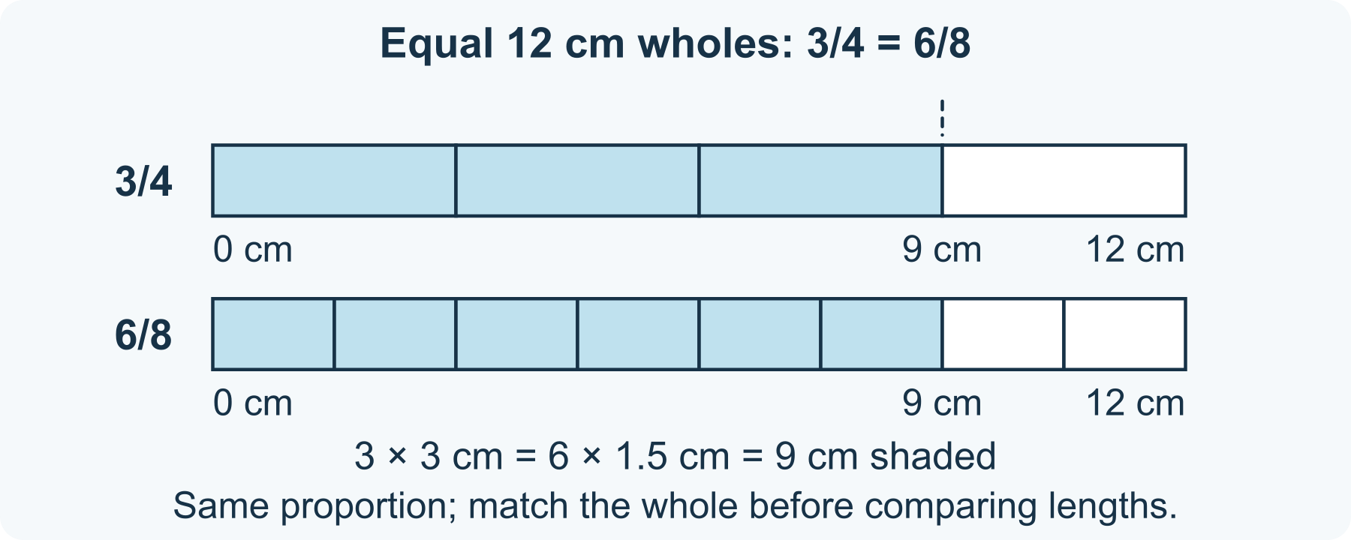
One 12 cm whole: 3/4 = 6/8
1 Choose one whole
Keep the whole lengths identical for this direct length comparison. The parts inside each strip must be equal to one another; quarters and eighths do not have the same part length.
2 Shade the same proportion
Shade three parts of A and six parts of B. A quarter of 12 cm is 3 cm, so three quarters cover 9 cm. An eighth is 1.5 cm, so six eighths also cover 9 cm.
3 Explain the equivalence
Write 3/4 = 6/8. Multiplying both numerator and denominator by 2 gives the same proportion. The numerator counts shaded parts; the denominator counts equal parts in one whole.
4 Check what the picture proves
Compare the shaded endpoints, or use the labels to explain their match. If a new whole were only 8 cm long, three quarters would cover 6 cm: still the fraction 3/4, but a different length.

42 A worked example | mathematics-fraction-models

Original strip model of equivalent fractions
The supplied strips are a constructed model. Both represent a whole length of 12 cm; they are not measurements from a real object.
• A: 12 ÷ 4 = 3 cm per quarter; 3 × 3 = 9 cm shaded.
• B: 12 ÷ 8 = 1.5 cm per eighth; 6 × 1.5 = 9 cm shaded.
• Both shade 9/12 of the same whole, which is 3/4 = 6/8.
What this example can show Equivalent fractions name the same proportion even when used with different-sized wholes. Equal shaded lengths are evidence only when the whole lengths are comparable; unequal parts would make these particular fraction labels unreliable.

A different way
Point to the supplied shaded endpoints, dictate a label or use a folded-paper sketch without measuring. A spoken explanation is enough.

If you want to go further
Use the same 12 cm whole to show 1/3 = 2/6. Calculate the shaded length as 4 cm in both cases, then explain why unequal whole lengths would change the amount.

Something to notice
Have I kept the proportion separate from the size of the whole?

Read or explore more
Horizon topic Fractions Equivalence
https://launchhorizonhq.com/learn/fractions-equivalence/
Horizon topic Ratios Proportion
https://launchhorizonhq.com/learn/ratios-proportion/
Horizon topic Area Perimeter
https://launchhorizonhq.com/learn/area-perimeter/
NRICH, University of Cambridge Fractional Wall
https://nrich.maths.org/problems/fractional-wall
The Open University, OpenLearn Teaching mathematics: The fraction wall
https://www.open.edu/openlearn/mod/oucontent/view.php?id=82589&section=1.1.1

43 Music | music-pattern-remix

Remix an eight cell rhythm
Can two rhythms have the same length and number of sounds but different patterns?
Read an original visual rhythm, move one sound and explain the change. Sound-making is entirely optional.
Make | 10-20 minutes, or one silent comparison | Paper and a pen or pencil, A finger for silent tracing; no instrument or audio app needed
Start here Draw eight equal boxes in a row. Each box represents half a beat, so all eight fill four beats. Write A as X . X . X X . .
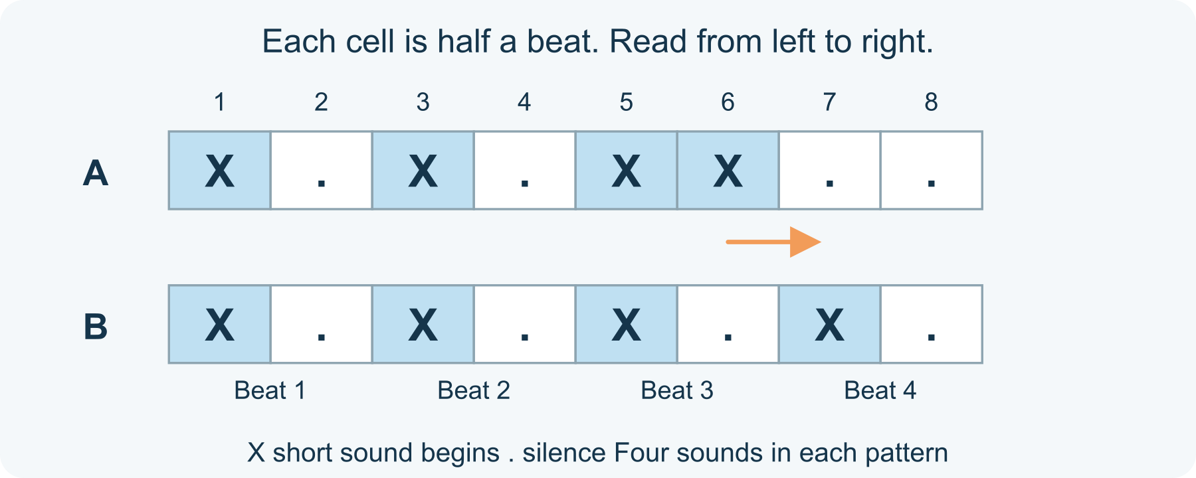
Four beats, four sounds, different timing
1 Set a clear legend
Read left to right. X means one short sound begins at the start of that half-beat cell; a dot means silence for that cell. There are no held notes in this little notation. You can simply point to each cell without making sound.
2 Read the first pattern
Number the cells 1 to 8. In A, sounds begin in cells 1, 3, 5 and 6. Count four sound beginnings across eight half-beat cells. The total duration is four beats.
3 Move one sound
Copy A as B, then move the X from cell 6 to cell 7. B is X . X . X . X . Keep the cell length and reading pace the same. Compare by tracing; gentle tapping is optional.
4 Explain what changed
Both patterns contain four sound beginnings and last four beats under this legend. The timing differs because one sound starts later. Keep, redraw or change the pattern; there is no performance test.

43 A worked example | music-pattern-remix

Original pattern comparison
These two short patterns were written for this activity. They do not reproduce a song or report a listener study. One cell is half a beat, and a dot is silence.
• A: X . X . X X . . - sound beginnings in cells 1, 3, 5 and 6.
• B: X . X . X . X . - sound beginnings in cells 1, 3, 5 and 7.
• Each has four sound beginnings and eight half-beat cells: four beats. Only the sound in cell 6 moved, to cell 7.
What this example can show Equal duration and equal sound count do not make the rhythms identical. No particular mood, listener preference or musical ability follows from this comparison.

A different way
Read the numbered cells silently, trace the example or dictate where an X should move. Keeping a steady performed beat is unnecessary.

If you want to go further
Write a new legend in which one larger box lasts a whole beat. Show how two half-beat cells fit inside it, without silently changing the original pattern's duration.

Something to notice
What stayed the same even though the rhythm changed?

Read or explore more
Horizon topic Music
https://launchhorizonhq.com/learn/music/
Horizon topic Rhythm Metre
https://launchhorizonhq.com/learn/rhythm-metre/
Horizon topic Musical Variation
https://launchhorizonhq.com/learn/musical-variation/
The Open University, OpenLearn Repetition, contrast and variation
https://www.open.edu/openlearn/mod/oucontent/view.php?id=139369&section=3.1
MIT OpenCourseWare Basic Musical Terms Definitions
https://ocw.mit.edu/courses/21m-011-introduction-to-western-music-fall-2024/pages/week-1-basic-musical-terms-definitions/

44 Music | music-graphic-score-key

Write a graphic score legend
What must a reader know before a symbol becomes a musical instruction?
Give three symbols exact time meanings, then check whether someone could follow your score without guessing. Listening or making a sound is optional.
Make | 15-25 minutes, or one comparison | Paper and a pen or pencil, The supplied model; no purchase, account or internet connection needed
Start here Copy the symbols ○, △ and ·. Give ○ one beat of sound, △ two beats of sound, and · one beat of silence.
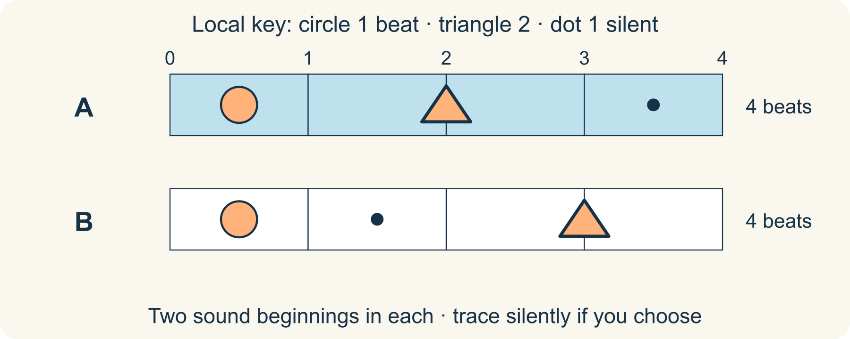
A local key gives exact timing
1 Write a complete key
Read left to right. A symbol begins when the previous one ends. Both sound symbols can use the same imagined quiet tone; pitch and loudness are not specified by their shapes.
2 Trace the supplied score
Read ○ △ ·. Mark boundaries at beats 0, 1, 3 and 4: circle from 0 to 1, triangle from 1 to 3, then silence from 3 to 4. No performance is needed.
3 Change one instruction
Try ○ · △ using the same key. It still lasts four beats, but the silence moves to 1-2 and the triangle now lasts 2-4. Explain the difference by pointing, drawing or writing.
4 Check what remains open
Choose one detail your key leaves free, such as the imagined sound. If exact agreement matters, add one instruction and check the score again.

44 A worked example | music-graphic-score-key

One key two four beat scores
This is an original local notation, not a standard musical convention.
• A: ○ △ · means sound for 1 beat, sound for 2 beats, then silence for 1 beat: 1 + 2 + 1 = 4. It has two sound beginnings.
• B: ○ · △ also totals 4 beats. Its silent beat falls earlier, so equal total duration does not mean identical timing.
• A reader can trace either score silently. The key does not claim that a triangle always has this meaning in other music.
What this example can show A precise timing key need not specify every sound quality. Our diagrams do not record an actual performance.

A different way
Use only a circle and a dot, or point through the supplied trace while someone writes the beat boundaries. Silent comparison is a complete activity.

If you want to go further
Add a symbol lasting half a beat. Write a new score totalling four beats and show the addition before claiming it fits.

Something to notice
Which information came from my key, and which detail did I leave for a reader to choose?

Read or explore more
Horizon topic Graphic Scores
https://launchhorizonhq.com/learn/graphic-scores/
Horizon topic Musical Form
https://launchhorizonhq.com/learn/musical-form/
Horizon topic Music
https://launchhorizonhq.com/learn/music/
The Open University, OpenLearn Week 1: Understanding the principles of musical scores
https://www.open.edu/openlearn/mod/oucontent/view.php?id=26857&printable=1&section=3
MIT OpenCourseWare Week 1: Basic Musical Terms Definitions
https://ocw.mit.edu/courses/21m-011-introduction-to-western-music-fall-2024/pages/week-1-basic-musical-terms-definitions/

45 Music | music-sound-design-brief

An imagined instrument on paper
Which design choices would need checking before claiming a particular sound?
Sketch a possible string instrument and label an aim, a prediction and the evidence still missing. The entire investigation stays on paper.
Explore | 15-25 minutes, or one comparison | Paper and a pen or pencil, The supplied sketch; no string, tool, instrument or sound needed
Start here Draw two imaginary strings: A has a 20 cm vibrating length and B a 40 cm vibrating length. Label them as the same kind and thickness of string, at the same tension, comparing the same vibration pattern.
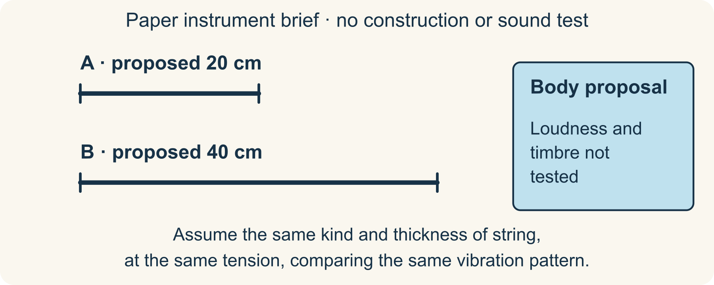
Length is one variable, not a sound recording
1 Label the proposal
Sketch the strings beside a possible resonating body. State an aim, such as making two contrasting pitches. The 20 cm and 40 cm are proposed dimensions, not a measuring or building instruction.
2 Make a conditional prediction
For a simple comparison, assume the same kind and thickness of string, at the same tension, comparing the same vibration pattern. With only vibrating length different, expect the longer string to give a lower pitch. Keep the phrase “if the other conditions stay the same”.
3 Separate three sound questions
Pitch concerns how high or low a sound seems. Loudness and timbre are different questions. A longer string or bigger drawn box does not by itself prove a louder or particular-coloured sound.
4 Write a checking plan
List what an actual controlled comparison would have to hold fixed: string kind, thickness, tension and vibration pattern. Plan to change only vibrating length and observe the resulting pitch. You can finish with this paper plan; do not build or tension strings for this activity.

45 A worked example | music-sound-design-brief

An instrument brief not an invented test result
Two proposed lengths differ by a factor of 2: 40 / 20 = 2. No instrument was constructed.
• Aim: two contrasting pitches. Assume uniform strings of the same kind and thickness, giving the same mass per centimetre, at the same tension and with the same vibration pattern. With only vibrating length different, B would have the lower pitch.
• A body might couple string vibration into surrounding air, but this drawing supplies no loudness measurement. “Twice as long” does not mean “twice as loud”.
• Next evidence needed: a controlled record of vibrating length, string kind and thickness, tension, vibration pattern and resulting sound. The exact pitch and timbre remain unknown.
What this example can show Real strings, bodies and playing methods interact. The sketch is not a guarantee that a proposed instrument will work.

A different way
Annotate the supplied drawing with “aim”, “prediction” and “not yet known”, or ask someone to scribe those labels. No sound or instrument is required.

If you want to go further
Propose changing one body feature while leaving the strings unchanged. Identify which new comparison would be needed before attributing a difference to that feature.

Something to notice
Have I described a design intention as though it were something I actually heard or tested?

Read or explore more
Horizon topic Instrument Design
https://launchhorizonhq.com/learn/instrument-design/
Horizon topic Instruments Acoustics
https://launchhorizonhq.com/learn/instruments-acoustics/
Horizon topic Musical Texture
https://launchhorizonhq.com/learn/musical-texture/
UNSW Sydney, Music Acoustics How does a guitar work?
https://newt.phys.unsw.edu.au/music/guitar/guitarintro.html
UNSW Sydney, Physclips Pitch, loudness and timbre
https://www.animations.physics.unsw.edu.au/jw/sound-pitch-loudness-timbre.htm

46 Philosophy | philosophy-claims-check

A claim a reason and a question
What would make an invented explanation stronger or weaker?
Use four invented machine records to separate a claim, its supporting reason and the question that could change it.
Investigate | 15-25 minutes, or one comparison | Paper and a pen or pencil, The supplied model; no purchase, account or internet connection needed
Start here Copy this fictional record: striped tile A went left; striped tile B went left; plain tile C went right. The machine is only a drawing.
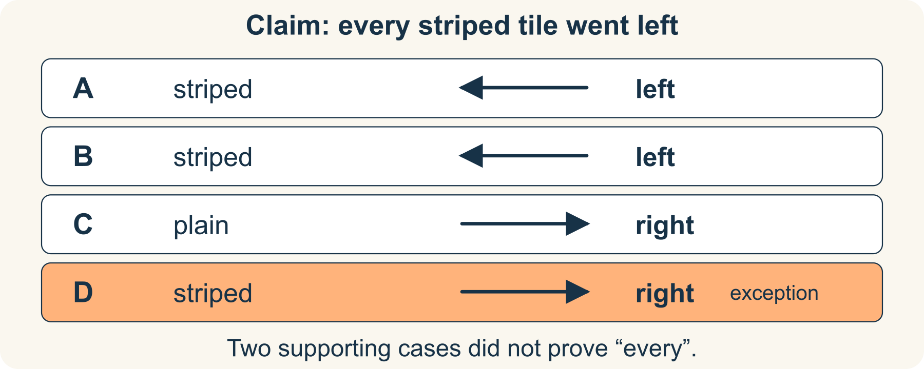
Four records, one over-wide claim
1 Name the claim
Write: “Every striped tile goes left.” Underline “every”. This claims more than the three listed records: it covers striped tiles not yet shown.
2 Give the reason accurately
A and B support the claim because both are striped and went left. C says something about a plain tile, so it does not settle what every striped tile does.
3 Use a new supplied record
Now add invented tile D: striped, went right. Check whether it belongs to the claim’s category and whether its result conflicts. D does both, so the “every” claim fails for this record set.
4 Revise and ask
A defensible replacement is: “A and B went left; D did not.” Ask what feature or rule might explain the different result. Do not invent an unseen mechanism as an established fact.

46 A worked example | philosophy-claims-check

A reason can support a claim without proving it
A, B, C and D are constructed examples, not observations from a real machine.
• Before D: A and B are positive cases, but checking two striped tiles does not establish an unrestricted “every” claim.
• After D: a striped tile went right. One genuine conflicting case defeats the claim as stated.
• Revised report: 2 of the 3 supplied striped tiles went left. That is a description of these records, not a prediction for all possible tiles.
What this example can show Changing a claim to fit records is different from discovering why the records occurred. The hidden rule remains unspecified.

A different way
Compare A and D only, or use two columns headed “claim” and “record”. Someone may read or scribe; no personal belief needs discussing.

If you want to go further
Construct a different rule that fits all four records. Explain why fitting them still does not prove it is the machine’s actual rule.

Something to notice
Did I change my confidence because of evidence, or quietly change what my claim meant?

Read or explore more
Horizon topic Knowledge Evidence
https://launchhorizonhq.com/learn/knowledge-evidence/
Horizon topic Arguments Logic
https://launchhorizonhq.com/learn/arguments-logic/
Horizon topic Philosophy
https://launchhorizonhq.com/learn/philosophy/
The Philosophy Foundation Knowledge
https://www.philosophy-foundation.org/enquiries/view/knowledge
Lancaster University 3.5 Counterexamples - MATH111: Numbers and Relations
https://www.lancaster.ac.uk/~prendivs/accessible/math111/doth3.S5.html

47 Philosophy | philosophy-counterexample-cards

Find a shape that breaks a rule
What can one clear counterexample show about an ‘all’ claim?
Check an “all” claim with three constructed shape cards, then write exactly what one exception establishes.
Investigate | 15-25 minutes, or one comparison | Paper and a pen or pencil, The supplied model; no purchase, account or internet connection needed
Start here Draw A as a rectangle, B as a square and C as a slanted parallelogram. Keep all three closed and four-sided.
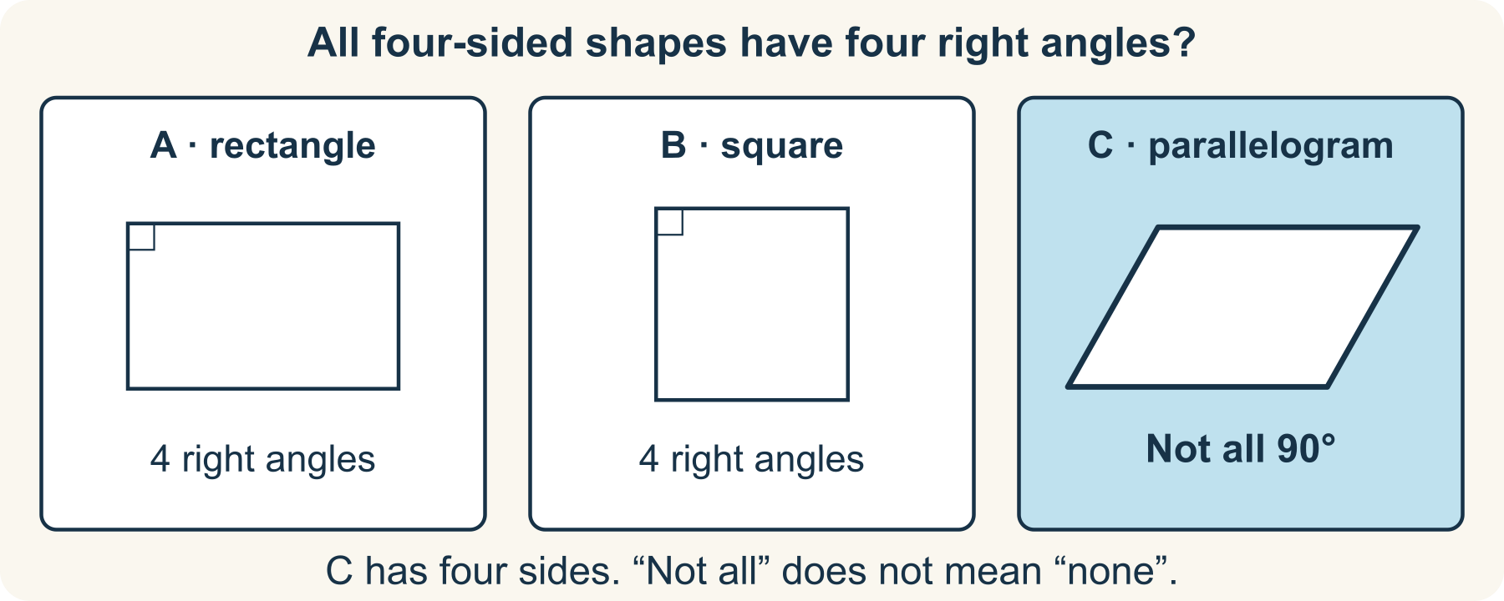
A four-sided exception
1 State the rule to test
Use this claim: “All four-sided shapes have four right angles.” A right angle is 90°. The claim concerns every quadrilateral, not just rectangles.
2 Sort support and contradiction
A and B fit the claim. C has two pairs of parallel sides but slanted corners, so not all of its angles are right angles. It still has four sides, so it is a relevant counterexample.
3 Repair the scope
A true narrower statement is: “Rectangles have four right angles.” Squares are rectangles with equal sides. The change is to the named category, not to the shape C.
4 Say what has not followed
C does not show that no quadrilateral has right angles: A and B already do. Keep “not all” separate from “none”.

47 A worked example | philosophy-counterexample-cards

One exception is enough for an all claim
These three original drawings are examples chosen to test the stated rule.
• A rectangle and B square both have four right angles. Two fitting examples cannot establish the universal claim.
• C is a parallelogram with oblique, not right, corners. It is four-sided, so it falls inside the claim but fails its stated property.
• Conclusion: not every quadrilateral has four right angles. This says nothing about how common each shape is.
What this example can show A sketch must show the intended properties clearly. A triangle would be irrelevant here because it has only three sides.

A different way
Use only A and C, or trace the four sides while someone labels the corners. Pointing to a relevant exception is enough.

If you want to go further
Test “All rectangles are squares.” Construct a rectangle with unequal adjacent sides and state why the reverse category relationship does not hold.

Something to notice
Have I shown both that my example belongs to the category and that the claimed property fails?

Read or explore more
Horizon topic Categories Counterexamples
https://launchhorizonhq.com/learn/categories-counterexamples/
Horizon topic Concepts Definitions
https://launchhorizonhq.com/learn/concepts-definitions/
Horizon topic Philosophy
https://launchhorizonhq.com/learn/philosophy/
Lancaster University 3.5 Counterexamples - MATH111: Numbers and Relations
https://www.lancaster.ac.uk/~prendivs/accessible/math111/doth3.S5.html
NRICH, University of Cambridge Completing Quadrilaterals
https://nrich.maths.org/problems/completing-quadrilaterals

48 Philosophy | philosophy-definition-game

A definition that needs revising
When does an invented category become too broad or too narrow?
Invent a precise category for five supplied shape cards, including a boundary case. Your definition must tell another reader what to do.
Make | 15-25 minutes, or one comparison | Paper and a pen or pencil, The supplied model; no purchase, account or internet connection needed
Start here Call the target category “one-dot quad”. Card A is an irregular quadrilateral with one dot inside; B is a square with one dot inside. These are your intended examples.
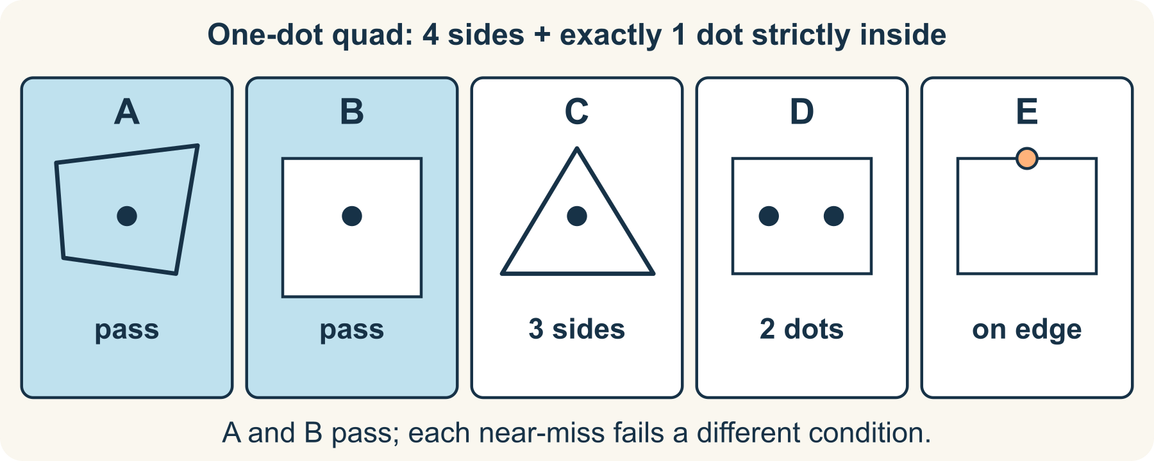
Which condition does each card fail?
1 Add three near-misses
C is a triangle with one inside dot. D is a rectangle with two inside dots. E is a rectangle with one dot centred on its top edge. These are deliberately different cases.
2 Test a broad definition
“A shape with a dot” wrongly includes C, D and E. It does not state side count, exact dot count or whether an edge counts as inside.
3 Test a narrow definition
“A square with one inside dot” keeps B but wrongly excludes intended example A. A definition can exclude something you meant to include as well as include too much.
4 Write the working definition
For this game use: “A closed four-sided shape with exactly one dot strictly inside.” Apply it again: A and B pass; C, D and E do not. “Strictly inside” excludes the boundary.

48 A worked example | philosophy-definition-game

A definition is a usable membership rule
All five cards and the category name are invented for this activity.
• A and B are intended members even though their side lengths and angles differ.
• The final rule requires four sides, exactly one dot and an interior position. Each requirement removes a different near-miss.
• C fails side count; D fails exact dot count; E fails the strictly-inside condition.
What this example can show This is a locally invented category, not a new official geometry term. Agreeing a rule is different from proving that a word has always meant it.

A different way
Compare only A, B and C first. Cards may be described aloud, enlarged or marked by a scribe; drawing neatness is irrelevant.

If you want to go further
Add a four-sided outline with a curved side and decide whether your use of “side” needs clarification. State any revised convention before sorting it.

Something to notice
Which single word in my definition changed a card’s membership?

Read or explore more
Horizon topic Concepts Definitions
https://launchhorizonhq.com/learn/concepts-definitions/
Horizon topic Questions Assumptions
https://launchhorizonhq.com/learn/questions-assumptions/
Horizon topic Analogy Comparison
https://launchhorizonhq.com/learn/analogy-comparison/
NRICH, University of Cambridge Completing Quadrilaterals
https://nrich.maths.org/problems/completing-quadrilaterals
NRICH, University of Cambridge Guess My Quad
https://nrich.maths.org/problems/guess-my-quad

49 Physics | physics-friction-record

Read an invented friction comparison
Which variables need controlling before a surface comparison is useful?
Read a completely invented steady-pull table, calculate its averages and identify what a real comparison would need to hold consistent.
Investigate | 15-25 minutes, or one table row | Paper and a pencil or pen, The supplied fictional force table; no pulling test or equipment required
Start here Copy this invented record in newtons (N): surface A, 2, 2, 2; surface B, 4, 4, 4. The model uses the same sliding block at steady speed on a level surface.
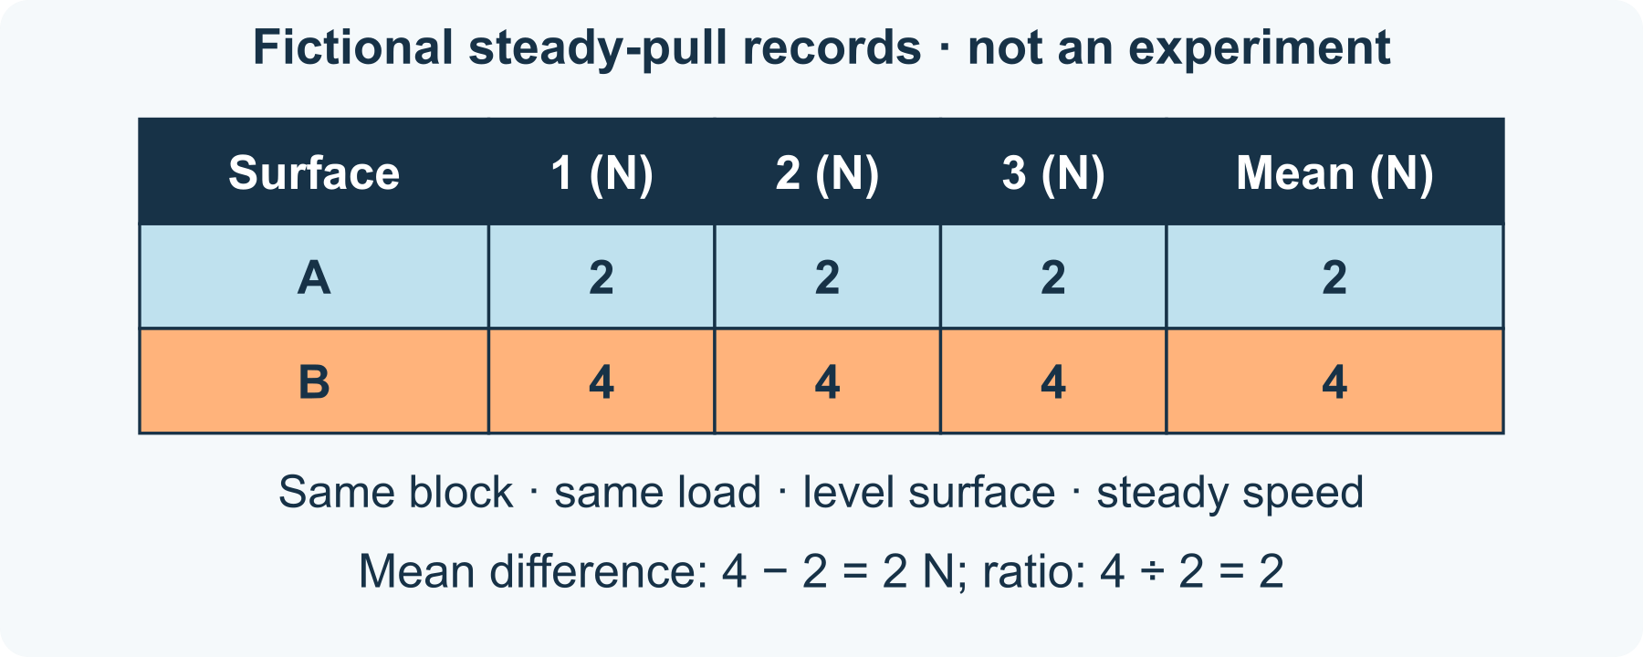
Invented steady-pull table
1 State the model conditions
Assume the same block, contact face, added load, level track and steady speed for both surface labels. Each entry represents the horizontal pull needed to balance sliding friction in this simplified model.
2 Read and calculate
There are three fictional entries per surface. A averages (2 + 2 + 2) ÷ 3 = 2 N. B averages (4 + 4 + 4) ÷ 3 = 4 N. Keep the unit beside each result.
3 Make a bounded comparison
In this table, B needs 2 N more pull and twice A’s average pull. These labels do not identify real materials. The table does not establish that a rough-looking surface always has a larger friction force.
4 Identify missing evidence
Name one condition that would need checking in a real investigation, such as a consistent load or speed. Do not turn invented entries into actual observations. You can finish by annotating the supplied table.

49 A worked example | physics-friction-record

Fictional steady pull records
All six numbers were invented to practise reading a controlled comparison. Horizon did not perform a friction experiment.
• Surface A: 2, 2, 2 N; mean = 2 N. Surface B: 4, 4, 4 N; mean = 4 N.
• Difference of the means: 4 − 2 = 2 N. Ratio: 4 ÷ 2 = 2.
• At the assumed steady speed, the forward pull and backward sliding-friction force balance. Equal opposite forces do not mean the block is stationary.
What this example can show This model does not measure a coefficient of friction, test named materials or establish measurement precision. Real records can vary; constant invented numbers are not evidence of perfect measurement.

A different way
Read one row aloud, point to the larger mean or have someone scribe your explanation. Use only the invented records; no practical test is needed.

If you want to go further
Try another explicitly invented table: A: 1, 3, 2 N and B: 3, 5, 4 N. Both means remain 2 and 4 N, but each set now has a range of 2 N. Explain how a mean can hide variation.

Something to notice
Am I describing what the invented records say, or claiming an experiment happened?

Read or explore more
Horizon topic Friction Surfaces
https://launchhorizonhq.com/learn/friction-surfaces/
Horizon topic Forces Motion
https://launchhorizonhq.com/learn/forces-motion/
Horizon topic Physics
https://launchhorizonhq.com/learn/physics/
Institute of Physics, IOPSpark Friction
https://spark.iop.org/friction
National Institute of Standards and Technology SI Units
https://www.nist.gov/pml/owm/metric-si/si-units

50 Physics | physics-light-model

Explain a drawn shadow
How can a ray diagram show what a shadow model assumes?
Use a complete point-source drawing to locate a shadow region and explain what an ideal ray model leaves out.
Explore | 15-25 minutes, or two rays | Paper and a pencil or pen, The supplied coordinate model; no lamp, laser, sunlight viewing or experiment needed
Start here Use a drawn point source at (0, 0), an opaque vertical block at x = 2 from y = −1 to 1, and a parallel screen at x = 6. All coordinates use the same arbitrary unit.
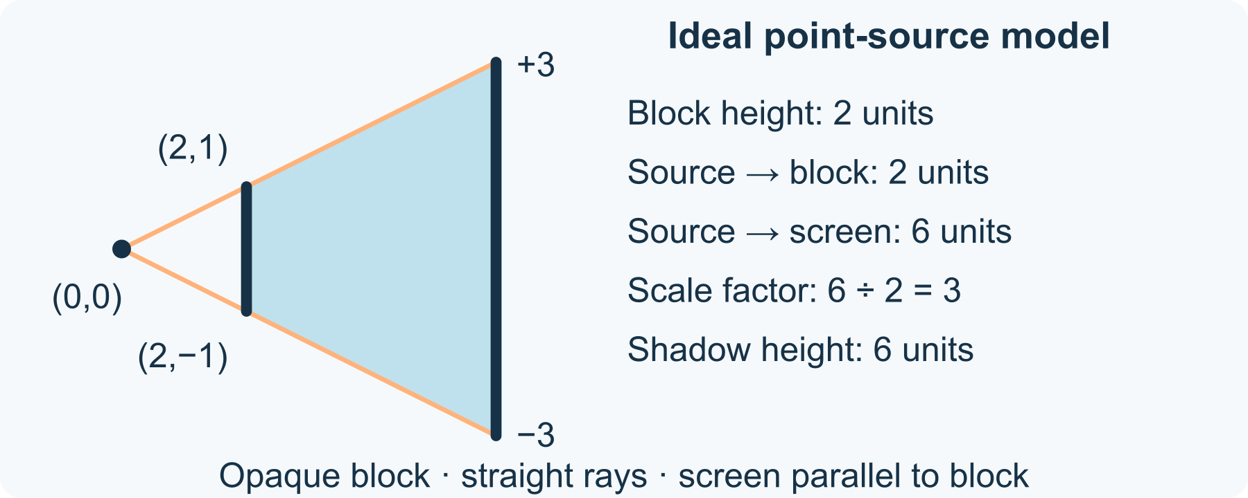
Point-source shadow: an ideal drawing
1 Draw the boundary rays
Join the source to the block’s top (2, 1) and bottom (2,−1). Continue each straight line to the screen. These construction lines just skim the edges; they do not pass through the block.
2 Find the shadow limits
The screen is three times as far from the source as the block: 6 ÷ 2 = 3. The upper boundary reaches y = 3 and the lower y = −3, so the ideal shadow height is 6 units.
3 Label the assumptions
State point source, opaque block, straight rays in one uniform medium, parallel screen and no other illumination. Mark the region between the boundaries on the screen as missing direct light.
4 Explain one limit
A large real light source, surrounding reflected light or different geometry can give a different or blurred boundary. Keep this a paper model; it is not a photograph or a test of an actual lamp.

50 A worked example | physics-light-model

Constructed ray model a threefold scale factor
The coordinates and diagram are original ideal geometry, not experimental observations. Source-to-block distance is 2 units; source-to-screen distance is 6.
• Upper boundary: y/x = 1/2, so at x = 6, y = 3. Lower boundary: y/x = −1/2, so y = −3.
• The block’s height is 1 − (−1) = 2 units. The screen’s ideal shadow height is 3 − (−3) = 6 units.
• The height ratio is 6 ÷ 2 = 3. The shadow is a region with direct light blocked, not a second object travelling from the block.
What this example can show A point source is an idealisation. This two-dimensional construction does not include an extended source, scattering, diffraction or ambient reflected light.

A different way
Trace the supplied rays with a finger, have the coordinates read aloud or discuss only the blocked region. Accurate ruler work is optional.

If you want to go further
Keep the source and block fixed but draw the screen at x = 4. The same model gives boundaries y = ±2 and a 4-unit shadow height. Compare the new ratio with the original without performing a light test.

Something to notice
Which features belong to this ideal drawing rather than every real shadow?

Read or explore more
Horizon topic Light Optics
https://launchhorizonhq.com/learn/light-optics/
Horizon topic Refraction Lenses
https://launchhorizonhq.com/learn/refraction-lenses/
Horizon topic Physics
https://launchhorizonhq.com/learn/physics/
Science Learning Hub, University of Waikato Light basics
https://www.sciencelearn.org.nz/resources/171-light-basics
Science Learning Hub, University of Waikato Light and shadows
https://www.sciencelearn.org.nz/resources/2771-light-and-shadows

51 Physics | physics-energy-chain

An energy transfer explanation
Which transfers belong in a clear model of an invented machine?
Complete a fictional machine’s energy ledger, distinguish transfers from stores and account for every stated joule without building anything.
Investigate | 15-25 minutes, or one balance | Paper and a pencil or pen, The supplied invented energy account; no battery, circuit or moving device needed
Start here Draw a fictional battery-driven wheel and its surroundings as one model boundary. The battery’s chemical store begins at 140 J and ends at 40 J during one stated interval.
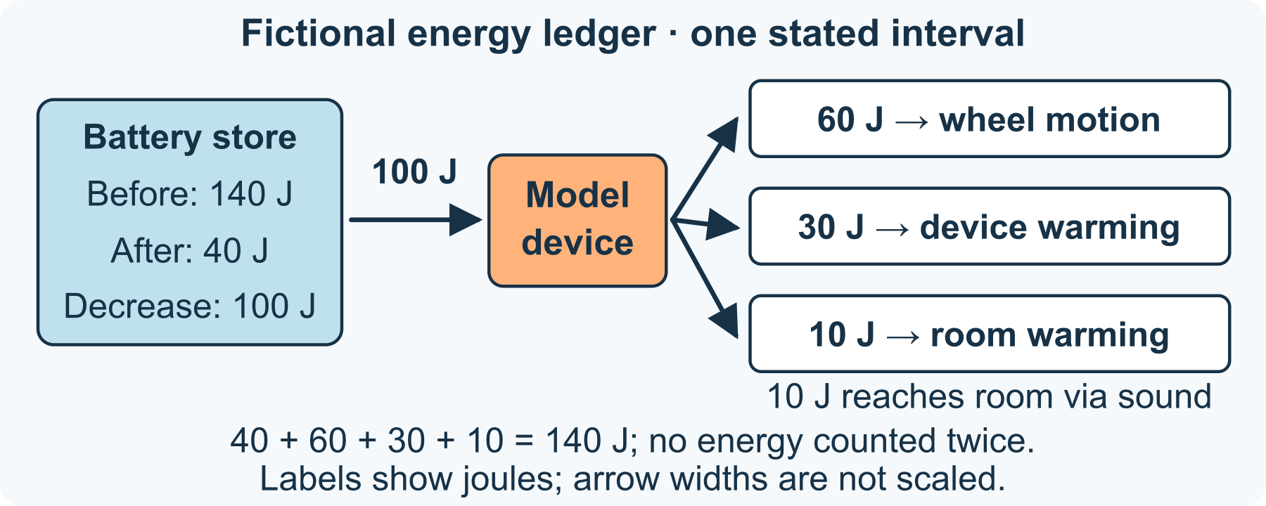
Fictional ledger: every joule accounted for
1 Account for the decrease
Calculate 140 − 40 = 100 J transferred from the battery during that interval. J means joules, a unit of energy; these are invented values, not instrument readings.
2 Allocate the stated transfers
The model assigns 60 J to an increase in the wheel’s kinetic store, 30 J to increased thermal stores of the device, and 10 J transferred by sound then absorbed into the room’s thermal store.
3 Check both balances
The assigned transfers total 60 + 30 + 10 = 100 J. Including the 40 J left in the battery gives 40 + 60 + 30 + 10 = 140 J. Do not add the sound transfer again as another permanent store.
4 Name what the model cannot show
Explain which quantities were supplied rather than measured. The ledger balances, but does not establish the machine’s design, speed, temperature or performance. Choose a label or diagram change that would make the account clearer.

51 A worked example | physics-energy-chain

Fictional machine keep all 140 J accounted for
This is an invented energy ledger over one interval. It is not a measured machine, construction plan or claim about a real battery.
• Before: 140 J in the battery’s chemical store. After: 40 J remains there, 60 J is in wheel motion, 30 J increases device thermal stores, and 10 J ends in the room’s thermal store after sound is absorbed.
• Battery decrease = 100 J; stated destinations = 60 + 30 + 10 = 100 J. The complete before/after total is 140 J.
• Sound is a transfer process here, not a separate store to count twice. Energy in the surroundings remains part of the account even when it is less useful for turning the wheel.
What this example can show Numerical balance is necessary for this account, but is not evidence that a machine with these values exists. Arrow labels carry the numbers; their widths in this simple diagram are not a scaled Sankey chart.

A different way
Use four labelled boxes, point to each amount or dictate the sums. A spoken account is enough; no building, noise-making or electricity is needed.

If you want to go further
Create a new explicitly fictional balanced account with the same 140 J start and 40 J battery remainder: 70 J to wheel motion, 20 J to device warming and 10 J via sound to the room. State which numbers changed and check the totals again.

Something to notice
Have I followed the stated energy to its destination without counting a transfer twice?

Read or explore more
Horizon topic Energy Power
https://launchhorizonhq.com/learn/energy-power/
Horizon topic Waves Sound
https://launchhorizonhq.com/learn/waves-sound/
Horizon topic Models Explanations
https://launchhorizonhq.com/learn/models-explanations/
Institute of Physics, IOPSpark The law of conservation of energy
https://spark.iop.org/law-conservation-energy
Institute of Physics, IOPSpark The Sankey diagram
https://spark.iop.org/sankey-diagram

52 Sport & Movement | sport-inclusive-game-plan

Design a game with more than one way to join
Which rule changes create a real participation choice?
Design a paper game in which the objective stays clear while the way someone communicates a move can change. No physical game or group is required.
Make | 15-25 minutes, or one comparison | Paper and a pen or pencil, or the supplied route, No sport equipment, partner, timer or physical performance needed
Start here Draw a route of boxes S → A → B → F. The paper-game objective is to visit A then B before finishing at F.
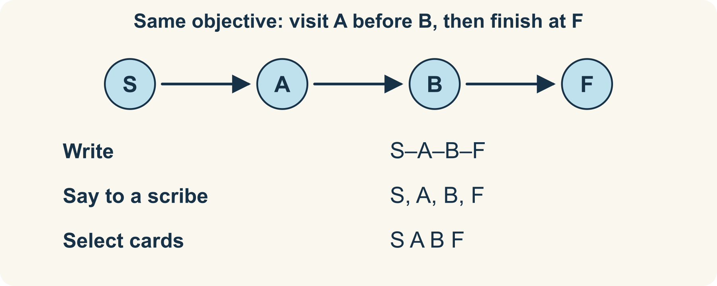
One objective, more than one reporting route
1 Spot the unnecessary restriction
An invented first rule says “Only written letter sequences count.” It ties a planning task to one way of reporting it. Identify that restriction without guessing anyone’s abilities.
2 Offer equivalent choices
A revised rule accepts writing S-A-B-F, saying the letters to a scribe, or selecting the ready-made letter cards in order. Every mode must communicate the same complete route.
3 Check the objective stays fixed
Trace each offered version. All three must visit A before B and finish at F. Changing the communication method does not quietly remove a required stop for only one mode.
4 Ask about a remaining barrier
Could the letters, directions or recording arrangement still be unclear? Propose one practical change, such as larger cards or read-aloud labels. A proposed option is not proof it suits everyone.

52 A worked example | sport-inclusive-game-plan

Three ways to report the same planned route
This is an invented desk-game plan, not a report of a participant trial.
• Written: S-A-B-F. Spoken to a chosen scribe: “S, A, B, F.” Selected cards: S then A then B then F.
• Each communicates the same four positions. The objective, available route and order stay unchanged.
• A learner may inspect the worked route without playing. Independent use does not require a team, timer, movement task or performance score.
What this example can show Real access preferences need to be asked about, not diagnosed from this model. The plan is not universal accessibility certification.

A different way
Use the supplied route and identify one equivalent pair of communication options. Observing, reading or having the choices described is complete participation.

If you want to go further
Add a branch S-A-C-B-F and supply a second valid route. Check that every communication mode can express the extra choice.

Something to notice
Did I create a genuine choice, or give one option less information or a different objective?

Read or explore more
Horizon topic Inclusive Sport
https://launchhorizonhq.com/learn/inclusive-sport/
Horizon topic Equipment Design
https://launchhorizonhq.com/learn/equipment-design/
Horizon topic Sport Movement
https://launchhorizonhq.com/learn/sport-movement/
Australian Sports Commission Using TREE
https://www.ausport.gov.au/schools/resource-hub/sports-ability/using-tree
Australian Sports Commission Game sense approach
https://www.ausport.gov.au/schools/resource-hub/p4l/game-sense-approach

53 Sport & Movement | sport-sequence-map

Explain a movement sequence on paper
What order and timing information would a diagram need?
Represent order and timing with a paper token, then find which information a sequence diagram must supply.
Explore | 15-25 minutes, or one comparison | Paper and pen, or three labelled cards, No sport equipment, timing device or physical movement needed
Start here Mark A (0, 0), B (2, 0) and C (2, 2) on paper. These are invented board positions in grid units, not places you need to move to.
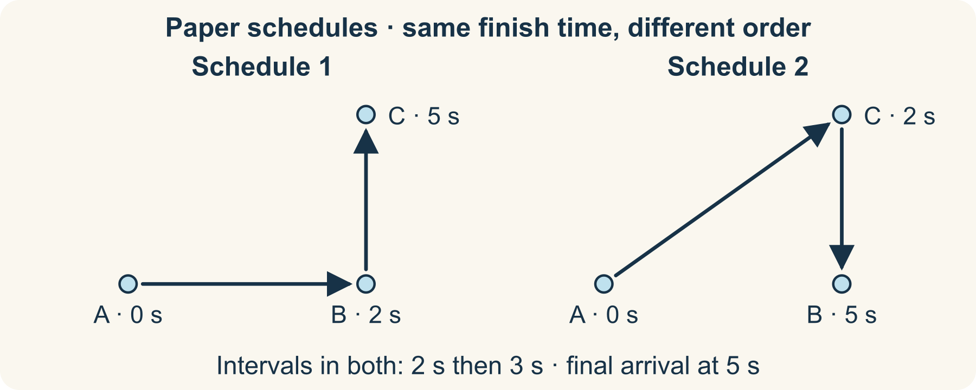
Same clock times, different positions
1 Read schedule 1
At time 0 the token is at A. It reaches B at 2 seconds and C at 5 seconds. Draw arrows A→B→C and label each arrival time.
2 Find the intervals
The first interval is 2−0 = 2 seconds; the second is 5−2 = 3 seconds. Arrival time 5 is not a five-second second interval.
3 Compare another order
Schedule 2 reaches C at 2 seconds and B at 5 seconds: A→C→B. Total time is still 5 seconds, but the intermediate position and final position differ.
4 Complete the instructions
Label the start, order, positions, time unit and what each time means. A dot at an arrival time does not tell you the exact movement or speed between dots.

53 A worked example | sport-sequence-map

Equal total time different sequence
Both schedules are fictional paper records, not exercise targets or measured performance.
• Schedule 1: A at 0 s, B at 2 s, C at 5 s. Its intervals are 2 s then 3 s.
• Schedule 2: A at 0 s, C at 2 s, B at 5 s. Its intervals are also 2 s then 3 s.
• The shared 5-second finish time does not make the sequences identical. Without more detail, several paths or timing patterns between the points could fit.
What this example can show A paper schedule demonstrates how information is represented. It does not show whether a real person could or should perform a movement in that time.

A different way
Use three large A/B/C cards and arrange the supplied orders, or describe the difference without moving a token. There is no need to time yourself.

If you want to go further
Create a third schedule with the same 5-second finish but different arrival times. Explain what changed and what still cannot be inferred.

Something to notice
Have I confused a time on the clock with the duration between two events?

Read or explore more
Horizon topic Movement Sequences
https://launchhorizonhq.com/learn/movement-sequences/
Horizon topic Timing Pacing
https://launchhorizonhq.com/learn/timing-pacing/
Horizon topic Practice Skills
https://launchhorizonhq.com/learn/practice-skills/
CS Unplugged, University of Canterbury Kidbots
https://www.csunplugged.org/en/at-home/kidbots/
NRICH, University of Cambridge Olympic Records
https://nrich.maths.org/problems/olympic-records

54 Sport & Movement | sport-scoring-model

What does a scoring rule reward
How can the same fictional play produce different results under two scoring systems?
Apply two transparent scoring rules to the same invented action record, then ask what each rule rewards.
Investigate | 15-25 minutes, or one comparison | Paper and pen, or drawn counters, The supplied fictional record; no game equipment or physical play needed
Start here Copy two fictional four-hit records: Route A has 3 near hits and 1 far hit; Route B has 1 near hit and 3 far hits. Treat them as paper data, not real play.
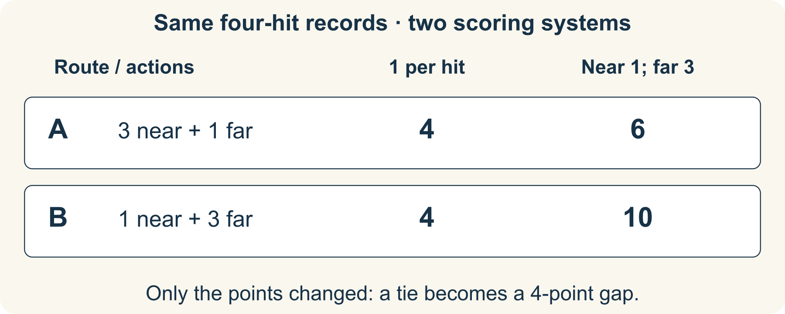
Same actions, different point mapping
1 Score every hit equally
System 1 gives 1 point for any hit. A scores 3 + 1 = 4; B scores 1 + 3 = 4. Neither is ahead under this rule.
2 Weight one category
System 2 gives 1 point per near hit and 3 per far hit. A scores 3 × 1 + 1 × 3 = 6. B scores 1 × 1 + 3 × 3 = 10.
3 Explain the changed result
The actions did not change; the point mapping did. System 2 rewards far hits more strongly. State the rule beside the totals rather than presenting a score without its meaning.
4 Check a limit
The record has no misses, attempt difficulty or timing information. It cannot tell you which real strategy is best, whose skill is greater or whether a rule would feel fair to actual players.

54 A worked example | sport-scoring-model

Same actions a tie or a four point gap
Both route records and scoring systems are original fictional examples.
• Equal-hit scoring: A = 4 and B = 4.
• Weighted scoring: A = 6 and B = 10, so B is ahead by 10−6 = 4 points.
• The totals answer different rule-defined questions. If far hits were difficult, that would need separate evidence; it is not supplied by these totals.
What this example can show A score is a defined summary, not a complete description of play or a judgement of a person.

A different way
Use only one route and compare its two totals, or move paper counters into near/far columns. All results are already supplied; no competition is necessary.

If you want to go further
Choose a new far-hit weight of 2. Recalculate A = 5 and B = 7, then explain how the score gap changed without changing the actions.

Something to notice
Am I talking about the recorded actions, the scoring rule, or an unsupported judgement about a player?

Read or explore more
Horizon topic Sport Scoring
https://launchhorizonhq.com/learn/sport-scoring/
Horizon topic Teamwork Fair Play
https://launchhorizonhq.com/learn/teamwork-fair-play/
Horizon topic Sport Movement
https://launchhorizonhq.com/learn/sport-movement/
NRICH, University of Cambridge Dominoes
https://nrich.maths.org/games/dominoes
Australian Sports Commission Game sense approach
https://www.ausport.gov.au/schools/resource-hub/p4l/game-sense-approach

55 Storytelling | storytelling-three-openings

Three openings for one invented story
What does each beginning invite a reader to wonder about?
Write three different entry points to the same harmless invented event, then compare what each lets a reader know first.
Make | 15-25 minutes, or one comparison | Paper and a pen or pencil, The supplied model; no purchase, account or internet connection needed
Start here Keep these shared facts: Tavi finds a folded paper bird on an empty market table. Its wing carries a blue square. Tavi decides to ask at the map stall.
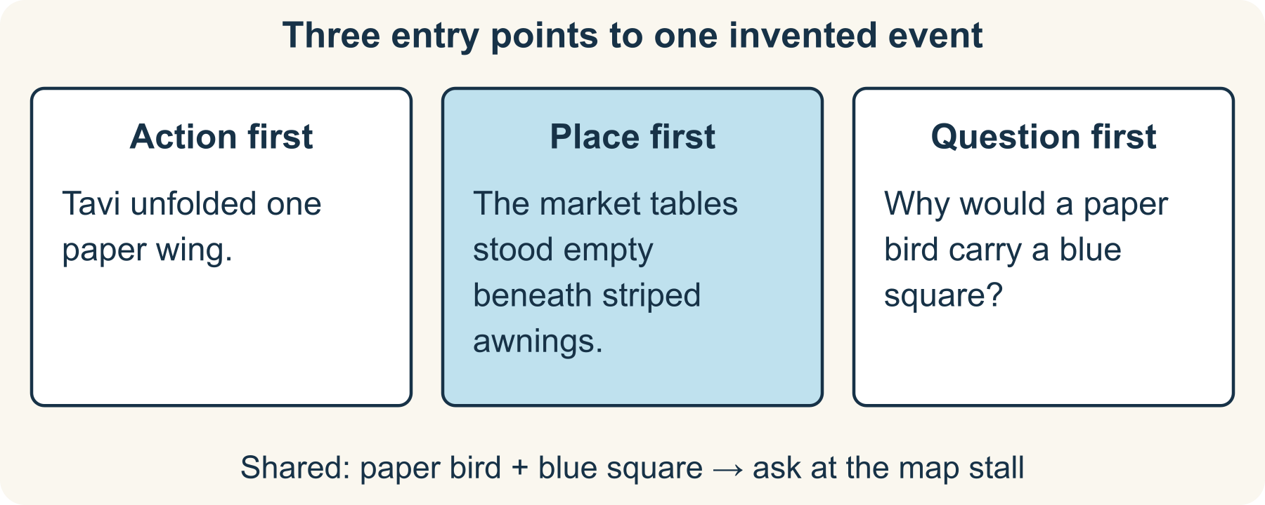
Three entry points, shared facts
1 Read the three models
The example below begins with an action, a place or a question. Each keeps the shared facts; none is the one required opening.
2 Compare the first information
Underline what a reader learns first in each version. Name the question that opening leaves in play: the object’s meaning, its arrival or where Tavi will go.
3 Draft a different opening
Write two or three sentences, draw three frames or dictate a version. Change the entry point without adding a contradiction to the fixed facts.
4 Connect a next line
Add one sentence that could follow your opening. Check that its detail grows from what you have introduced rather than explaining an unrelated event.

55 A worked example | storytelling-three-openings

Three original beginnings one event
These snippets are new Horizon fiction, not a retelling of an existing story.
• Action: “Tavi unfolded one paper wing. A blue square appeared in the crease. The map stall was still open; perhaps someone there could explain it.”
• Place: “The market tables stood empty beneath striped awnings. On the nearest table rested a paper bird with a blue square on its wing. Tavi looked towards the map stall.”
• Question: “Why would a paper bird carry a blue square? Tavi found no other mark on the folded wings. The next place to ask was the map stall.”
What this example can show These are possible stylistic choices, not tested claims about what every reader finds most engaging. The story can stay unfinished.

A different way
Choose between the three supplied openings and explain one difference, or arrange ready-written sentences. Original writing is optional.

If you want to go further
Write a closing line that answers your opening’s main question without inventing an unrelated surprise. Compare two possible endings.

Something to notice
What did my opening invite the reader to wonder about, and did my next line follow that invitation?

Read or explore more
Horizon topic Openings Endings
https://launchhorizonhq.com/learn/openings-endings/
Horizon topic Setting Place
https://launchhorizonhq.com/learn/setting-place/
Horizon topic Storytelling
https://launchhorizonhq.com/learn/storytelling/
NSW Education Standards Authority narrative - glossary
https://curriculum.nsw.edu.au/resources/glossary/narrative
NSW Education Standards Authority voice - glossary
https://curriculum.nsw.edu.au/resources/glossary/voice

56 Storytelling | storytelling-two-viewpoints

The same small event from two viewpoints
Which details change when an invented narrator changes?
Give two invented narrators different access to one small event. Separate what they can observe from what they merely suppose.
Make | 15-25 minutes, or one comparison | Paper and a pen or pencil, The supplied model; no purchase, account or internet connection needed
Start here Use this fixed event: Renn puts folded blue paper under a book on a table. A bell rings. Lio saw the placement from a window; Kai notices only the corner after the bell.
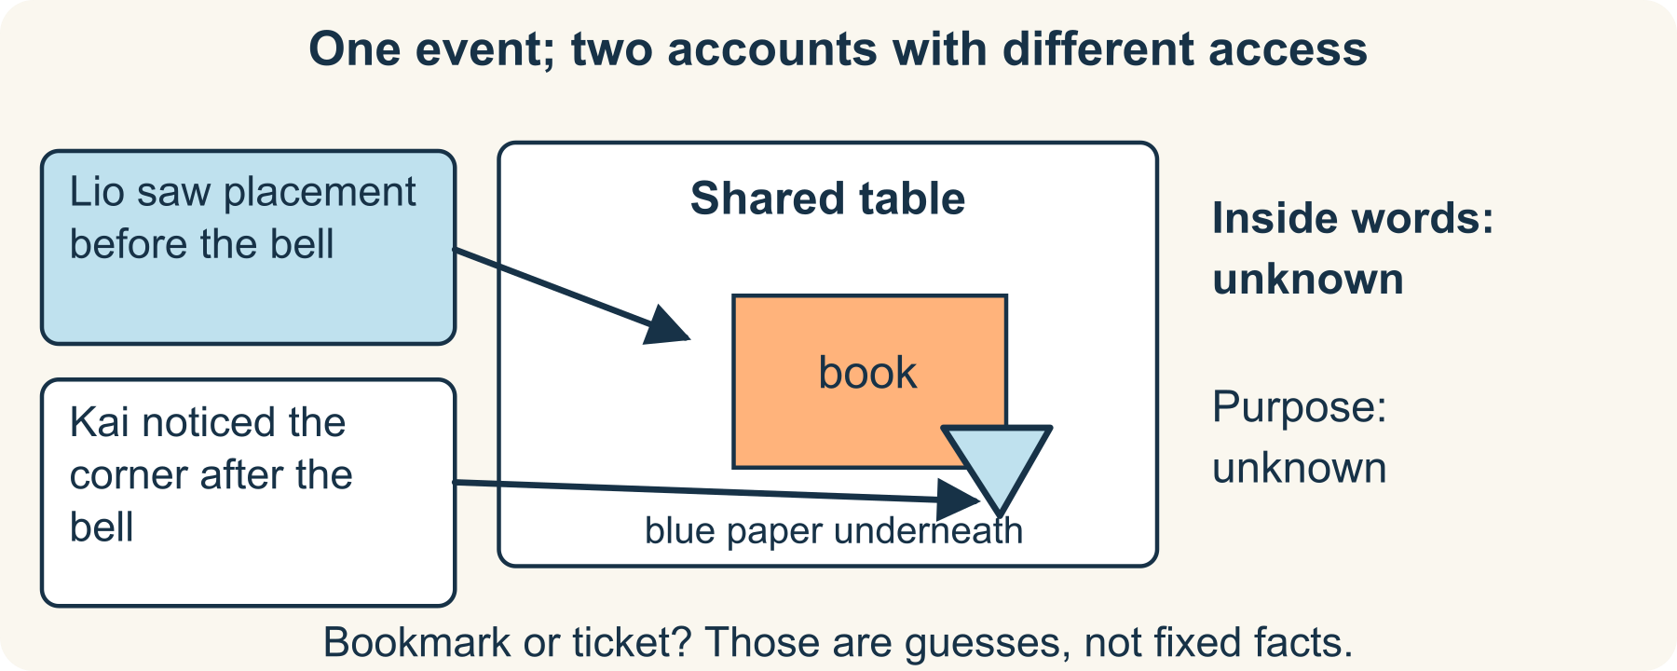
Same event, different access
1 Track who could know what
Lio saw the paper arrive but cannot read inside it. Kai did not see its arrival. Both can notice the blue corner; neither has been told Renn’s purpose.
2 Read the two voices
Compare the supplied first-person versions. “Perhaps a bookmark” and “looked like a ticket” are guesses, not new facts the writer has established.
3 Write within one viewpoint
Add a sentence for Lio or Kai that preserves the fixed event and that narrator’s access. You may describe visible detail or a labelled guess; do not silently give them hidden knowledge.
4 Check the reader’s picture
Mark observation and inference differently. If you switch narrators, signal the change so a reader can follow whose knowledge is available.

56 A worked example | storytelling-two-viewpoints

Two tellings without changing the event
Renn, Lio and Kai are fictional; no real scene or private note is being described.
• Lio: “From the window I saw Renn slide folded blue paper under the book. Then the bell rang. I could not read the paper. Perhaps it was a bookmark.”
• Kai: “The bell rang before I noticed a blue corner under the book. From my seat I had not seen it arrive. It looked like a ticket, but I could not be sure.”
• Kai noticed later; this does not mean the paper arrived later. A change in telling need not be a change in the event itself.
What this example can show First person does not make an inference true, and third person does not automatically mean a narrator knows everything. Choose and maintain the access you establish.

A different way
Compare the two supplied accounts using “saw” and “guessed” labels, or draw the table and viewing positions. You need not write about yourself.

If you want to go further
Write a clearly signalled third-person limited version that stays with Kai’s knowledge. Check that changing pronouns has not added hidden facts.

Something to notice
Did I change the viewpoint, or accidentally change what happened?

Read or explore more
Horizon topic Viewpoint Voice
https://launchhorizonhq.com/learn/viewpoint-voice/
Horizon topic Description Detail
https://launchhorizonhq.com/learn/description-detail/
Horizon topic Character Motivation
https://launchhorizonhq.com/learn/character-motivation/
NSW Education Standards Authority voice - glossary
https://curriculum.nsw.edu.au/resources/glossary/voice
NSW Education Standards Authority narrative - glossary
https://curriculum.nsw.edu.au/resources/glossary/narrative

57 Storytelling | storytelling-world-rule

One world rule three consequences
How does an invented rule create connected story possibilities?
Give an invented place one clear rule, then derive consequences that follow from it without adding unexplained powers.
Explore | 15-25 minutes, or one comparison | Paper and a pen or pencil, The supplied model; no purchase, account or internet connection needed
Start here In invented Dotfall, every arrow drawn on paper turns 90° clockwise whenever the town bell rings. Other marks stay still. Begin with an arrow pointing north.
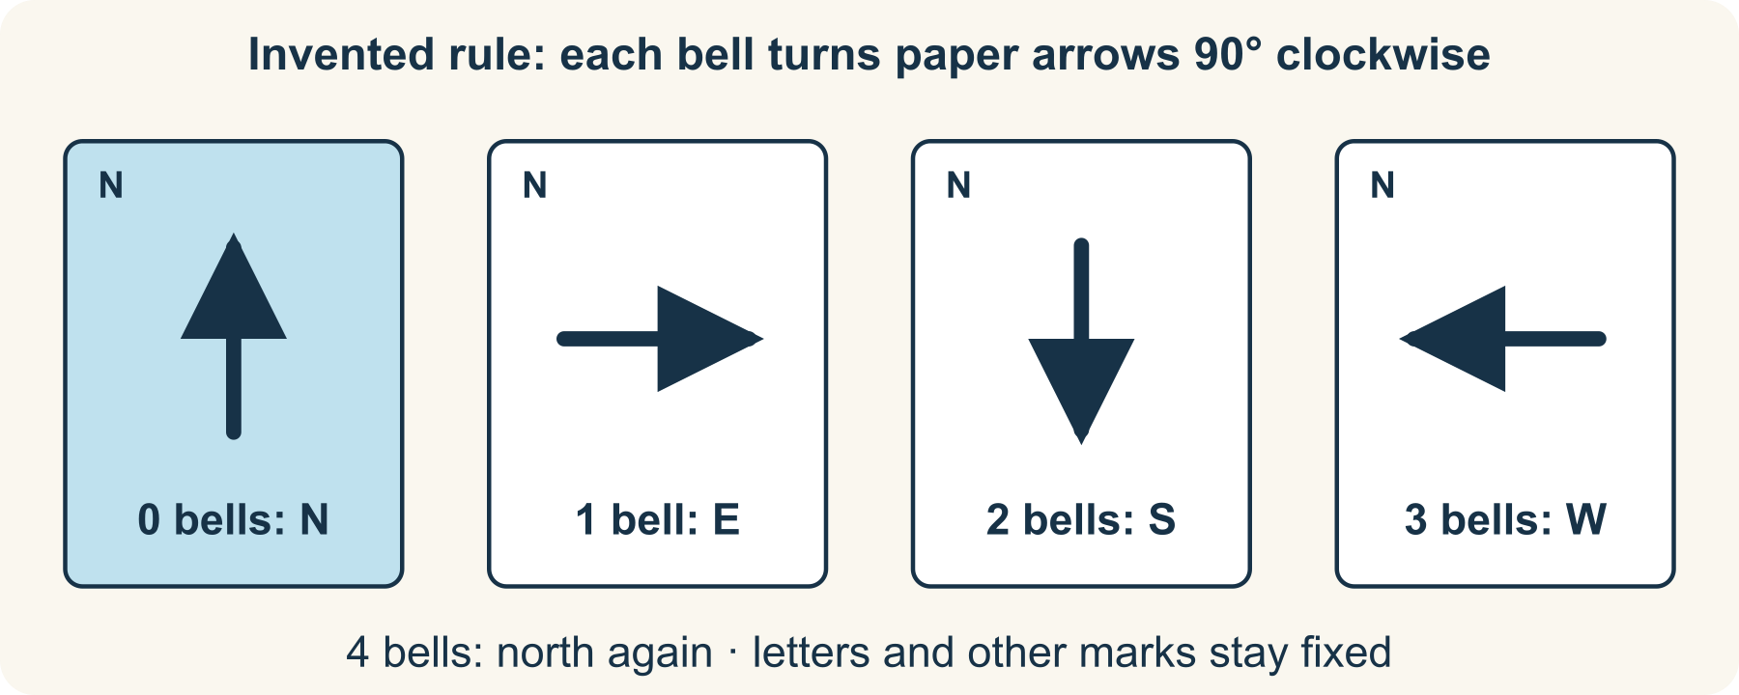
A quarter-turn at each fictional bell
1 Trace the rule exactly
After 1 bell it points east, after 2 south, after 3 west and after 4 north again. The arrow’s position on the page does not move; only its direction changes.
2 Derive three consequences
A paper map needs the bell count; a north arrow can point east after one ring; the written word NORTH stays fixed because the rule affects arrows, not other marks.
3 Make a small story problem
An invented character wants to label the route to a flower stall. Write or draw a choice between using an arrow and using a written direction. Show how the rule affects that choice.
4 Check consistency
If a scene has an arrow turn 180° after one bell, either revise that scene or explicitly revise the world rule. Do not silently change the rule whenever the plot needs help.

57 A worked example | storytelling-world-rule

One rule a cycle and a workaround
Dotfall is original fiction. No real paper changes direction when a bell rings.
• The clockwise cycle is north→east→south→west→north: 4 × 90° = 360°.
• A map arrow’s meaning depends on when it was read. A character could track the bell count or choose fixed written directions instead.
• Possible scene: “Miri crossed out the arrow and wrote NORTH. When the bell rang, the word stayed put.” This follows the stated exception for other marks.
What this example can show These are consequences of a chosen fictional rule, not a claim that every story needs magic, a fixed plot formula or a surprise ending.

A different way
Rotate a drawn arrow on paper through four labelled directions, or check only the supplied consequences. There is no need to invent a whole world.

If you want to go further
Predict the arrow after 5 and 6 bells, then use the four-step cycle to explain east and south without tracing every ring.

Something to notice
Does this event follow my stated rule, or am I adding a new rule without saying so?

Read or explore more
Horizon topic Worldbuilding
https://launchhorizonhq.com/learn/worldbuilding/
Horizon topic Plot Consequences
https://launchhorizonhq.com/learn/plot-consequences/
Horizon topic Revision Editing
https://launchhorizonhq.com/learn/revision-editing/
NSW Education Standards Authority narrative - glossary
https://curriculum.nsw.edu.au/resources/glossary/narrative
NSW Education Standards Authority voice - glossary
https://curriculum.nsw.edu.au/resources/glossary/voice

58 Zoology | zoology-evidence-cards

Sort animal clues without guessing
What happens when a grouping rule meets a missing detail?
Group four fictional animal cards by stated features, change the rule and keep unknown information visible.
Explore | 10-20 minutes, or one grouping | Paper and a pen or pencil, The four complete fictional card descriptions below; no wildlife observation needed
Start here Copy four labels, or use the supplied cards: A has feathers and stripes; B has feathers and spots; C has fur and stripes; D has stripes but its covering is hidden.
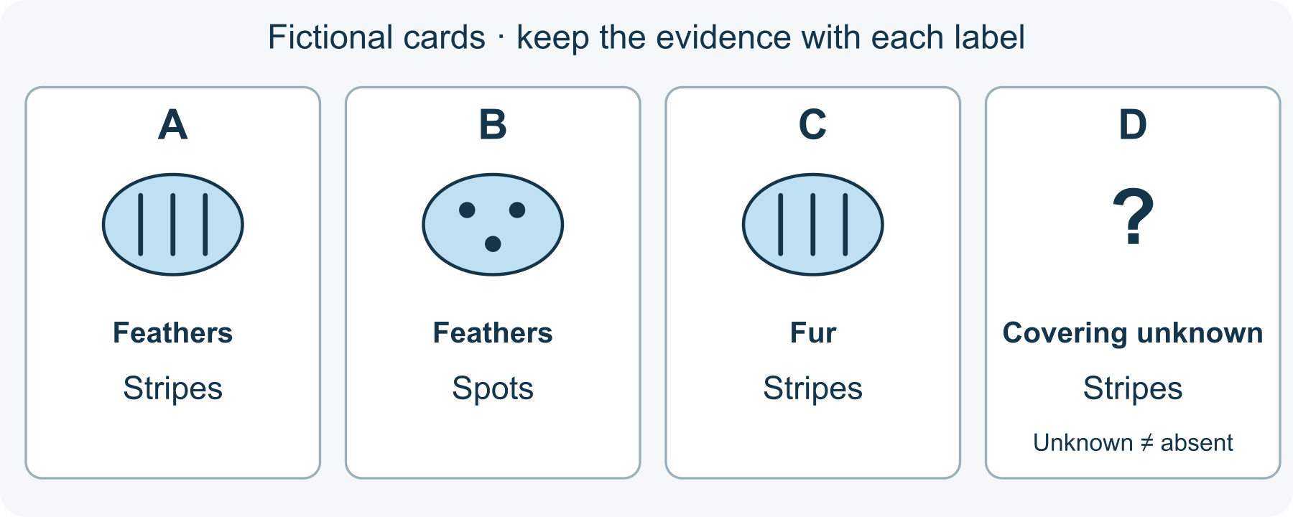
A known pattern can have an unknown covering
1 Keep the evidence attached
These are invented creatures described for a sorting model, not real species records. Record only what each description supplies. For D, ‘covering hidden’ means unknown, not ‘no covering’.
2 Choose one rule
First group by the stated covering: feathers, fur or unknown. Put A with B, C in fur and D in unknown. You can draw boxes, point or say the groups instead of making cards.
3 Change the question
Now group by stated pattern: stripes or spots. A, C and D go together for stripes; B has spots. This grouping answers a different question, so changing groups is not a contradiction.
4 Name a limit
Write one conclusion supported by the descriptions and one question they cannot answer, such as how the animals move. Do not fill a missing detail with a guess. You may design an additional fictional card if you want.

58 A worked example | zoology-evidence-cards

Four fictional cards two sensible groupings
The supplied model descriptions are complete: A = feathers, stripes; B = feathers, spots; C = fur, stripes; D = stripes, covering hidden. These labels are invented, not observations of actual animals.
• Covering rule: feathers A/B; fur C; unknown D.
• Pattern rule: stripes A/C/D; spots B.
• D can join the striped group while its covering remains unknown. One known feature does not supply a missing one.
What this example can show These convenient groups do not identify a species, establish evolutionary relationships or prove a feature's function. No animal contact or collection is part of this activity.

A different way
Use only A and D, have the labels read aloud, or direct another person to draw the groups. You can use the model without identifying a real animal.

If you want to go further
Create a fifth fictional card with a clearly labelled feature. Test whether both rules can place it, adding ‘unknown’ or ‘another pattern’ where needed instead of forcing a match.

Something to notice
Did I keep ‘unknown’ different from ‘absent’?

Read or explore more
Horizon topic Zoology
https://launchhorizonhq.com/learn/zoology/
Horizon topic Animal Coverings
https://launchhorizonhq.com/learn/animal-coverings/
Horizon topic Classification Keys
https://launchhorizonhq.com/learn/classification-keys/
Australian Museum What is classification?
https://australian.museum/learn/species-identification/ask-an-expert/what-is-classification/
Science Learning Hub, University of Waikato Develop a classification system
https://www.sciencelearn.org.nz/resources/158-develop-a-classification-system

59 Zoology | zoology-beak-evidence

A beak drawing and a function question
What can shape alone suggest, and what needs a checked reference?
Compare two original beak models numerically, then separate a visible feature from a claim about how a bird lives.
Investigate | 15-25 minutes, or one comparison | Paper and a pen or pencil, The supplied model; no purchase, account or internet connection needed
Start here Use two fictional beak models measured by the same drawing convention: A is 12 mm long and 6 mm wide; B is 24 mm long and 6 mm wide. These are model labels, not measurements of real birds.
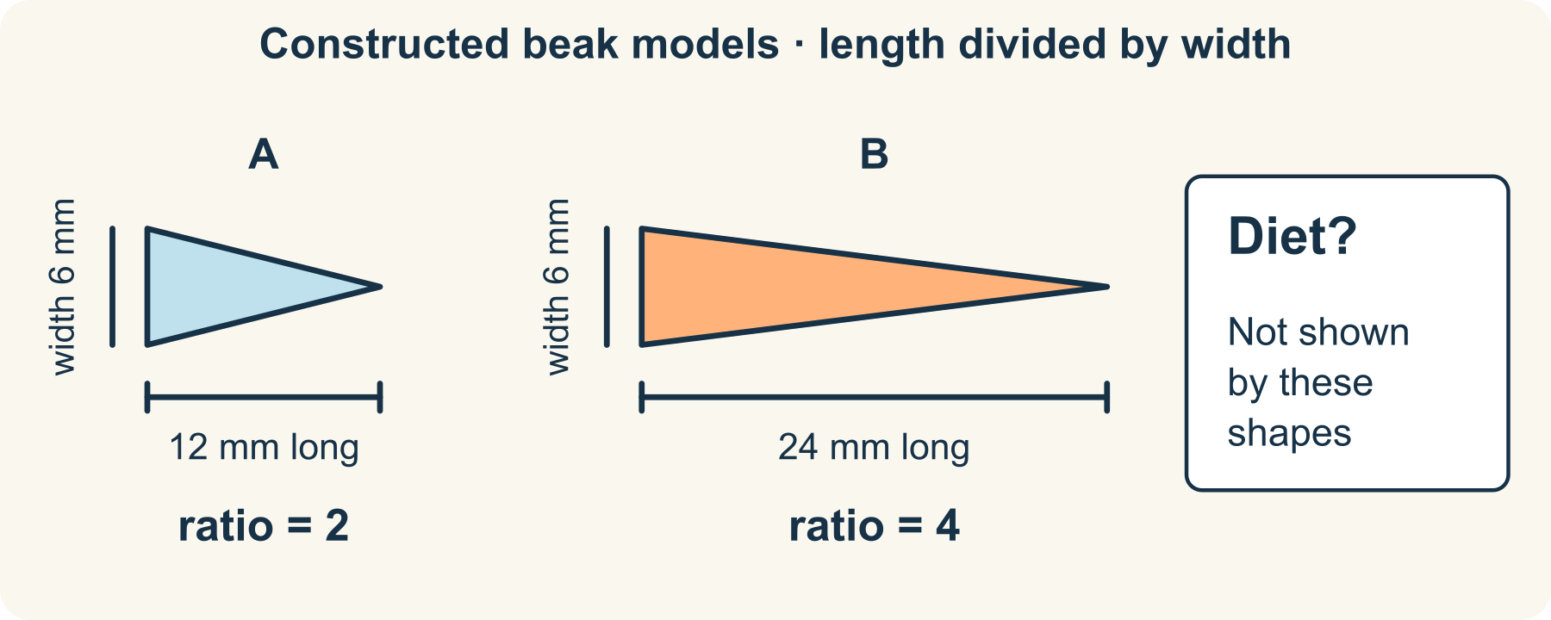
Shape measurements do not name a diet
1 Compare like measurements
Keep units and measurement points consistent. Length-to-width ratio is length divided by width: A = 12 / 6 = 2; B = 24 / 6 = 4.
2 State what the drawing supports
B is twice as long in this model and has twice A’s length-to-width ratio. Both have the same stated width. This is a shape comparison, not an identification.
3 Question a function claim
The silhouette might suggest a question about reach or handling food, but it does not establish a diet. Real beaks serve several functions, and similar shapes need not be used in exactly the same way.
4 Name better evidence
For a real species question, seek a checked species reference and observations of what that species does. You can finish by stating what evidence is missing; do not catch, feed or test a bird.

59 A worked example | zoology-beak-evidence

Two ratios no invented diet
Both outlines and all dimensions are original constructed models.
• A: 12 mm/6 mm = 2. B: 24 mm/6 mm = 4. These ratios have no unit because the same units cancel.
• B’s model length is 2 × A’s. The figures alone do not prove B eats a particular food or has greater feeding success.
• A useful question is “What evidence would connect this feature with a function in a named species?” It is more precise than assigning a diet to an unnamed drawing.
What this example can show Model dimensions do not reveal material properties, movement, ancestry, behaviour or ecological context. The reference research does not validate these fictional beaks.

A different way
Use the supplied calculations and compare “what is labelled” with “what is unknown”, or have someone describe the two outlines. A calculator is optional, not required.

If you want to go further
Scale A to 24 mm long and 12 mm wide. Its ratio remains 2: explain why size and proportion are different comparisons.

Something to notice
Which part of my account came from the model, and which would require evidence about a real species?

Read or explore more
Horizon topic Bird Beaks
https://launchhorizonhq.com/learn/bird-beaks/
Horizon topic Animal Classification
https://launchhorizonhq.com/learn/animal-classification/
Horizon topic Zoology
https://launchhorizonhq.com/learn/zoology/
University of Bristol Bird beaks did not adapt to food types as previously thought
https://www.bristol.ac.uk/news/2019/january/adaptation-of-bird-beaks-.html
Okinawa Institute of Science and Technology Birds have beaks that are a compromise of many functions
https://www.oist.jp/news-center/news/bbu/2022/1/27/birds-have-beaks-are-compromise-many-functions

60 Zoology | zoology-movement-model

Invent a creature with a labelled inspiration
Which movement idea is researched and which part belongs to invention?
Design an imaginary creature while labelling what came from research and what is only an untested invention.
Make | 15-25 minutes, or one comparison | Paper and a pen or pencil, The supplied model; no purchase, account or internet connection needed
Start here Sketch an invented “River Skipper”: an oval body, a side-to-side rear fin and a muscular tail that might contact the ground. Label the whole creature “invented; function untested”.
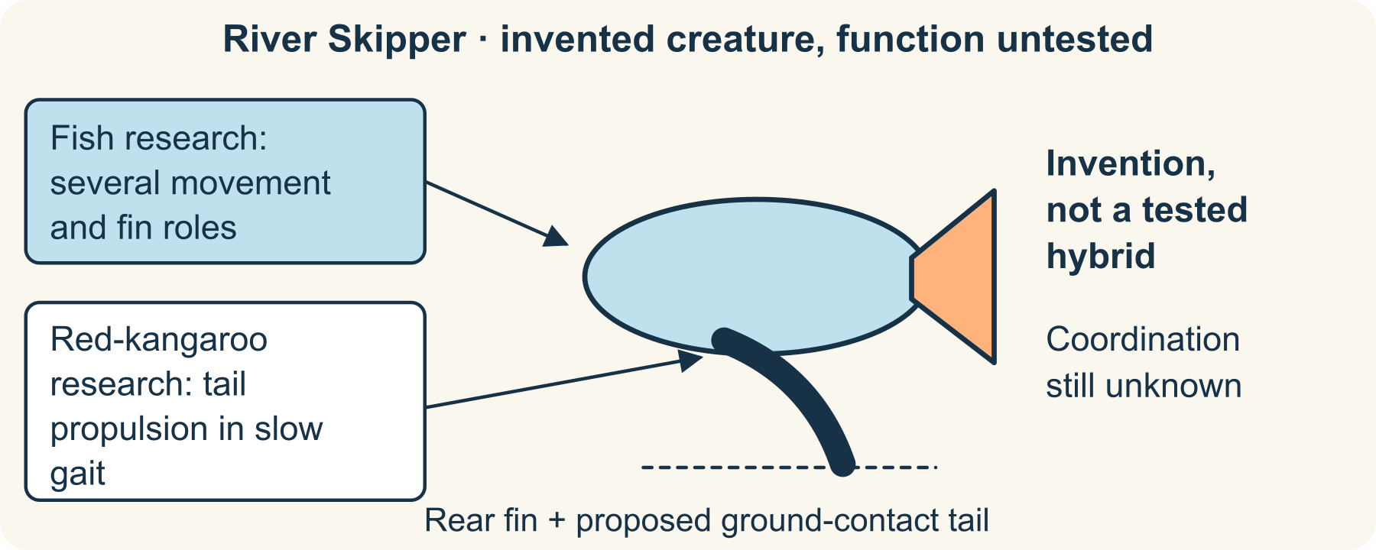
Research is an inspiration, not a hybrid test
1 Read the two supplied research notes
The Florida Museum describes different ways fish propel and stabilise themselves, including body/tail motion. A red-kangaroo study measured a propulsive role for the tail during its slow five-part gait. These are different real cases.
2 Mark the borrowed ideas
Label rear-fin movement “inspired by fish locomotion” and proposed ground-contacting tail “inspired by the red-kangaroo study”. These labels identify an inspiration, not evidence that a hybrid would work.
3 Add one invented feature
For example, give the creature broad folding fins. Explain their proposed purpose with “might”. Write one unanswered question about support, movement or coordination; do not describe the proposal as an observed adaptation.
4 Keep the categories separate
Use three headings: researched statement, design invention, evidence still needed. The paper creature is complete as a labelled idea, even when its physical feasibility remains unknown.

60 A worked example | zoology-movement-model

A research inspired drawing with honest labels
The River Skipper is original fiction; no animal was made, measured or observed for this activity.
• Research: some fish use body/tail movement in swimming. The museum also describes fins helping with stability and manoeuvring, so “all fins do the same job” would be inaccurate.
• Research: the cited red-kangaroo work concerns slow pentapedal locomotion; it does not establish a universal function for every animal’s tail.
• Invention: one creature combines a rear fin with a proposed ground-contact tail. Unknown: whether its structures, materials and movement could work together.
What this example can show A useful biological analogy is not proof of engineering feasibility, evolutionary history or real animal behaviour. Keep the inspiration’s species and movement context visible.

A different way
Annotate the supplied creature with R for research and I for invention, or dictate labels to a scribe. There is no need for artistic skill, outdoor observation or animal handling.

If you want to go further
Remove one proposed structure and explain which movement question changes. A paper redesign can test consistency of your explanation, not physical performance.

Something to notice
Can a reader tell exactly which statement is researched and which part I invented?

Read or explore more
Horizon topic Animal Movement
https://launchhorizonhq.com/learn/animal-movement/
Horizon topic Aquatic Movement
https://launchhorizonhq.com/learn/aquatic-movement/
Horizon topic Zoology
https://launchhorizonhq.com/learn/zoology/
Florida Museum of Natural History, University of Florida How Fish Swim
https://www.floridamuseum.ufl.edu/discover-fish/fish/how-fish-swim/
O’Connor and colleagues, Biology Letters; PubMed record The kangaroo’s tail propels and powers pentapedal locomotion
https://pubmed.ncbi.nlm.nih.gov/24990111/

